**Egg drop lab Report Format**

**Below is a guideline for how to write your lab report**

**Remember to refer to: How to write a lab report and example of a well written lab report from my website: Kowenscience.com for additional guidance**

**Introduction:**

**You need to have a purpose statement**: such as (The purpose of this lab was to design and build a device that will safely deliver a raw egg from a free height of insert height here .)

**You also need to have background information that was pulled from or considered in order to design your project:**  You can use motion ( laws of motion), kinetic energy and gravitational potential energy, gravity, force ( You do not need to include all of these but pick and use one as your background and how it will aid in your design.)

**You need to stay out of first person (no I or we)**

**The intro should be between a paragraph and ¾ a page long. If you pull info from a source, you need site your source. Make sure that your paragraph flows smoothly when read.**

**Methods:**

**You need to have a list of material used to build your device. No sentences, just listed**

**You need to have the procedure of how you built and tested your project written in step form. This section need to be written in first person**

**Ex 1. I dropped my device from a height of 10 feet.**

**Look at my example lab reports from my website to help in this section**

**A photo of your project will be an added plus. Label parts if necessary.**

**Results:**

**Include the Chart below:**

**Score Group Time Distance Velocity Mass Force GPE KE**

**Score formula: mass + 100 x time Force = mass x acceleration GPE = weight x height KE = ½ mass x velocity 2**

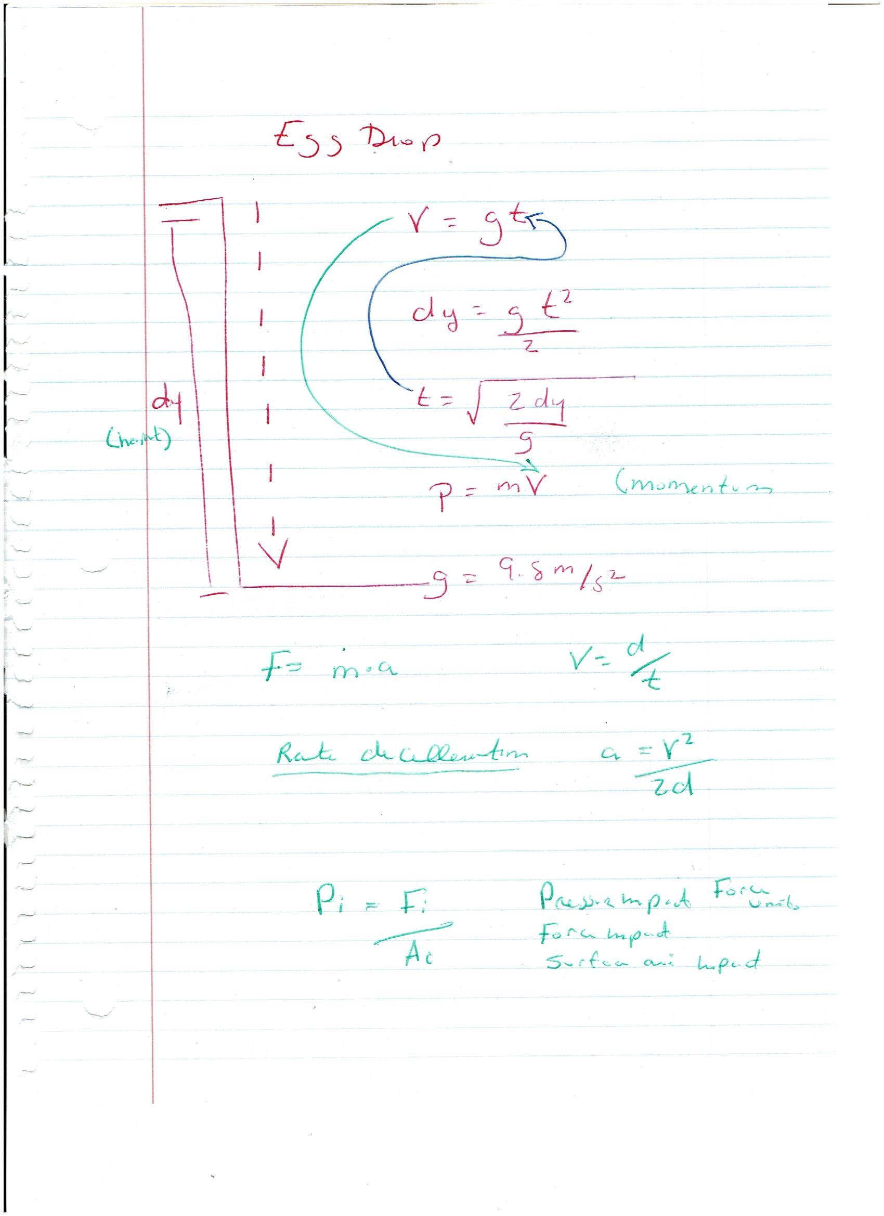

**Conclusion:**

**BE sure and spend time on this section, it is the most important part of a lab. This is where you draw conclusions and apply what you witness in the experiment and the known laws of science. This is where all great discoveries are made!!**

**Restate your purpose statement.**

**Discuss how the background you used in the introduction aided in this project**

**Remember to stay out of first person.**

**State whether your design was successful or not and any errors or improvements that could be made to the design**

**Show how the force, GPE, and KE formulas played a role in this project**