

The Hillside Stranglers

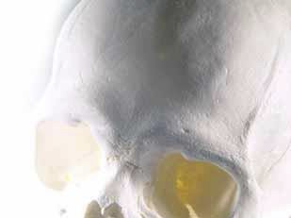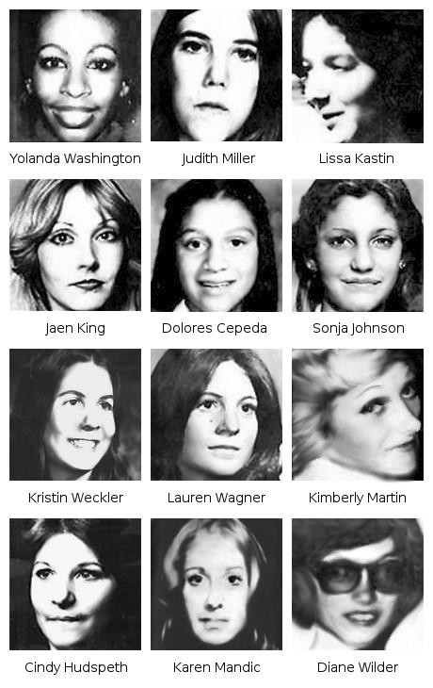

Angelo Buono Jr. & Kenneth Alessio Bianchi,   
 also known as "The Hillside Stranglers"

• Were a pair of

serial killers

responsible for the   
murders of at least

12 women.

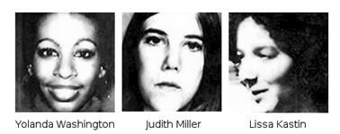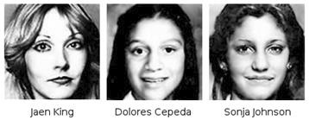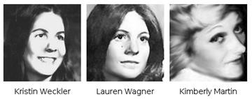

Overview of The Killings

• In October of 1977, the two committed their first

murder together.

• By the beginning of 1978, the pair had killed a total   
 of ten women. At that point, they stopped killing,   
 possibly because Bianchi's son was born.

• Also, Bianchi, who had been applying for law   
 enforcement jobs even while killing, had made   
 some acquaintances in the LAPD and been

brought along when officers drove around the city,

scouting for the killers. He might have gotten a   
little scared.

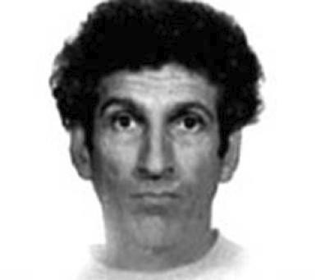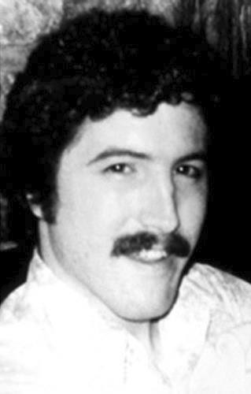

History of the suspects:

• Angelo Buono Kenneth Bianchi

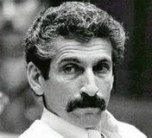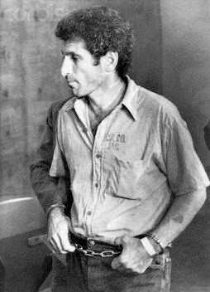

Angelo Buono

• Born: Rochester, New York,

1934.

• Parents: Italian immigrants who

divorced when he was young.

• At 5, he moved to California with   
his mother.

• Displayed a high interest in sex at

a young age.

• When he was a teenager, told his

classmates that he had raped

several girls.

• Began stealing cars and was

placed in reform school.

• 1955: married his high school sweetheart,

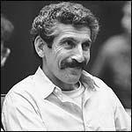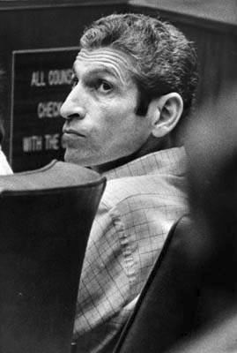

who was pregnant, but left her soon after.

• Later, he married Mary Castillo and

fathered 5 children. Also ended in

divorce, in 1964; she claimed he had   
been physically and sexually abusive.

• Married a third time, to single mother   
Nannette Campino and had 2 children

with her. Divorced in 1971, both for

abusing of her, and raping of her   
daughter.

• He became a car upholsterer and was,

despite his physical appearance and   
abusive behavior, considered very

attractive by women.

Kenneth Bianchi

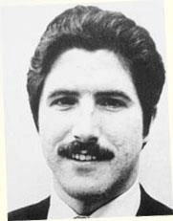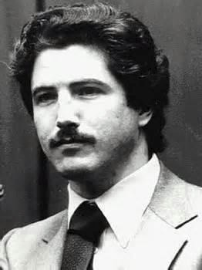

• Also born in Rochester, New York,

almost 17 years later.

• Mother: a prostitute who gave him up   
 for adoption at birth.

• Adopted by local residents Nicholas

Bianchi and Frances Sciolono.

• Upbringing was stable, but he became   
 a pathological liar early in childhood.

• Spent a lot of time daydreaming due to

petit mal seizures when he was five.

• Had a bad temper & was diagnosed   
 with passive-aggressive personality   
 disorder.

• Had an IQ of 116, was an   
 underachiever in school.

• After graduating in 1971, he married   
 his high school sweetheart, but they   
 divorced after eight months.

• Dropped out of college after just one term

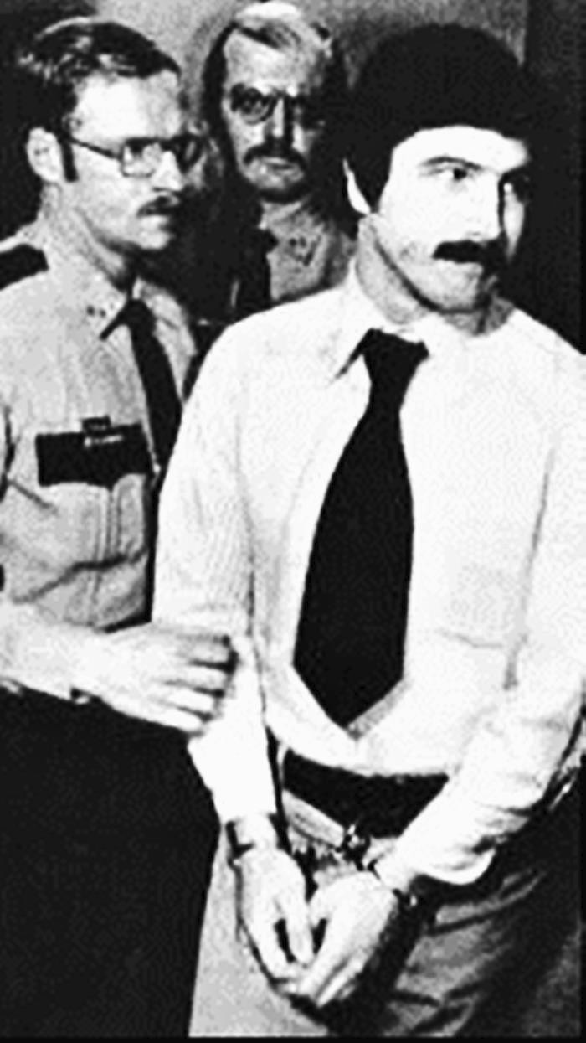

(studying police science and psychology)   
& applied for a position at the sheriff's   
department, but was rejected.

• He took on a series of menial jobs, from   
 which he was always fired for stealing.

• 1975: moved to California & moved in with

Angelo, who taught him to use a fake

police badge to extort free sex from   
prostitutes.

• The two also became pimps for a while.

• Bianchi got a job at a title company &

moved in with Kelli Boyd, whom he met at

work.

• In May 1977, she was pregnant with his   
 child.

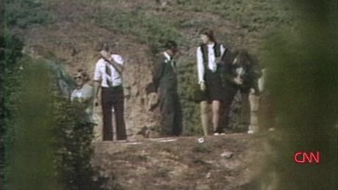

Modus Operandi

• Buono and Bianchi initially targeted prostitutes, but

later moved up to middle class women.

• The oldest victim was 28 years old and the youngest

12.

• The two would hunt for victims while cruising around

the streets in their car. When they found a suitable

victim, they would pick her up, either by soliciting them   
if they were prostitutes or by pretending to be

undercover cops, even carrying fake badges.

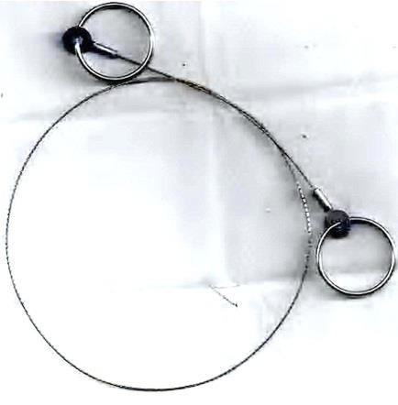

• Once the victim was in the car,   
they would drive her to Buono's

home and spend hours raping

and torturing them before killing   
them by strangling them with a

garrote, their signature

weapon.

• They also killed some victims

by different means, including   
gas asphyxiation, lethal   
injection and electric shock.   
The bodies were disposed of

outdoors, often in hilly areas.

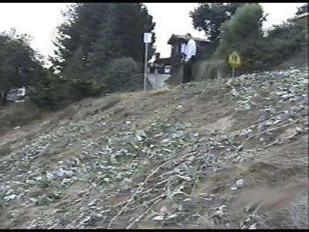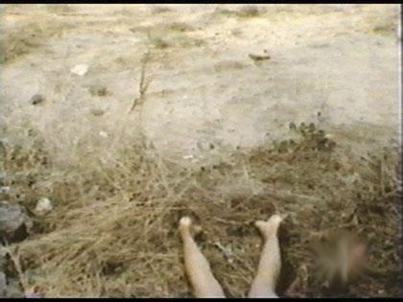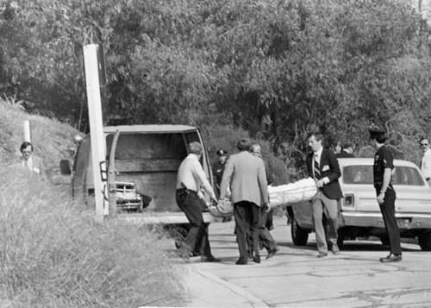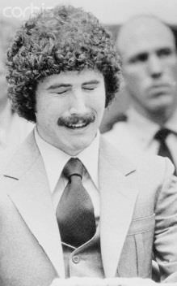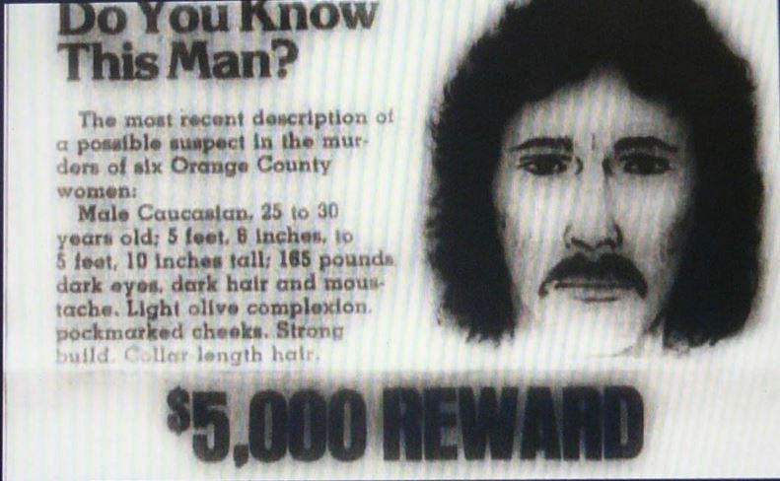

• November 1, 1977: La Crescenta neighborhood,



north east of downtown Los Angeles.

- Body of a teenage girl was found naked, face up on a   
parkway in a residential area. A nearby homeowner

had covered her with a tarp to keep neighborhood

kids from seeing her on their way to school.

- Bruises on her neck indicated strangulation.

- The body dumped, indicating she was killed

elsewhere.

- Eventually identified as Judith Lynn Miller, a runaway   
prostitute (barely 15 years old).

- She had been bound much like the first victim,   
Yolanda Washington.

• November 6, 1977: near the Chevy Chase



Country Club.

- Strangled with a ligature.

- Identified as 21-year-old Lissa Kastin, a waitress,   
and was last seen leaving work the night before   
she was discovered.

- Lissa was not a prostitute. She had also worked   
part-time for her father's real estate and   
construction business. A ballet student, she was

saving money to continue her training and hoped

to become a professional dancer.

• November 13, 1977: Dolores Cepeda,14, and Sonja Johnson, 12,

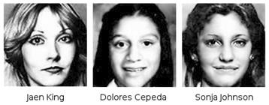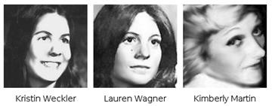

boarded a school bus and headed home.

- Last seen getting off this bus and approaching a car. Inside the car   
 were reportedly two men.

- November 20: a young boy, cleaning up a trash-strewn hillside

near Dodger Stadium, found their bodies. Both girls had been

strangled and raped.

• (Also) November 20, 1977: hikers found the nude, sexually

assaulted body of Kristina Weckler, 20, on a hillside near Glendale.

- There were now signs of torture, indicated by oozing injection marks.

- It was later revealed that she had been injected with Windex.

• November 23, 1977: badly decomposed body of Jaen King, 28, an   
 actress, was found near an off ramp of the Golden State freeway.

- She had gone missing around November 9.

• With the continued discovery of bodies in hilly areas, a task force   
 was formed to catch the predator, dubbed the "Hillside Strangler".

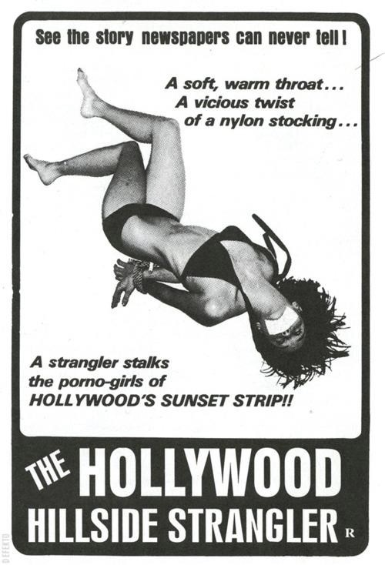

• November 29, 1977:

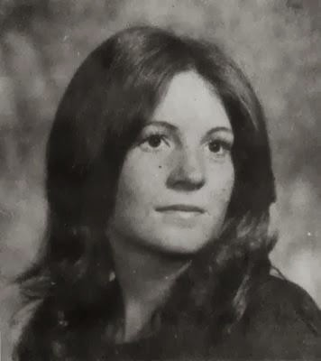

police found the body of

Lauren Wagner, 18.

- She also had been

strangled with a ligature.

- Burn marks on her hands

indicating she was

tortured.

- The law enforcement task   
force began to assume

more than one person was

responsible for the

murders.

• December 13, 1977,

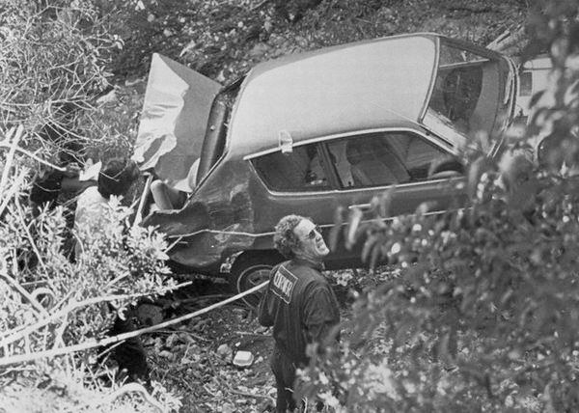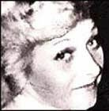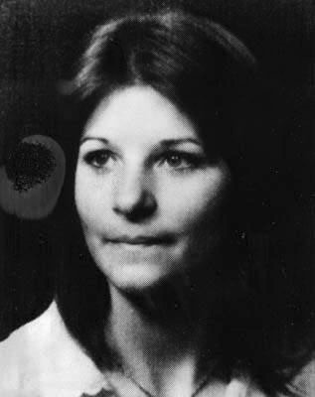

police found the body of   
17-year-old prostitute

Kimberly Martin on a

hillside.

• February 16, 1978: The

final victim in Los Angeles   
was discovered.

- Helicopter pilot spotted an

orange Datsun abandoned   
off a cliff on the Angeles

Crest Highway. Police

found the body of the car's   
owner, 20-year-old Cindy

Hudspeth, in the trunk.

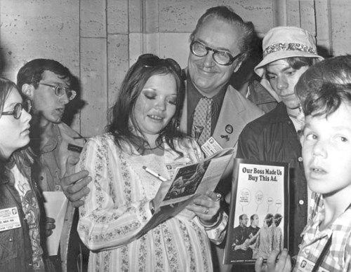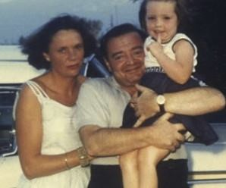

Interestingly,

• Sometime in 1977, the two   
men gave a ride to

Catharine Lorre with the

intent of killing her as well.

However, when they   
discovered that Catharine

Catharine Lorre

Catharine with her father

was the daughter of Austrian

actor Peter Lorre they did

not kill her. She did not

realize who the men were   
until they were arrested.

Peter Lorre (a movie star)

• Why?

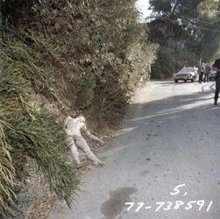

The Beginning of the End

• On the night when the duo   
tried to abduct an eleventh

victim, the two got into a

heated argument during   
which Bianchi revealed   
that he had been

questioned by police in the

Hillside Strangler case.

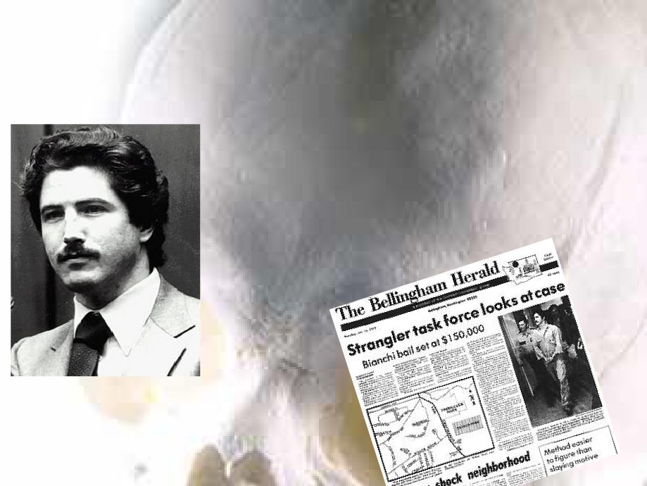

The Beginning of the End

• A furious Buono threatened to kill

him if he didn't get out of town.

Bianchi and his family moved to   
Bellingham, Washington in May,

1978, where he got a job as a

security guard.

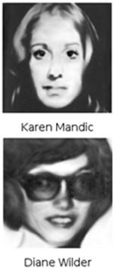

The Beginning of the End

• In January of the following year,

Bianchi abducted two female

Western Washington University

students, Karen Mandic and Diane   
Wilder, took them to a house he   
guarded, raped, tortured and killed   
them.

• Fortunately, he left behind some

clues this time; his car, which had   
California plates, was spotted and

he was connected to the addresses

of two Hillside Strangler victims. The   
next day, January 12, he was

arrested.

• When Bianchi's photo was broadcast in the media in

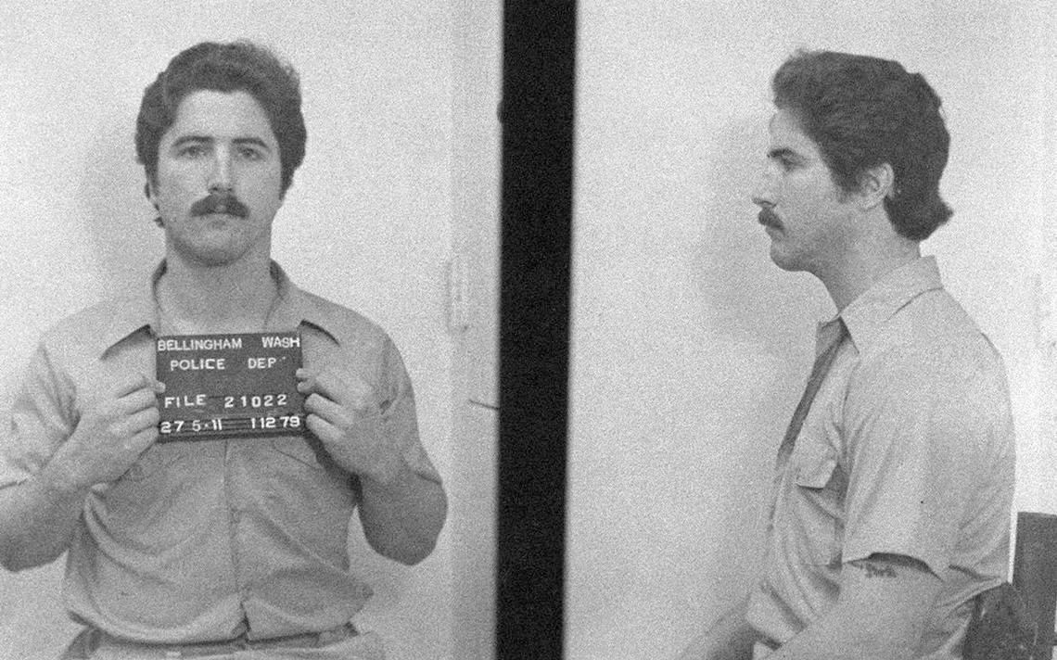

Los Angeles, the investigators received a call from a

lawyer named David Wood, who had helped one of the

two girls Buono and Bianchi had pimped. He tipped

them about Buono, who was also arrested on October   
22, 1979. Bianchi had also informed investigators of his

cousin's involvement in the murders.

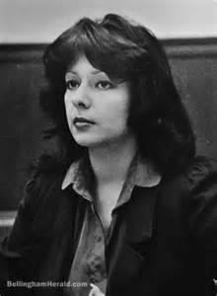

• During the two years leading   
up to the trial, Bianchi formed   
[a relationship with Veronica](http://criminalminds.wikia.com/wiki/Veronica_Comptonhttp://criminalminds.wikia.com/wiki/Veronica_Comptonhttp://criminalminds.wikia.com/wiki/Veronica_Compton)   
[Lynn Compton](http://criminalminds.wikia.com/wiki/Veronica_Compton)

• An actress and playwright

with an obsession with serial

killers, from behind bars.

• She sent him a copy of a   
screenplay, titled The   
Mutilated Cutter, about a   
female serial killer she had

written, asking for his

thoughts on the subject.

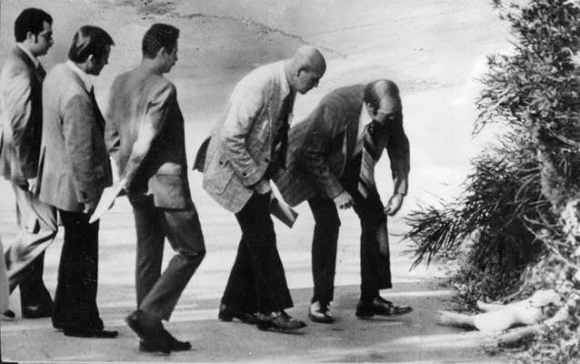

• She grew increasingly fixated with him until Bianchi

managed to manipulate her into [copycatting](http://criminalminds.wikia.com/wiki/Copycat) a Hillside   
Strangler murder in order to make it look like the killer

was still at large, even smuggling out some of his

semen out of prison in a rubber glove (DNA evidence   
had no forensic use at the time, but semen could still   
be analyzed to show what blood type the man who

produced it had).

• Compton lured a woman to a motel and attempted to   
strangle her, but was overpowered and arrested.



• In anticipation of his 1981 trial, Bianchi

prepared to mount an insanity plead,   
claiming to have a separate

personality named "Steve Walker"

who had committed the murders   
(Bianchi had watched the

movie [Sybil](http://en.wikipedia.org/wiki/Sybil_(film)) the night before he made   
the claim).

• He was interviewed by multiple people   
 who specialized in multiple

personalities and hypnosis, who

attempted to find out whether he truly   
was insane.

• It was eventually determined that he

was faking it (he had been inventing

more "alter egos" since he was told

that it was uncommon for there to only   
be one extra personality).

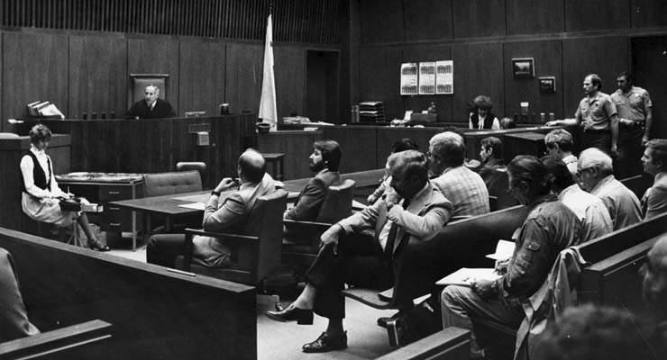

During the trial, there was a great deal of   
 trace evidence implicating the two:

• There had been fibers from

Buono's upholstery workshop   
and home on two victims,

• There was an imprint of a fake   
police badge on his wallet,

• There were hairs from rabbits   
Buono had raised on another   
victim.

• Bianchi also agreed to plead

guilty and testify to his cousin's

involvement, though he   
remained uncooperative

throughout the trial.

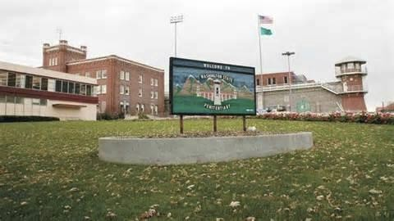

Sentence

• In 1983, both men were found guilty of the murders they   
 had committed and, in spite of the cruelty of their crimes,

spared the death penalty and sentenced to life in prison.

• Buono died of natural causes while serving his sentence in   
 2002 at the Calipatria State Prison in California.

• Bianchi is still serving his sentence at the Washington

State Penitentiary in Walla Walla, Washington and won't   
be eligible for parole again until 2025.