The Azaria Chamberlain   
Case: A Cry in The Dark

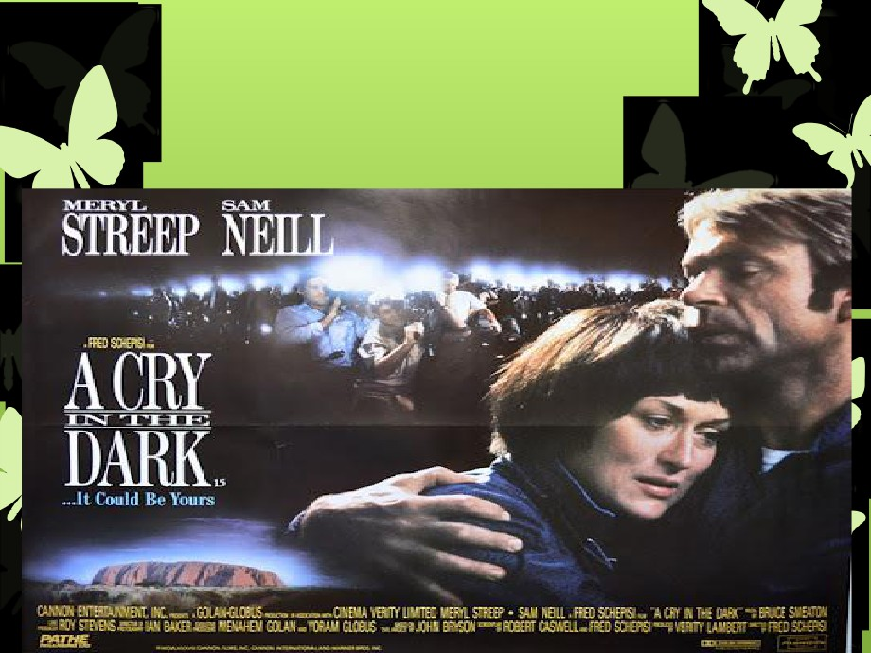

Movie: A cry in the Dark - Based on this story



You May Know it best for

the phrase:

“The Dingo Ate My Baby!”



 On the 17th August 1980, the Chamberlain family was   
 camping at Uluru in Australia's Northern Territory, when

at around eight o'clock at night, they heard a cry from

the tent where their ten week old baby girl and four   
year old son were sleeping.

 Rushing to the tent, the mother of the child, Lindy, saw   
 a dingo near the tent's entrance and upon entering,

realized with horror that her baby daughter Azaria, was   
missing and all that remained was a pool of blood on   
the floor. The police arrived and a search was organized   
but no traces of the baby were found.



 When the head park ranger arrived, she showed him   
 the blood as well as a torn and bloody blanket and   
 bloodstained items in the tent. Police officers took the   
 blanket and found bloodstains on the tent, but didn't

take the bloodied clothes of the Chamberlains until

long afterwards.

 When a tourist found the baby's jumpsuit near a

dingo lair, it was only slightly torn and bloody, but the

snaps were still mostly closed. It was pleated down

as if it had been pulled off. The baby had been

wearing other clothes that weren't found. A police   
officer arrived on the scene, and as one tourist

looked on in amazement, he picked up the bloody

jumpsuit and folded it. After a TV station crew

showed up, a reporter kept stating that the jumpsuit   
was found that way.

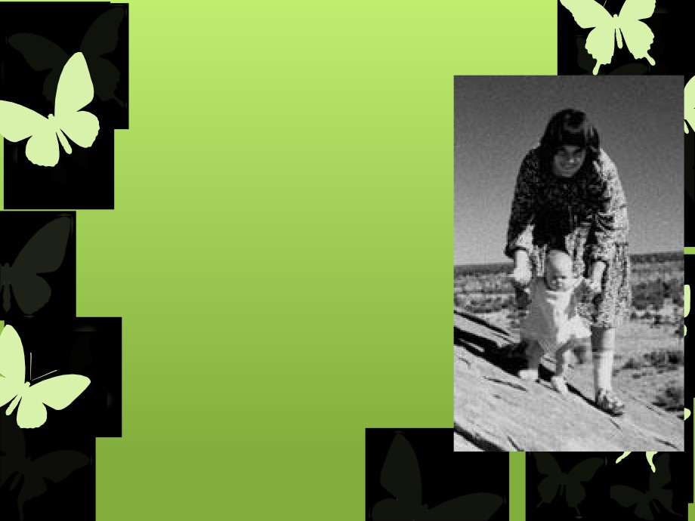

 The Chamberlains were interviewed the

next morning and only some of the

bloodstained items were removed from the tent, with many being left behind.

 The family was interviewed again later on   
 that same day, by a different officer who   
 thought the Chamberlains' recounts of the   
 previous night were suspicious.

 A week passed and no new evidence was   
 found, that is, until a tourist found Azaria's

vest and jumpsuit. But despite this new

piece of evidence, the crime scene was not sealed off and a full examination of the clothing was never conducted.

 This lack of proper crime scene and

evidence analysis led the police to believe   
that Lindy Chamberlain was lying about her   
story.

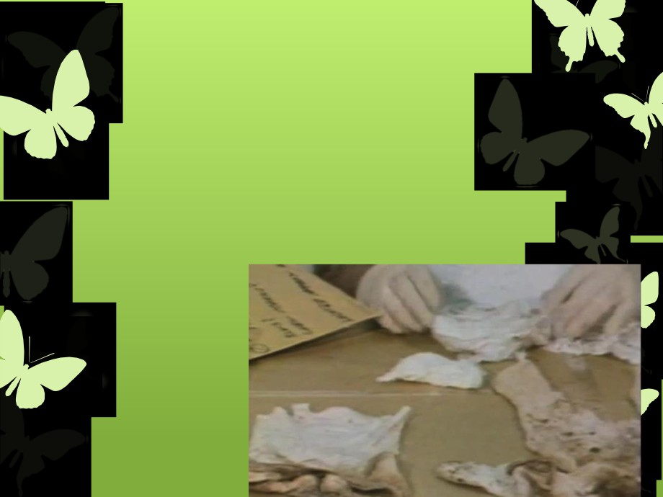

 The lack of dingo bite marks and saliva on Azaria's   
 jumpsuit and the fact that the baby's shoes were

still tied inside the jumpsuit while the vest was

inside out, heightened the police's suspicion even   
further.

 In 1981, it was however, concluded that Azaria was   
 indeed taken by a dingo, allowing Lindy and Michael   
 Chamberlain to at last get over the accusations after   
 the tragic loss of their child and move on with

everyday life.



This was however, not to be the case,

because after a later analysis of the baby's

clothing, it was found that there was a bloody

handprint in the shape of a women's hand,

reopening the case in 1982.

Analysis of the Chamberlains' car also

revealed a pair of scissors, baby's blood and

some experts claimed that the rip marks on   
the baby's clothing were actually scissor stab

marks. And so it was with this new evidence

that another court case was held on the 2nd   
February, 1982.



Initially, the small amount of blood found in   
the tent was suspicious as well; only later   
testing of the bassinet mattress showed that   
it had been saturated with enough blood to

have resulted in the death of a baby.

Fluorescent examination of the jumpsuit

showed that a bloody mark consistent with

the action of slitting a throat was present.



 Throughout the case, the local police improperly

handled blood spatter and other evidence. They

didn't photograph the scene or attempt to preserve   
materials found there, which essentially rendered

many of the conclusions that they reached invalid.

However, expert testimony proved to be enough to   
convict Lindy Chamberlain of murder and her   
husband of being an accessory to murder.



The case concluded for what was thought to   
be the last time, when Lindy was convicted   
with murder of her daughter and sentenced

to life in prison.

After serving six years in prison, there was   
a turn in the case when baby Azaria's jacket

was unbelievably, found partly buried at

Uluru. Just five days later, Lindy was

immediately released from prison, but to

this day, nobody knows the exact truth and

we'll probably never know.



The Azaria Chamberlain case shows what

can happen when law enforcement isn't

trained in proper collection of evidence such

at trace and blood. If the police had properly

conducted their investigation, the

Chamberlains may have remained

incarcerated, or they may have been able to   
definitively prove that a dingo ate their baby.   
The case officially remains unsolved.

