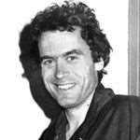

Case Study 1

Ted Bundy:

Campus Killer



• He was attractive, smart, and   
had a future in politics. He   
was also one of the most   
prolific serial killers in U.S.   
history. Ted Bundy screamed   
his innocence until his death   
in the electric chair became   
imminent, then he tried to   
use his victims one more   
time - to keep himself alive.   
His plan failed and the world   
got a glimpse of the true evil   
inside him.

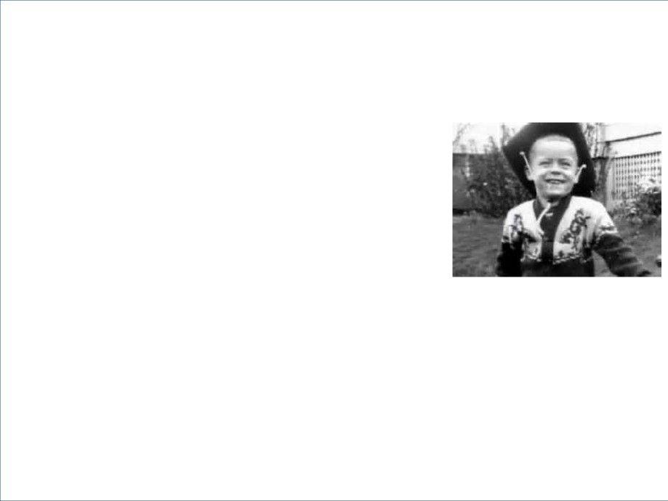

Ted Bundy was born Theodore Robert Cowell

• His mother, Louise Cowell gave birth to

him on on November 24, 1946, in   
Burlington, Vermont.

• After eight weeks, Louise and Ted

returned to her parents' house in   
Philadelphia.

• For the first several years of his life,

Ted thought his grandparents were his   
parents and his mother was his sister.

• In 1951 Louise and Ted moved to

Tacoma, Washington and Louise

married Johnnie Bundy, a military cook.

• Despite his circumstances and

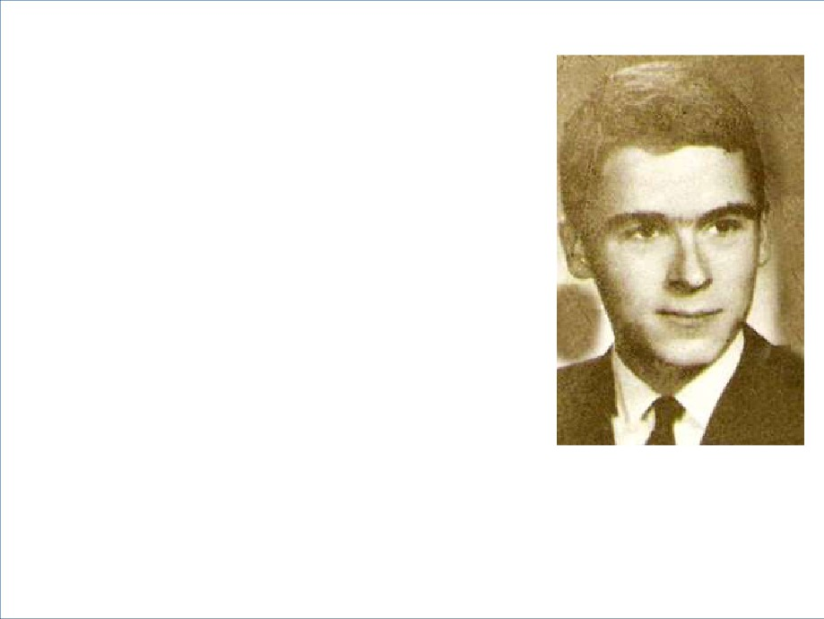

meager surroundings Bundy was well

behaved and grew into an attractive   
teen who was generally liked and   
who performed well in school.

• After high school he entered the

University of Puget Sound and

continued to do well academically,   
but felt uncomfortable around his

fellow peers who were predominantly

wealthy.

• In his sophomore year Bundy   
 transferred to the University of

Washington to escape the

uncomfortable feeling of his financial   
inadequacy.

Socially Challenged:

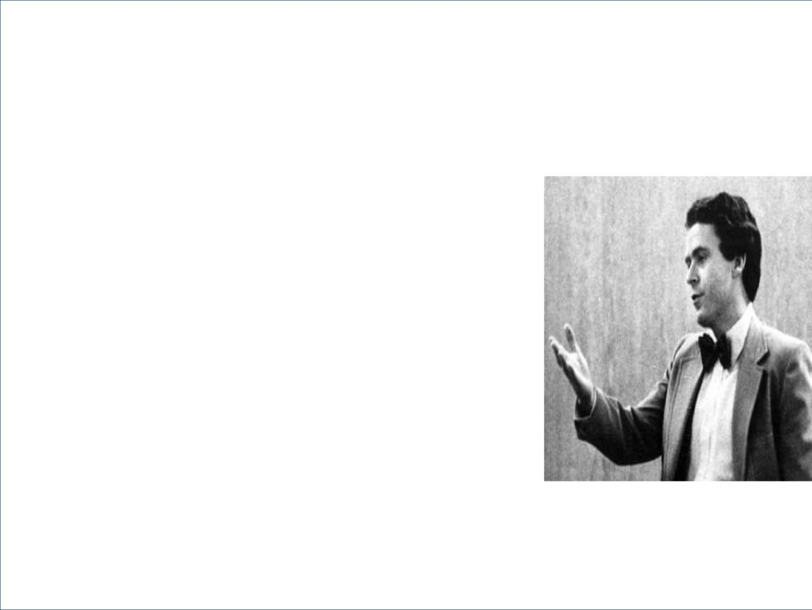

• Throughout his years in high

school & college, Bundy suffered   
from acute shyness that resulted   
in his appearing socially awkward.

• He rarely dated and kept to   
himself.

• But in 1967 Bundy met the woman

of his dreams. She was pretty,

wealthy, and sophisticated. They

both shared a skill and passion for

skiing and spent many weekends   
on the ski slopes.

Bundy's First Love:



• Ted fell in love with his new girlfriend and tried   
hard to impress her to the point of grossly

exaggerating his own accomplishments.

• He tried to gain her approval with a summer

scholarship to Stamford, but the result was less

than impressive.

• By 1968 she decided Bundy lacked any real   
future and was not husband material. She

ended the relationship and broke Bundy's heart

and his obsession toward her haunted him for   
years.

Depression:

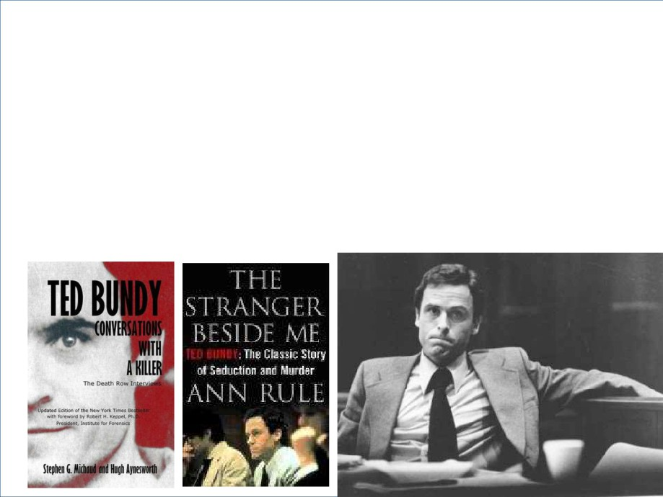

• Bundy suffered extreme depression over the break up and   
 dropped out of school.

• It was during this time that he learned the truth that his sister

was his mother and his parents were his grandparents.

• It was during this phase of his life that his shyness was   
 replaced with false bravado and he returned in college,   
 excelled in his major, and earned a law degree.

"Elizabeth":

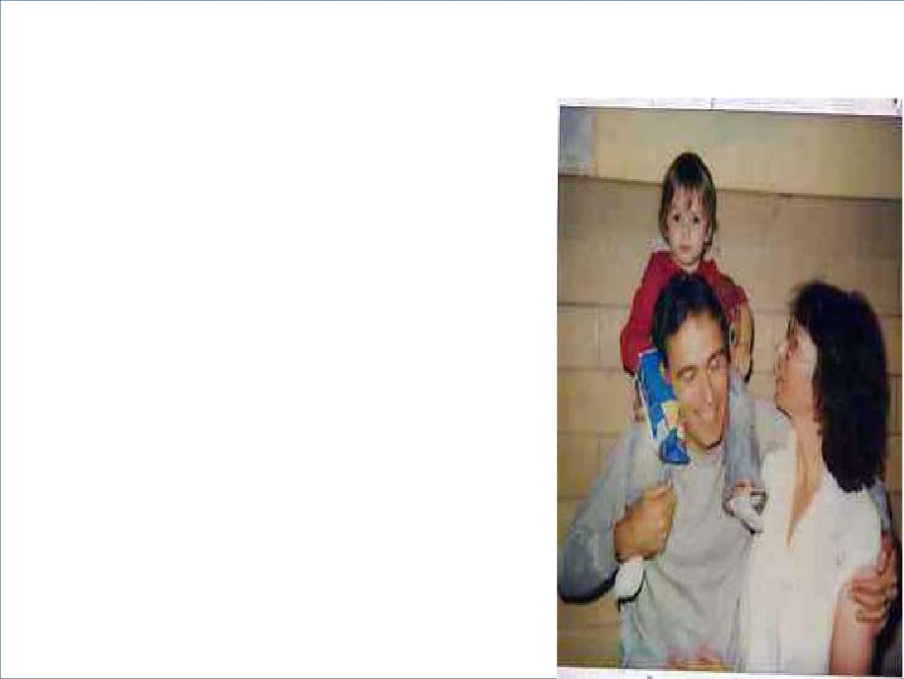

• Bundy became involved with   
another woman, Elizabeth

Kendall (a pseudonym) who

was a divorcee with a young   
daughter.

• Bundy was not receptive to

the idea of marriage, but   
allowed the relationship to

continue even after reuniting

with his first love who was   
attracted to the new

confident, Ted Bundy.

A New Ted Bundy:



• Bundy worked on the re-election campaign of

Washington's Republican Governor Dan Evans. After   
he was elected, he appointed Bundy to the Seattle   
Crime Prevention Advisory Committee.

• Bundy's political future seemed secure, when in 1973   
he became assistant to Ross Davis, chairman of the

Washington State Republican Party. It was a good

time in Bundy's life. He had a girlfriend, his old

girlfriend was once again in love with him, and his

footing in the political arena was strong.

And Then…

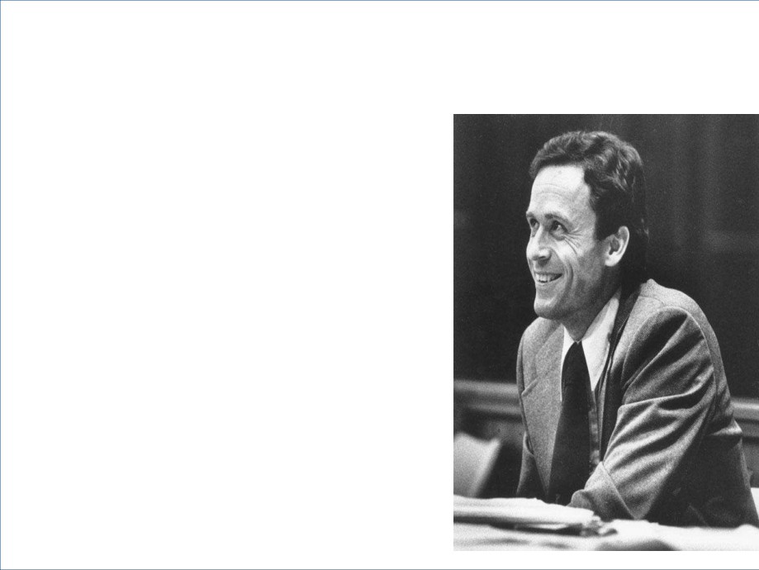

• In 1974 young women began

vanishing from college campuses   
around Washington and Oregon.

- Lynda Ann Healy, a 21-year-old   
radio announcer, was among   
those who were missing.

- In July 1974 two women were

approached at a Seattle state

park by an attractive man who   
introduced himself as Ted. He   
asked them to help him with his

sailboat but they refused. Later

that day two other women were   
seen going off with him and were   
never seen alive again.

Bundy Moves to Utah:



• In the fall of 1974 Bundy enrolled in law   
 school at the University of Utah and he   
 moved to Salt Lake City.

- In November Carol DaRonch was

attacked at a Utah mall by a man   
dressed as a police officer, but she   
managed to escape.

- She provided police with a description of

the man, the VW he was driving, and a   
sample of his blood that got on her   
jacket during their struggle.

- Within a few hours after DaRonch was

attacked, 17-year-old Debbie Kent   
disappeared.

A Grave Yard of Bones:

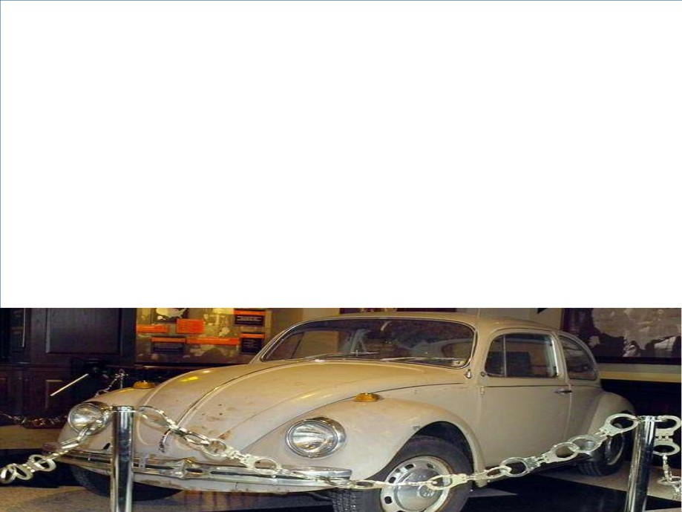

• Around this time hikers discovered a grave yard of bones in a   
 Washington forest, later identified as belonging to missing   
 women from both Washington and Utah.

• Investigators from both states communicated together and   
 came up with a profile and composite sketch of the man   
 named "Ted" who approached women for help, sometimes   
 appearing helpless with a cast on his arm or crutches. They

also had the description of his tan VW and his blood type

which was type-O.

Profiles:

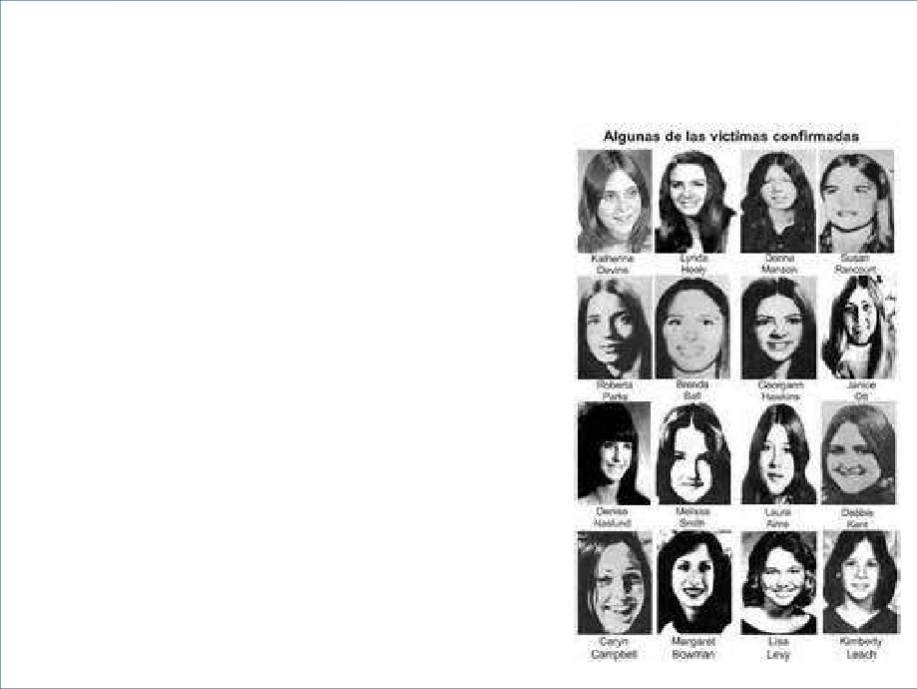

• Authorities compared   
the similarities of the   
women disappearing.

- They were all white, thin,

and single and had long   
hair that was parted in   
the middle.

- They also vanished

during the evening   
hours.

- The bodies of the dead   
women found in Utah   
had all been hit with a   
blunt object to the head,

raped and sodomized.

Murders in Colorado:

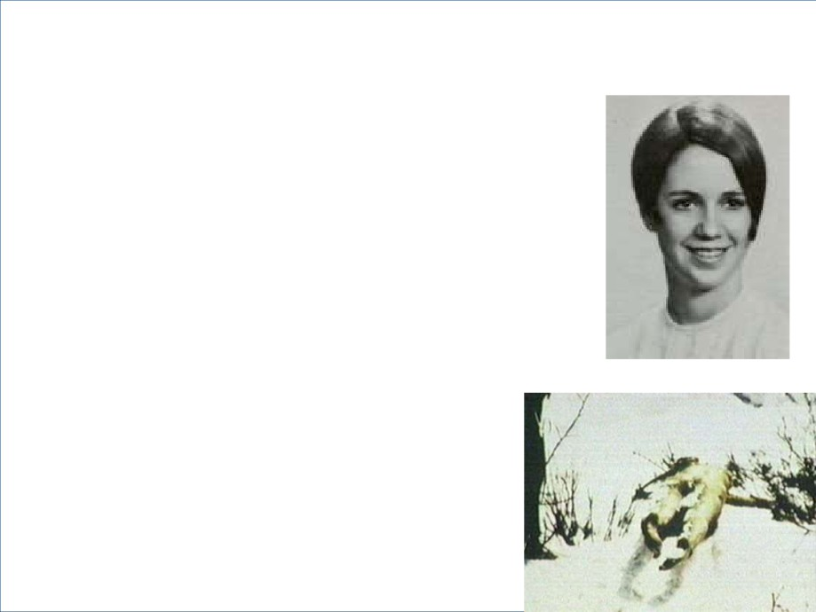

• On January 12, 1975, Caryn Campbell   
 vanished from a ski resort in Colorado   
 while on vacation with her fiance and his

two children.

• A month later Caryn's nude body was   
 found lying a short distance from the   
 road.

• An examination of her remains

determined she had received violent   
blows to her skull.

• Over the next few months five more   
 women were found dead in Colorado   
 with similar contusions to their head,   
 possibly a result of being hit with a

crowbar.

Ted Bundy's First Arrest:

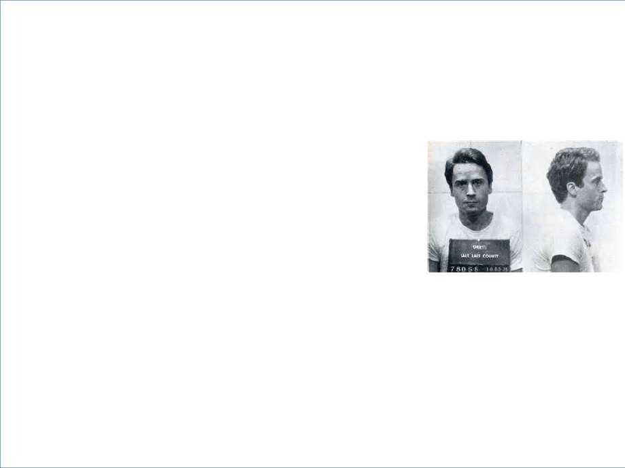

• In August 1975 police attempted to   
stop Bundy for a driving violation.

- He aroused suspicion when he tried to

get away by turning his car lights off

and speeding through stop signs.

- When he was finally stopped his VW   
was searched and police found   
handcuffs, an ice pick, crowbar,   
pantyhose with eye holes cut out along   
with other questionable items.

- They also saw that the front seat on the   
passenger side of his car was missing.   
Police arrested Ted Bundy on suspicion   
of burglary.

Charged With Kidnapping:



• Police compared the things found in   
Bundy’s car to those DaRonch   
described seeing in her attackers car.

The handcuffs that had been placed

around one of her wrists were the same   
make as those in Bundy’s possession.

• Once DaRonch picked Bundy out of a   
line-up the police felt they had enough   
evidence to charge him with attempted   
kidnapping.

• The authorities also felt confident they   
had the person responsible for the tri-  
state murder spree that had gone on for

more than a year.

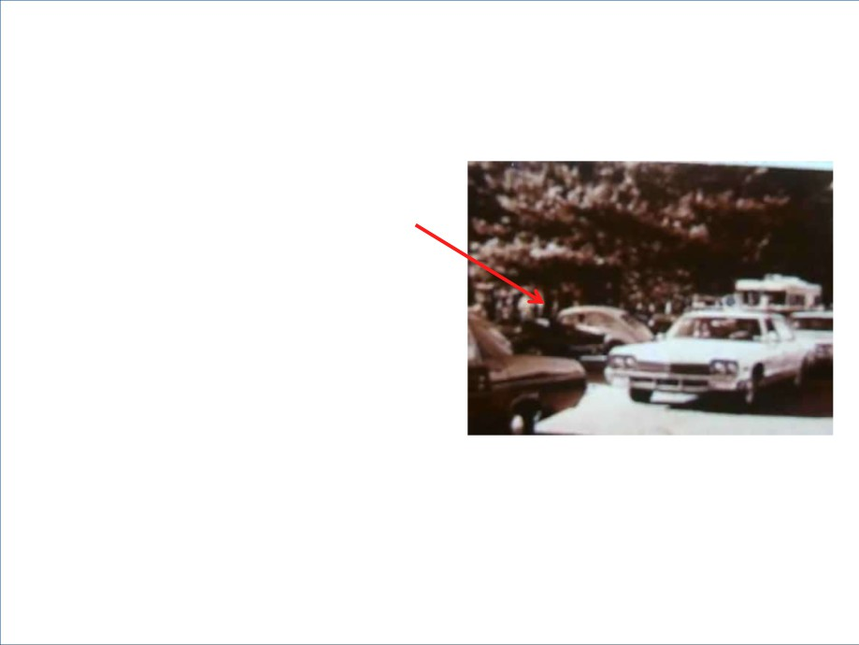

Rare Crime Scene Photo, showing

Bundy in is VW beetle at a crime scene

Charged With the Campbell Murder:



• Bundy went to trial for attempted kidnapping DaRonch   
in February of 1976.

• After waiving his right to a jury trial he was found   
guilty and sentenced to 15 years in prison.

• During this time police were investigating links to   
Bundy and the Colorado murders. According to his

credit card statements he was in the area where

several women vanished in early 1975. In October   
1976 Bundy was charged for the murder of Caryn

Campbell.

Bundy Escapes:

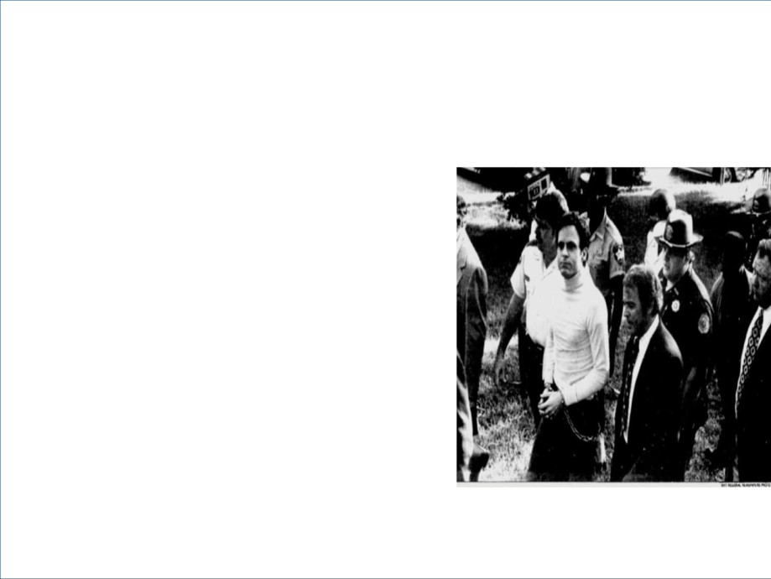

• Bundy was extradited from the Utah   
 prison to Colorado for the trial.

• Serving as his own lawyer allowed

him to appear in court without leg

irons, plus it gave him an

opportunity to move freely from the   
courtroom to the law library inside

the courthouse. In an interview,

while in the role as his own

attorney, Bundy said, "More than   
ever, I am convinced of my own

innocence."

• In June 1977 during a pre-trial

hearing he escaped by jumping out   
of the law library window. He was

captured a week later.

The Second Escape:



• On December 30 Bundy escaped from prison   
and made his way to Tallahassee, Florida   
where he rented an apartment near Florida   
State University under the name Chris Hagen.

• College life was something Bundy was familiar

with and one he enjoyed. He managed to buy

food and pay his way at local college bars with   
stolen credit cards.

• It was just a matter of time before the monster

inside Bundy would resurface.

The Sorority House Murders:



• On Saturday, January 14, Bundy broke into   
Florida State University's Chi Omega sorority

house and bludgeoned and strangled to death

two women, raping one of them and brutally   
biting her on her buttocks and one nipple.

• He beat two others over the head with a log.

They survived which investigators attribute to   
fellow roommate Nita Neary, who came home

and interrupted Bundy before he was able to

kill the other two victims.

• Nita Neary came home around 3 a.m. and



noticed the front door to the house was ajar.

• As she entered she heard hurried footsteps   
above going toward the stairway. She hid in a   
doorway and watched as a man wearing a   
blue cap and carrying a log left the house.

• Upstairs she found her roommates. Two were   
dead, two others severely wounded. That   
same night another woman was attacked and

the police found a mask on her floor identical

to one found later in Bundy’s car.

Bundy Arrested Again:

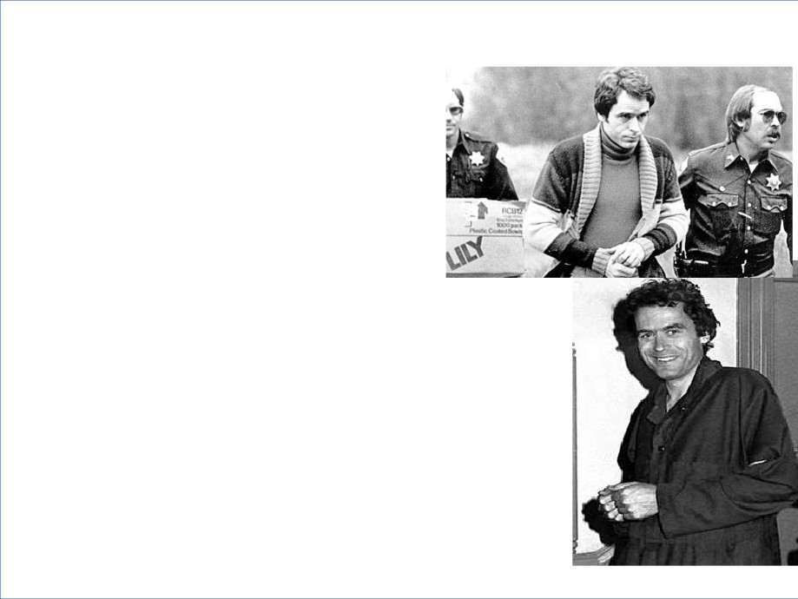

• On February 9, 1978, Bundy

killed again. This time it was 12-  
year-old Kimberly Leach, who he

kidnapped then mutilated.

• Within a week of the

disappearance of Kimberly,

Bundy was arrested in Pensacola

for driving a stolen vehicle.

• Investigators had eyewitnesses   
 who identified Bundy at the dorm   
 and at Kimberly's school. They

also had physical evidence that

linked him to the three murders,   
including a mold of the bite marks   
found on in the flesh of the

sorority house victim.

The Plea Bargain:

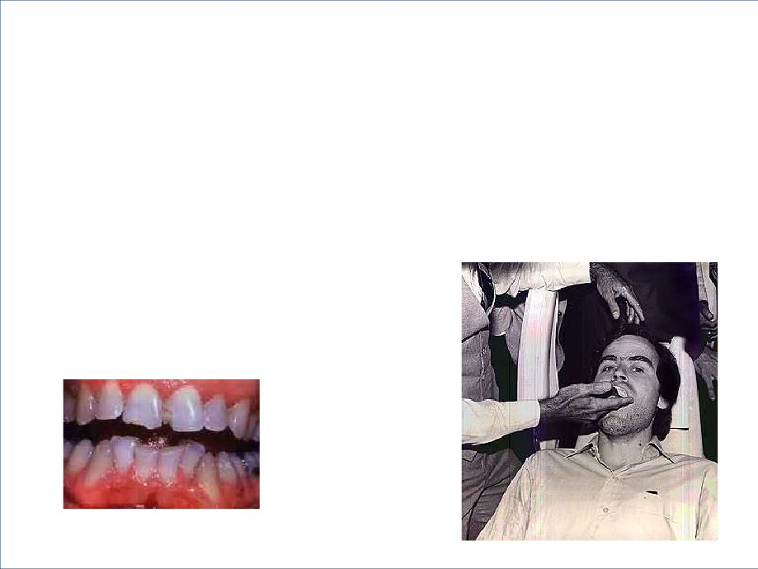

• Bundy, still thinking he could beat a guilty

verdict, turned down a plea bargain whereby   
he would plead guilty to killing the two

sorority women and Kimberly LaFouche in

exchange for three 25-year sentences.

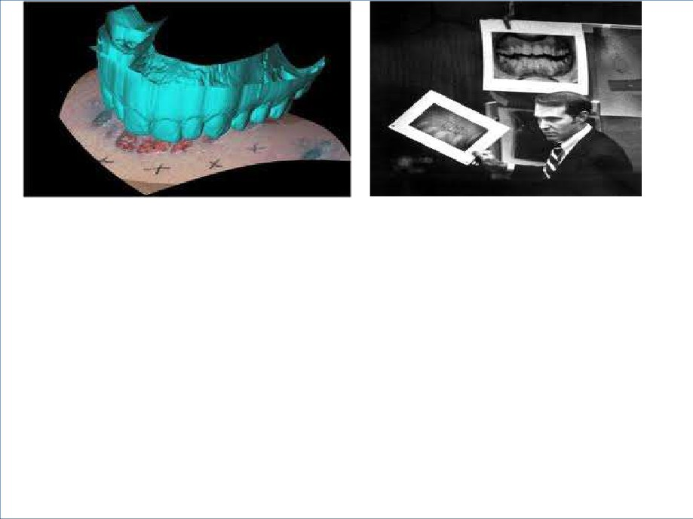

• Bundy was forced by court order to give a

dental impression.

• Forensic dentist Richard Souviron declared   
the outline of Bundy's front teeth, which were

chipped and misaligned, an exact match to the

pattern on the transparent overlay. This

proved to be a major piece of evidence for the

prosecution.

The End:



• Bundy went on trial in Florida on June 25, 1979 for the

murders of the sorority women. The trial was televised and

Bundy played up to the media when on occasion he acted as   
his own attorney.

• Bundy was found guilty on both murder charges and given two

death sentences by means of the electric chair.

• On January 7, 1980, Bundy went on trial for killing Kimberly

Leach. This time he allowed his attorney's to represent him.

They decided on an insanity plea, the only defense possible   
with the amount of evidence the state had against him.

• Bundy's behavior was much different during this trial than the

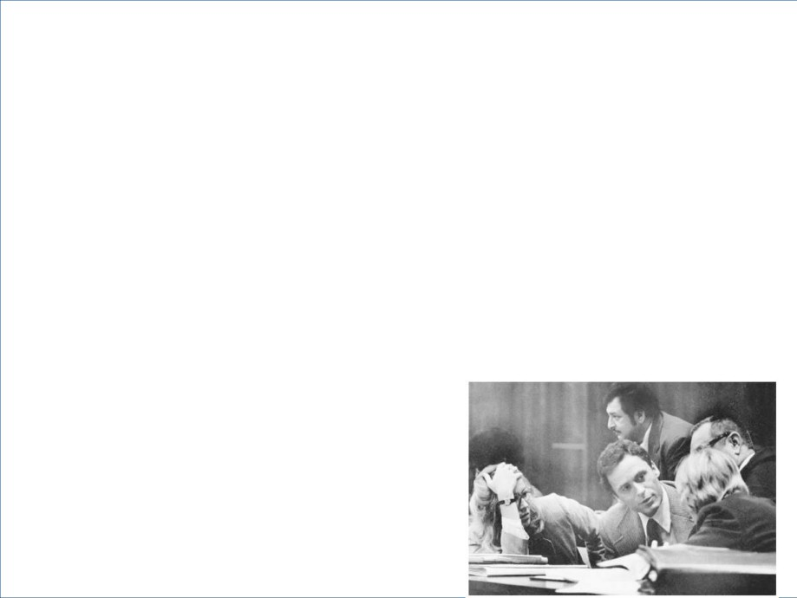

previous one. He displayed fits of anger, slouched in his chair,

and his collegiate look was sometimes replaced with a

haunting glare. Bundy was found guilty and received a third   
death sentence.

• During the sentencing phase, Bundy surprised everyone by

calling Carol Boone as a character witness and marrying her   
while she was on the witness stand. Boone was convinced of   
Bundy's innocence. She later gave birth to Bundy's child, a

little girl who Bundy adored.

• In time Boone divorced Bundy after realizing he was guilty of   
 the horrific crimes.

• After endless appeals Bundy's last stay of execution



was on January 17, 1989.

• Prior to being put to death Bundy gave the details of   
more than fifty women he had murdered to

Washington State Attorney General's chief

investigator, Dr. Bob Keppel.

• He also confessed to keeping the heads of some of

his victims at his home plus to engaging in necrophilia.

• In his final interview he blamed his exposure to

pornography at an impressionable age as being the   
stimulant behind his murderous obsessions.

• Many directly involved with Bundy believed he   
murdered at least 100 women.

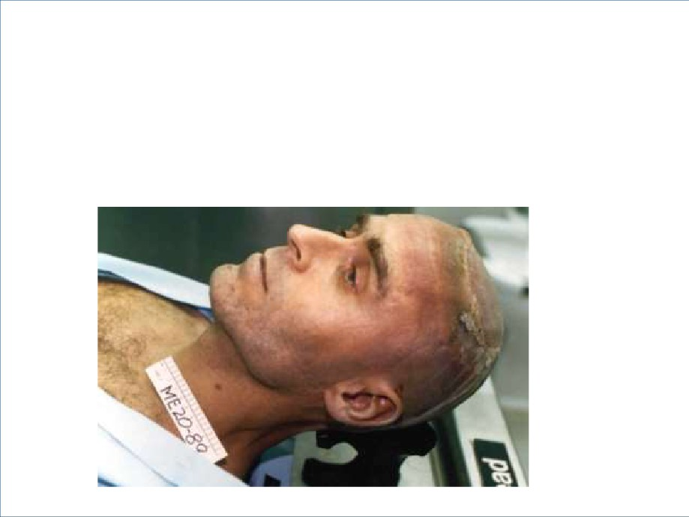

• The electrocution of Ted Bundy went as

scheduled amid a carnival like atmosphere   
outside the prison. On January 24, 1989,   
Theodore Bundy died at around 7:13 a.m. as   
crowds outside cheered his death.



The Ted Bundy Timeline:

• Investigation Discovery’s Timeline of Ted

Bundy’ Crimes: