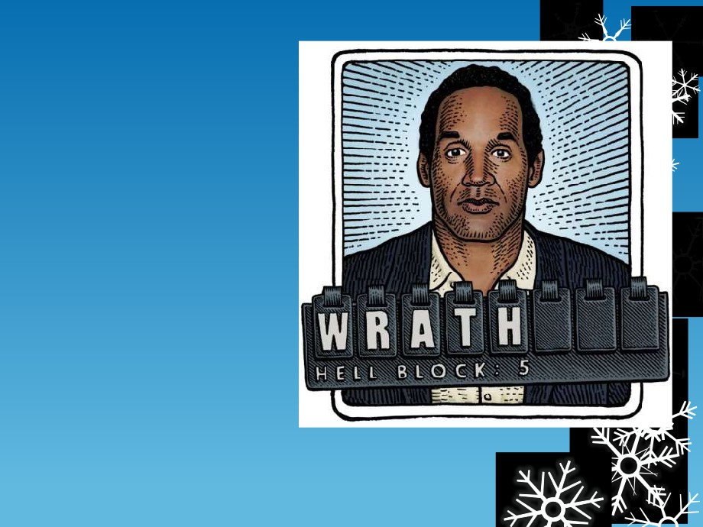

Case Study:

O. J.

Simpson



On the night of the 12th of June 1994:

 Orenthal James Simpson's ex-wife, Nicole and her friend,

Ronald Goldman, were discovered murdered at Nicole's Beverly

Hills abode by her next door neighbor.

 The police were notified and arrived immediately   
 at the horrific scene to find Nicole's severed body

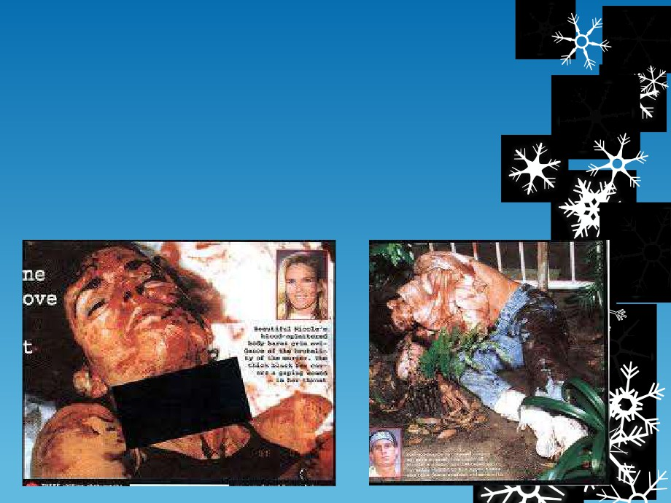

almost decapitated and her friend's body,

evidently fallen victim to a hysterical stabbing

attack. Upon further investigation of the scene, a

bloodstained left-hand glove was discovered and

her two sons were still inside the house, asleep in   
spite of the night's events.

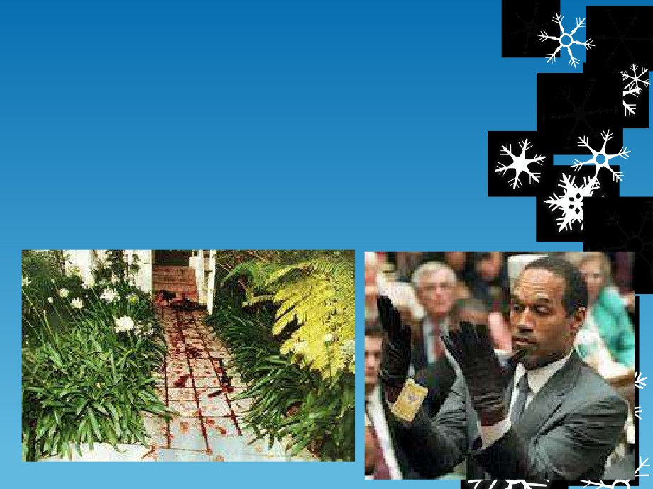

 Homicide experts were called in and other officers made their   
 way to O.J. Simpson's house, a five minute drive away, where   
 they then discovered that he had taken a night flight to   
 Chicago.

 The police noticed blood all over Simpson's car, which was

parked outside the house. They also saw a trail of blood drops leading from Simpson's car to the front door of the house, where they discovered another bloodstained glove identical to the one found near Nicole's body.

Simpson was contacted by police at   
his hotel in Chicago and although



he sounded distraught about his   
ex-wife's death, he didn't sound

curious to find out what happened.

He caught the next plane home and   
the police interviewed him on the

same day. He had a bandaged hand

which he claimed was cut some   
time ago and the wound had

reopened when he accidentally cut

it on some glass.

His hand was photographed, blood

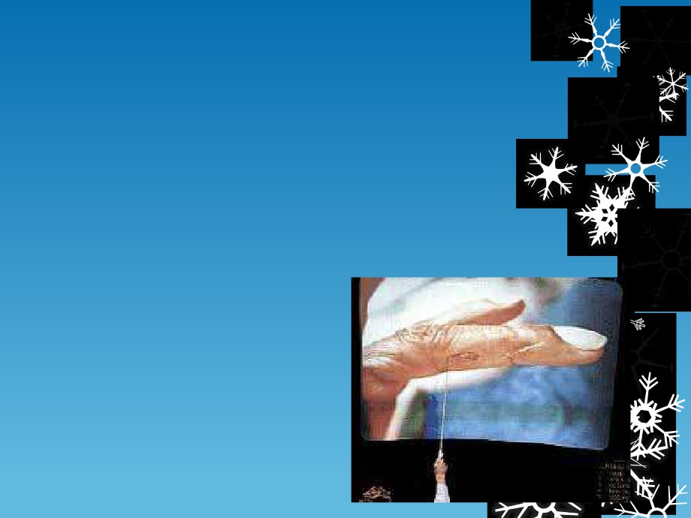

samples taken and fingerprints recorded,   
then after all of this, he was free to go.   
The search of his house was videotaped   
and by the afternoon of the same day, all

of the evidence needed was removed,

recorded and taken to a laboratory along   
with evidence taken from Simpson

himself.

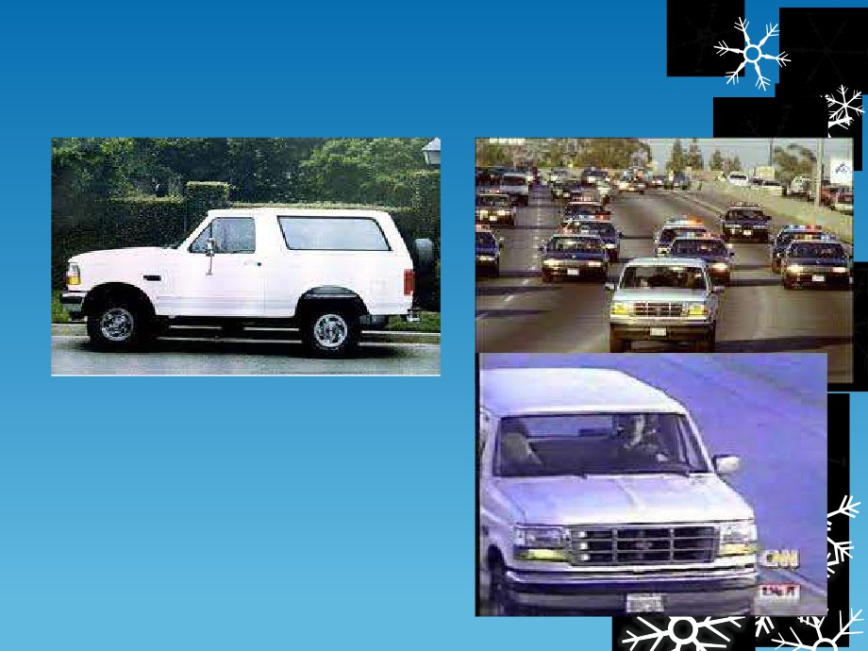

The Infamous Chase on the Freeway:

 As police were on the way to

arrest him, Simpson and a friend   
got into the friend’s white Ford   
Bronco and lead police on a   
chase down the So. Cal. Freeway.   
Headed toward Mexico. Sets the   
stage for the defense to play the   
racism card.



 Once arrested, Simpson was put on trial, one   
 of the most highly publicized trials in history,

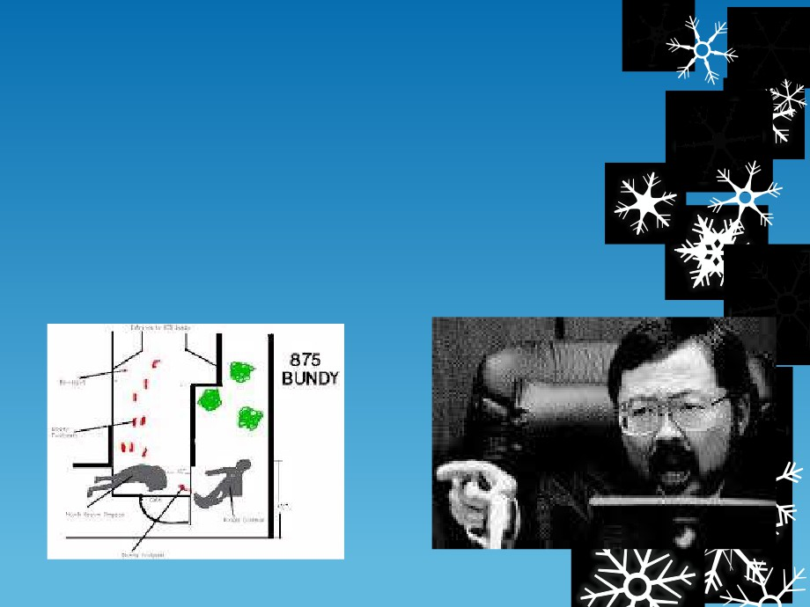

and all of the evidence seemed to point to him

being responsible for the murder. He had no   
alibi, DNA analysis showed his blood was   
present on a sock found in Nicole's room, both

gloves were stained with blood from both his

victims and the trail of blood leading from the   
car to his house seemed to heighten all   
suspicions.

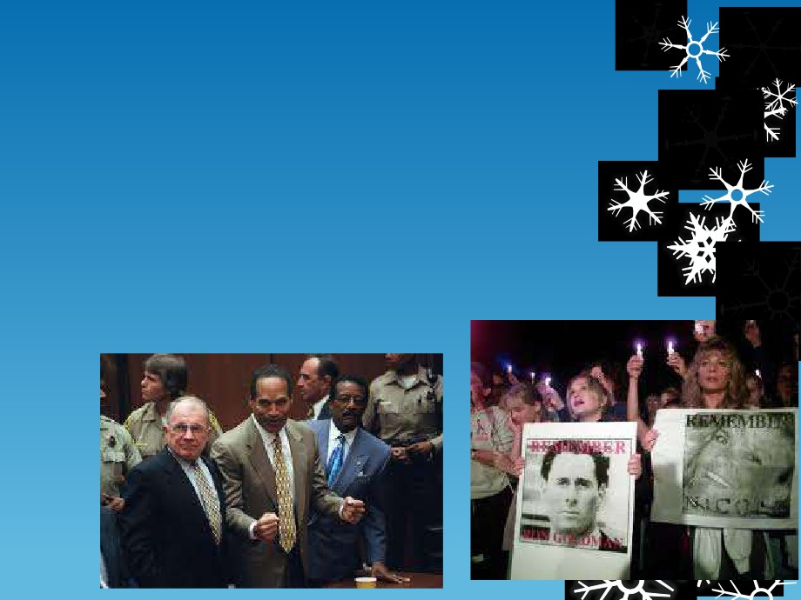

 The case, however, was turned around with Simpson's   
 expert lawyers claiming that a certain police officer

present at the initial scene, was racist against black

people and that the officer had plenty of time to 'set' the   
scene up while Simpson was in Chicago. The recorded   
tape of the investigation of Simpson's house also revealed

a large number of mistakes such as unsterile swabbing

methods and unnoticed vital

clues. Because of these claims from Simpsons laywers, the jury was convinced that Simpson was innocent and after a nine-month trial, Simpson was cleared of murder charges and that was that.

