Richard Ramirez



Richard Ramire -

The Night Stalker (1960-2013)

► Dubbed the "Night Stalker," Richard Ramirez was   
an American serial killer who broke into Californian

homes, raping and torturing more than 25 victims,

and killing at least 13, over a two-year rampage.

►“No big deal. Death always comes with   
the territory. I'll see you in

Disneyland.”

—Richard Ramirez

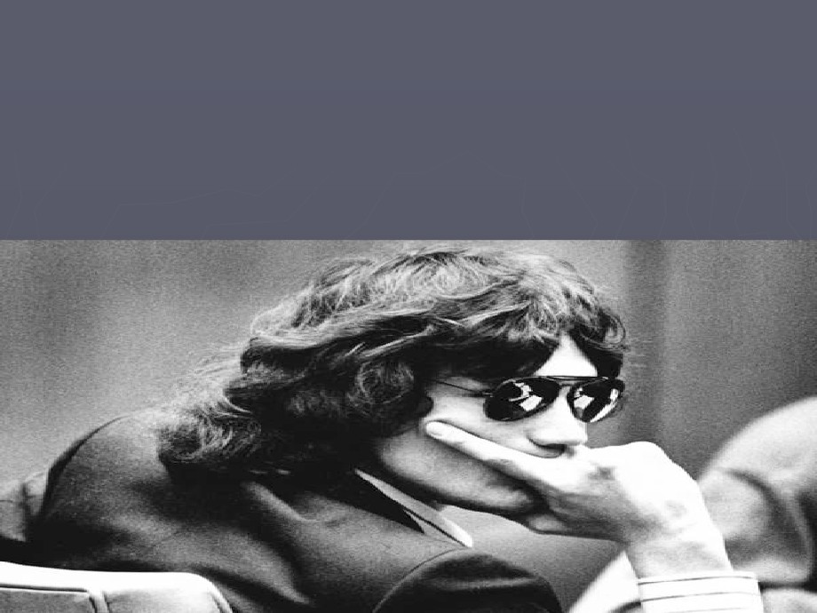

►Born in El Paso, Texas, on February 28,   
1960, Richard Ramirez was turned on to

Satanic worship at an early age by his

cousin Mike, a Green Beret solider who had   
recently returned from the war in Vietnam.

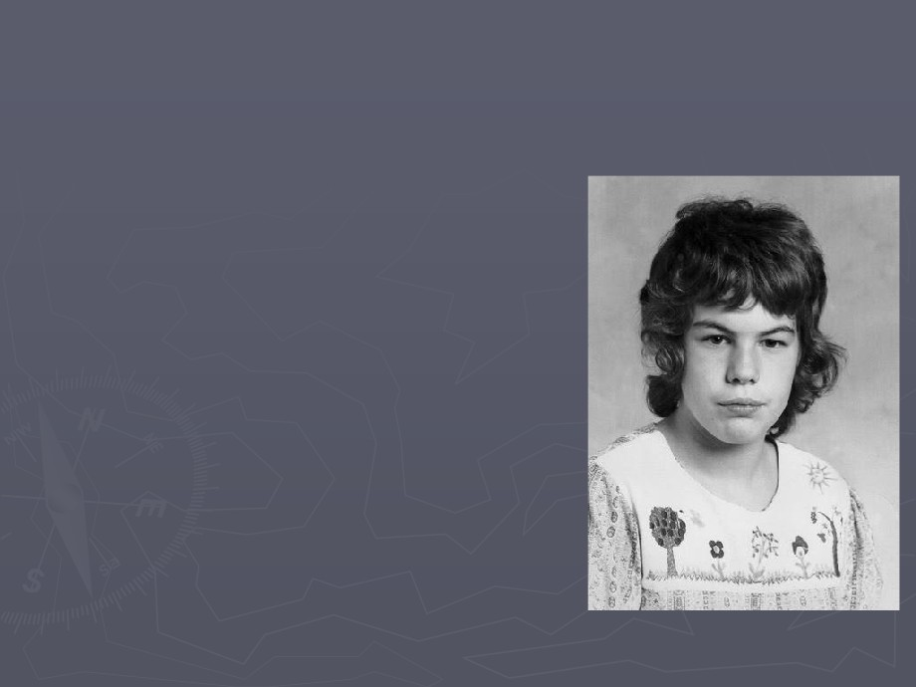

Criminal Beginnings

► Richard Ramirez was born

Ricardo Leyva Muñoz Ramírez on   
February 28, 1960, in El Paso,

Texas, the youngest of 7 children

born to Mercedes and Julian   
Ramírez.

► Ramirez had a troubled

childhood and was heavily

influenced by his older cousin,

Mike.



► Mike told Ramirez stories about   
the torture and mutilation he had

inflicted on Vietnamese women,

corroborating these stories with   
Polaroid pictures.

► They also discussed Satanic

worship and smoked marijuana   
together, and Ramirez's teenage

rebellion led to petty crime to

fuel his drug habit, further

alienating him from his parents.   
As a result, he spent even more   
time with his cousin.



The two spent a lot of time

together, smoking pot and talking

about war.

On one such day, Mike's wife

began to complain about Mike's

laziness. Mike's reaction was to kill   
her by shooting her in the face, in

front of Richard.

Because of Mike's war record, he

was sentenced to seven years for

the killing.



By the age of 18,

Richard was a habitual

drug user and chronic

candy eater, resulting in   
tooth decay and

extreme halitosis.   
He also became

involved in Satan

worshipping and his

general poor

appearance enhanced   
his satanic persona.

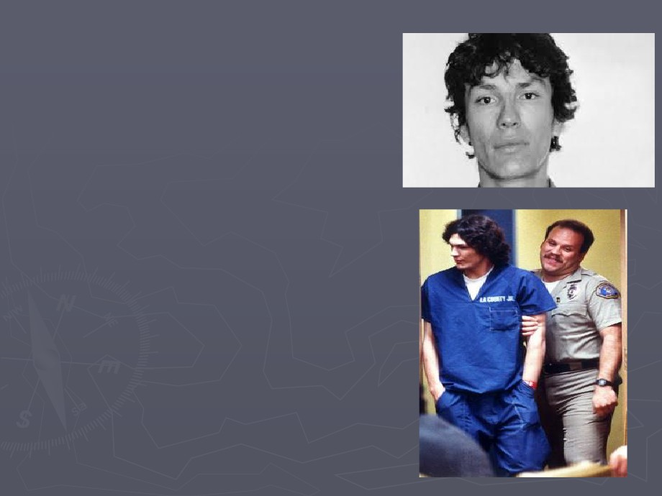

►Ramirez's was

placed in juvenile   
detention for a   
string of petty

crimes in 1977. He

also received a

probationary

sentence in 1982 for

marijuana

possession.



► He soon moved to San   
Francisco, and then to

Los Angeles.

► He also progressed to   
cocaine addiction and

burglary, and

cultivating an interest   
in weapons and

Satanism.

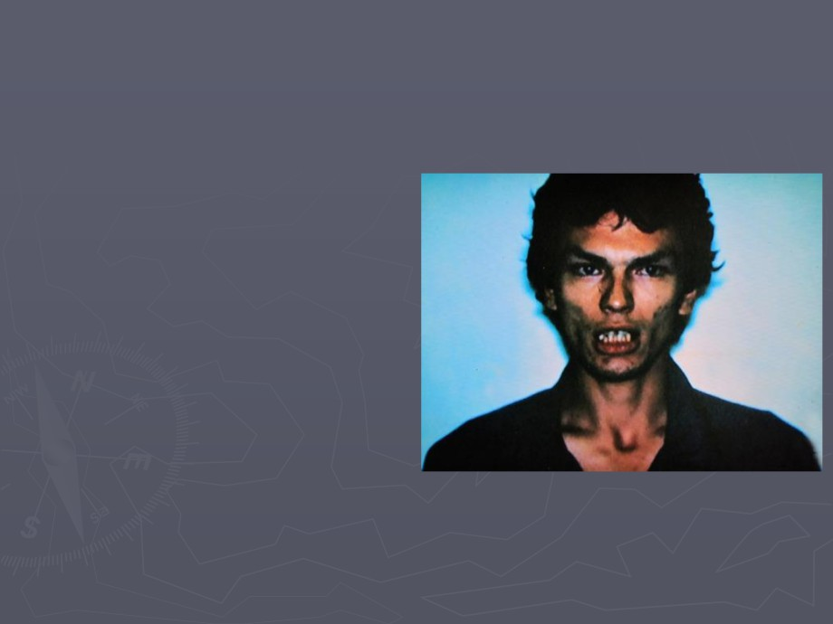

►A car theft charge in   
1983 led to a jail

sentence.

►The following year,

Ramirez was released

from jail.

►By now, he was a   
conscienceless,

Satanic criminal with

poor hygiene, rotten

teeth and no

prospects.

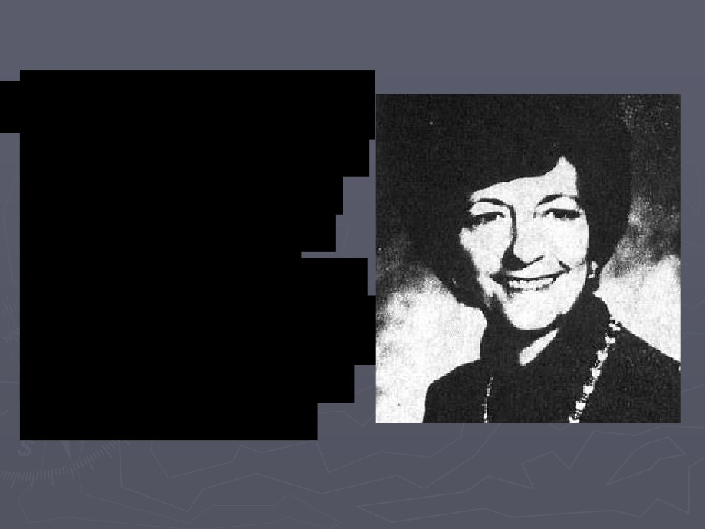

Killing Spree

On June 28, 1984, his

burglaries turned into   
something far more

evil. Ramirez broke

into the home of

Glasse Park resident,   
Jenni Vinco , age 79,   
by sneaking through

an open window.

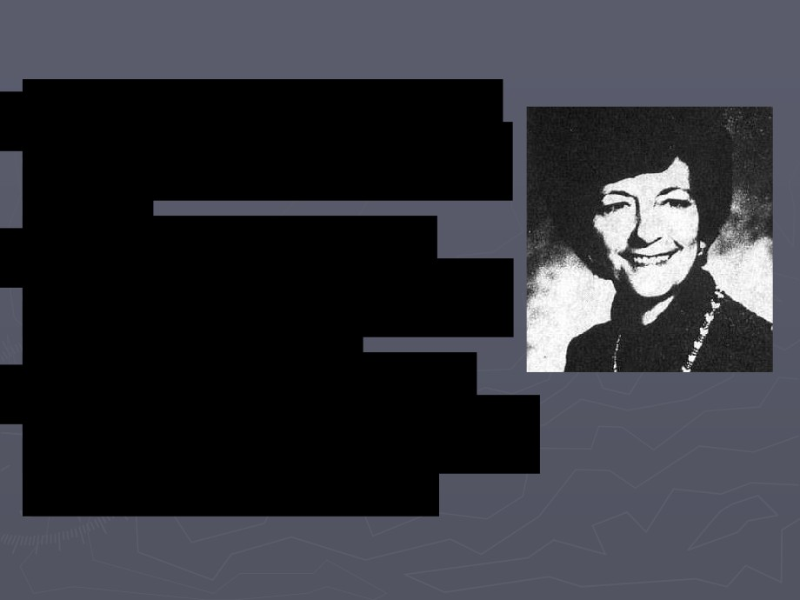

Killing Spree

He became angry after not

finding anything of value to   
steal.

He began stabbing the

sleepin Vinco , eventually

slitting her throat.

The act of killing aroused

him, and he had sex with the   
corpse before leaving.



►What followed was a   
spree of brutal

murders, rapes and

robberies, leaving

more than 25 victims

in its wake.

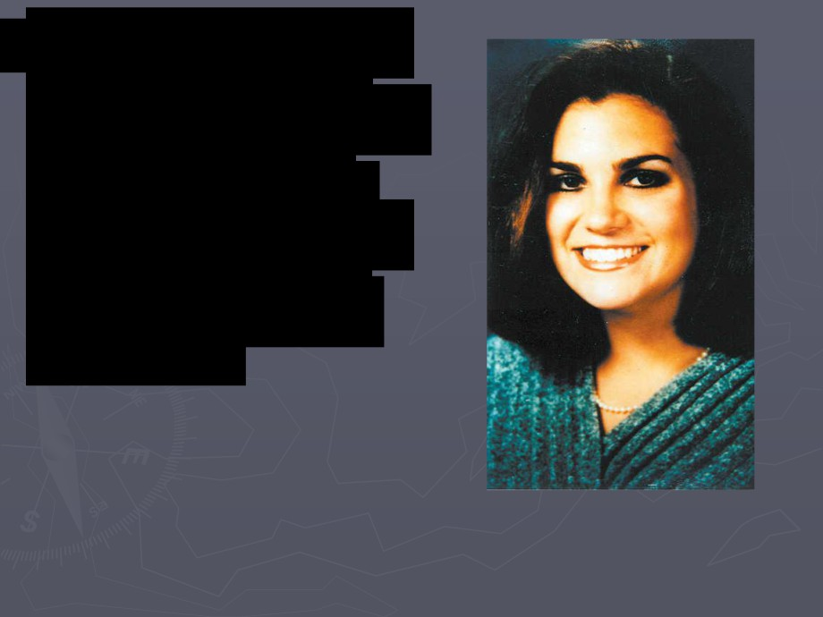

|  |  |  |
| --- | --- | --- |
| Ramirez remained quiet  for eight months. On  March 17, 1985, Ramirez  jumped 2 ye old  Angela Barrio outside  her condo. He shot her,  kicked her out of the  way, and headed into  her condo… |  |  |
|  |
|  | |



Inside, was roommate,

Dayl Okazaki, age 34, who   
Ramirez immediately shot   
and killed.

Barrio remained alive out of

pure luck. The bullet had

ricocheted off the keys she   
held in her hands, as she

lifted them to protect

herself.

Within an hour of killing Okazaki, Ramirez struck

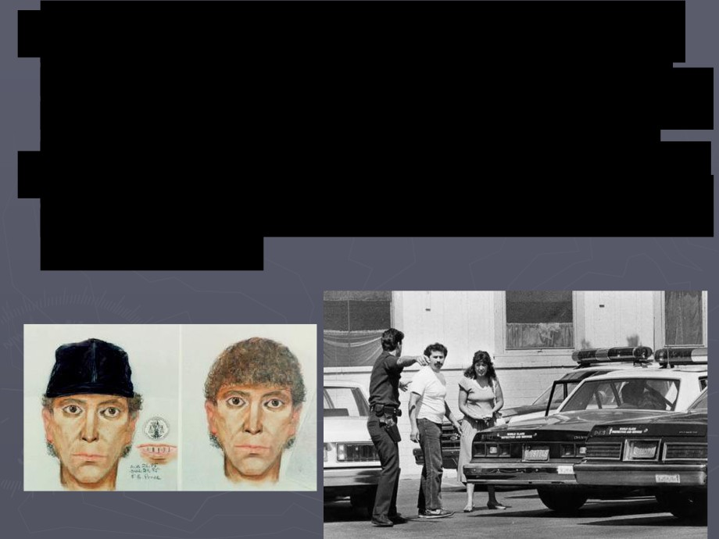

again in Monterey Park. He jumped 3 ye old

Ts Lia Yu and pulled her out of her car onto the

road. He shot several bullets into her and fled.

A policeman found her still breathing, but she died

before the ambulance arrived. Ramirez's thirst was

not quenched. This spurred a media frenzy that   
saw Ramirez dubbed the "Valley Intruder" by the

press.

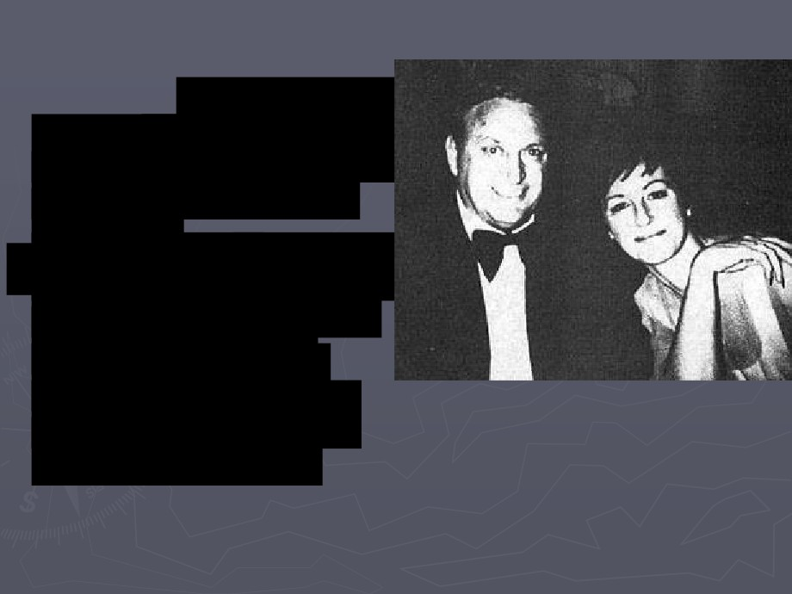

► Just 10 days later, on   
March 27 Ramirez shot

Vincen Zazarr , age 64,

and his wife Maxine,   
age 44.

Mrs Zazzara' body was   
mutilated with several

stab wounds, a -

carving on her left   
breast, and her eyes

were gouged out.

The autopsy determined

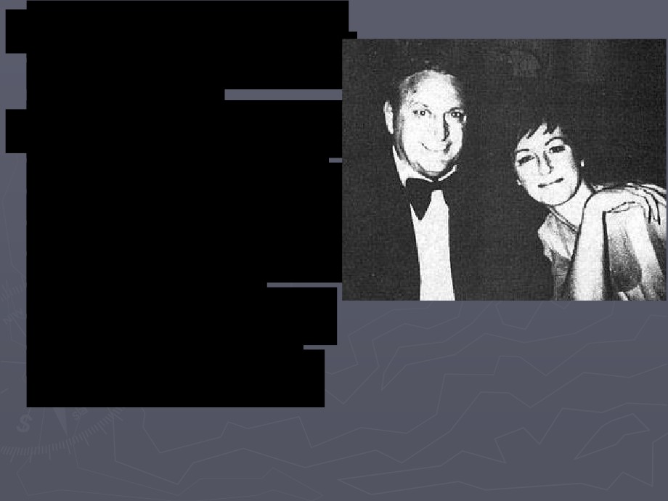

that the mutilations were   
po mortem.

Ramirez left footprints in   
the flower beds, which

the police photographed

and cast. Bullets found at   
the scene were matched

to those found at

previous attacks, police   
now realized a serial

killer was on the loose.

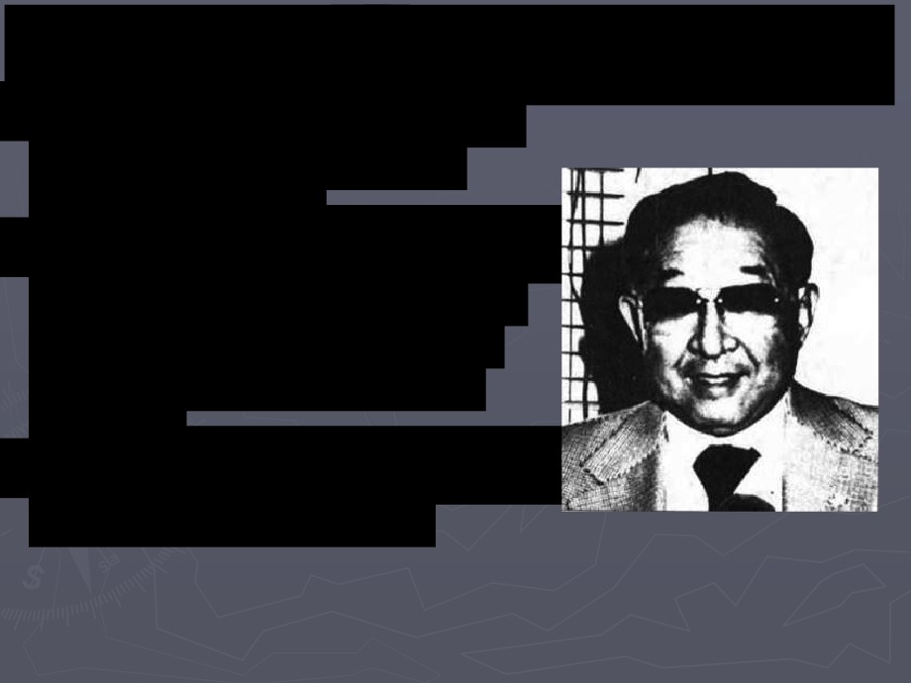

Ramirez's MO Kill the Man Quickly:

Two months after killing the

Zazzar couple, Ramirez

attacked again.

Harold Wu, age 66, was shot in

the head, and his wife, Jean

Wu, age 63, was punched,   
bound, and then violently

raped.

For unknown reasons, Ramirez

decided to let her live.

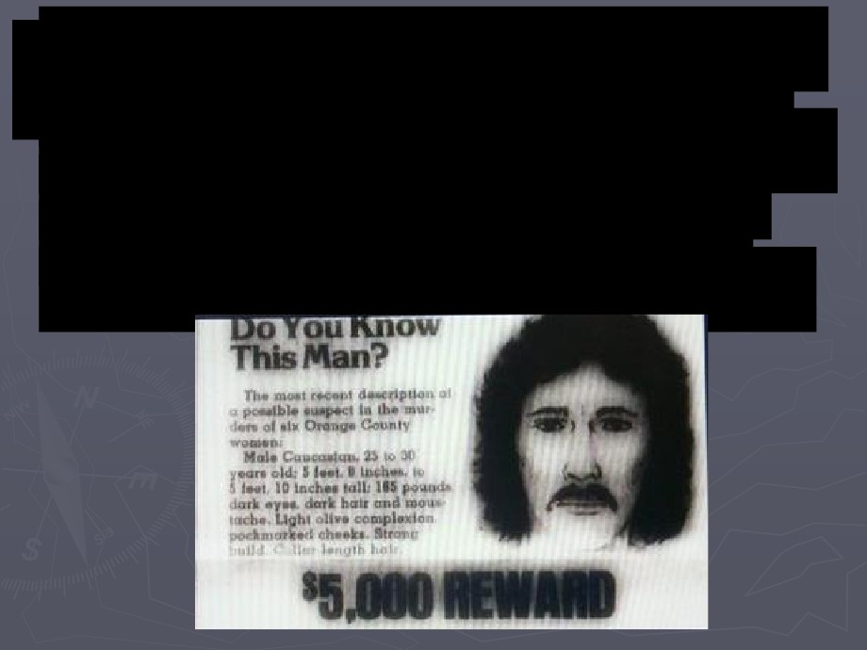

Ramirez's attacks were now in full throttle.   
He left behind more clues to his identity,

and was named, 'The Night Stalker,' by the

media. Those who survived his attacks,   
provided the police with a descriptio -  
Hispanic, long dark hair, and foul smelling.

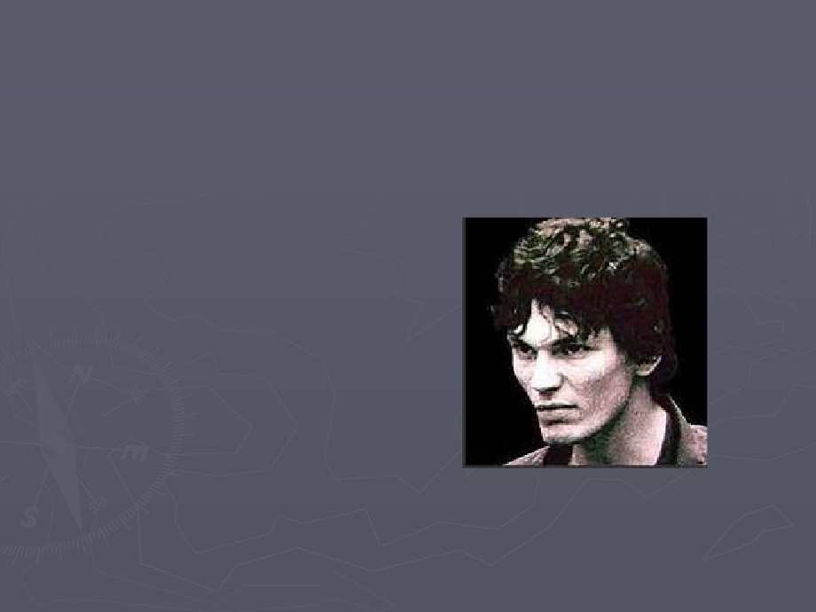

|  |  |  |
| --- | --- | --- |
| ►A full-scale police operation yielded no  concrete results, and Ramirez repeated his  attack pattern on pensioners William and  Lillie Doi in April 1985. |  |  |
|  |
|  | |



►Over the next two months, his murder rate   
escalated rapidly, claiming another dozen

victims in a frenzy of burglary, assault and

brutal violence—complete with Satanic

rituals—and driving Los Angeles into a

panic.

►After the press demanded that the police do   
more to catch the killer, a dedicated task

force comprised of hundreds of law-

enforcement officers was established, and

the FBI stepped in to assist.

On May 29, 1985, Ramirez attacke Malvial



Keller, 83, and her invalid sister, Blanche

Wolfe, 80, beating each with a hammer.

Ramirez attempted to rape Keller, but failed.   
Using lipstick, he drew a pentagram on

Keller's thigh and on the wall in the bedroom.

Blanche survived the attack.



The next day, Ruth Wilson, 41, was bound,   
raped, and sodomized by Ramirez, while her

1 year old son was locked in a closet.

Ramirez slashed Wilson once, and then

bound her and her son together, and left.



His Los Angele killing and rape spre :

► June 2 Ramirez raped a ye old girl in Acadia.

► June 2 Patty Higgins, age 32, was beaten and her throat

slit.

► July Mary Cannon, age 75, was beaten and her throat slit.   
► July Deidre Palmer, age 16, survived being beaten with a   
 tire iron.

► July Joyce Lucille Nelson, 61, was bludgeoned to death.   
► July Linda Fortuna, 63, was attacked and Ramirez tried to   
 rape her, but failed.

► July 2 Maxso Kneilin , 66, and his wife Lela, also 66, were

shot and their corpses, mutilated.

► July 20 Chita Assawahe , 31, was shot and his wif Sakim ,

29, was beaten then forced to perform oral sex. Ramirez then   
collected $30,000 in valuables, but before leaving, he

sodomized the couple's eig ye old son.



►This relentless media and police pressure,   
aided with photo-fit descriptions from his

surviving victims, forced Ramirez to leave

the L.A. area that August. He moved north   
to San Francisco, taking his first victims

there, Peter and Barbara Pan, on August 17.



On Aug. 24, 1985, Ramirez traveled

50 miles south of Los Angeles, and

broke into the home of Bil Carn , 29,

and his fiancée, Inez Erickson, 27.   
Ramirez sho Carn in the head and

raped Erickson. He demanded she

swear her love for Satan and

afterwards, forced her to perform oral

sex on him. He then tied her and left.

Erickson struggled to the window and   
saw the car Ramirez was driving. A   
teenager wrote down the license

plate number of the same car, after

noticing it cruising suspiciously in the   
neighborhood.

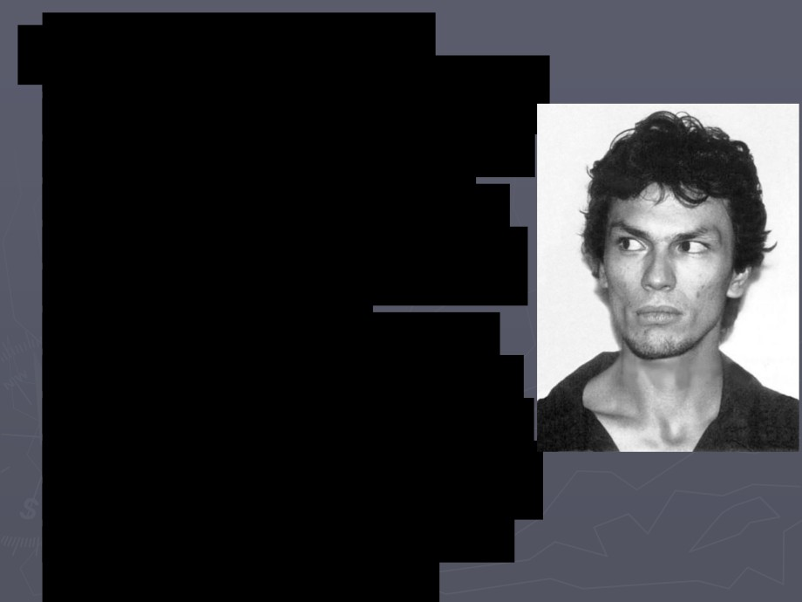

The information from

Erickson and the young man

enabled police to locate the

abandoned car, and get   
fingerprints from inside. A   
computer match was made   
of the prints, and

identification of the Night

Stalker became known. On   
August 30, 1985, the arrest   
warrant for Richard Ramirez   
was issued and his picture

released to the public.

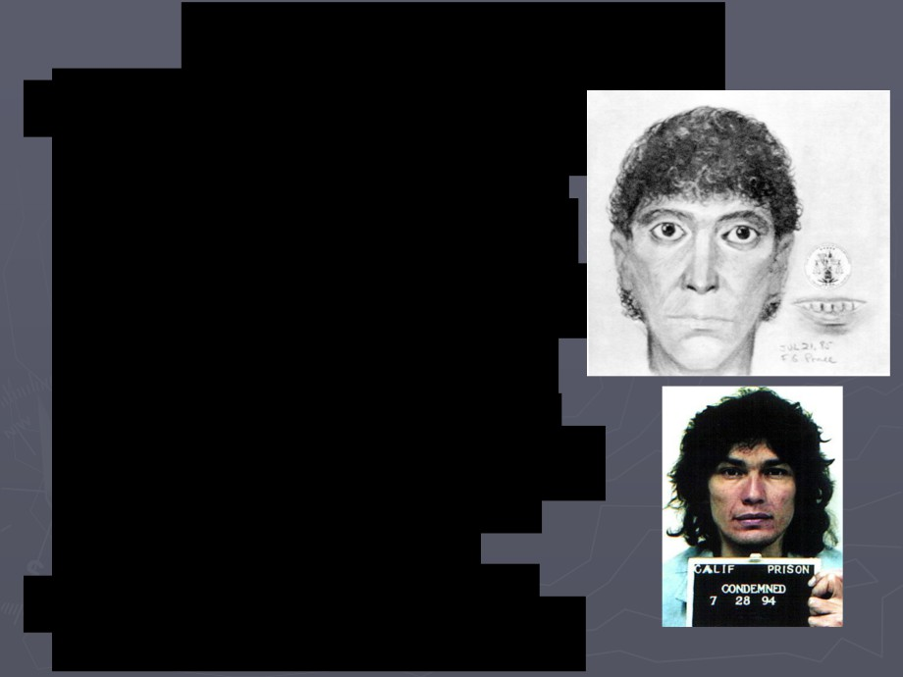

A Face Revealed:

On August 30, 1985, an arrest

warrant for Richard Ramirez was

issued and his face revealed to

the public. Ramirez, unaware

that his picture was all over the

newspapers, got off of a

Greyhound bus, and walked into   
a liquor store. The woman   
working inside recognized him

and began yelling that he was

the Night Stalker. Shocked, he

quickly fled the store and headed   
toward the heavily populated

Hispanic area of east Los

Angeles.

A small mob had formed and

were following close behind him.

Captured by a Mob:



Ramirez tried to steal a car, but the owner

was underneath it doing repairs. When

Ramirez started the engine, the man pulled

out from beneath the car and began chasing

Ramirez. The mob that was in pursuit of

Ramirez, now armed with steal rods, caught

up with him. He was subdued, while some of

the mob beat him, until the police arrived.

Reportedly, Ramirez raised his hands to the

police, begging for protection, and identified   
himself as the Night Stalker.



Trial, Conviction & Sentencing

► Ramirez claimed that he has been mistakenly

identified and did everything possible to delay the

onset of the trial, which saw him charged with 14   
murders and 31 other felonies in connection to his

killing spree. Because he changed his legal counsel a

number of times, and the geographical spread of his   
attacks also complicated the scope of the trial with   
jurisdictional issues, some of the charges against   
Ramirez were dropped in order to expedite what was

becoming a long journey to justice.

► The major evidence used to convict Ramirez was the   
fingerprint evidence found at the various crime

scenes.

►Almost three years after his apprehension,   
on 22 July 1988, the jury selection process



began. The case took a full year to hear,

given the number of witnesses and sheer   
amount of evidence. During this time,

Ramirez attracted a large, cult-like

following—many of whom were black-clad

Satan worshippers—who appeared daily at

his trial. One of his supporters was Doreen   
Lioy, whom he married while serving time in

prison. Further unsettling the jury was

Ramirez's own nonchalant behavior.

►Yet another delay occurred when one juror   
was found murdered on August 14, 1989,



but rumors that Ramirez had orchestrated

her death proved unfounded.

►On September 20, 1989, the jury finally

returned a unanimous guilty verdict on 43   
charges, including 13 counts of murder, five

counts of attempted murder, 11 sexual

assault charges and 14 burglary charges.

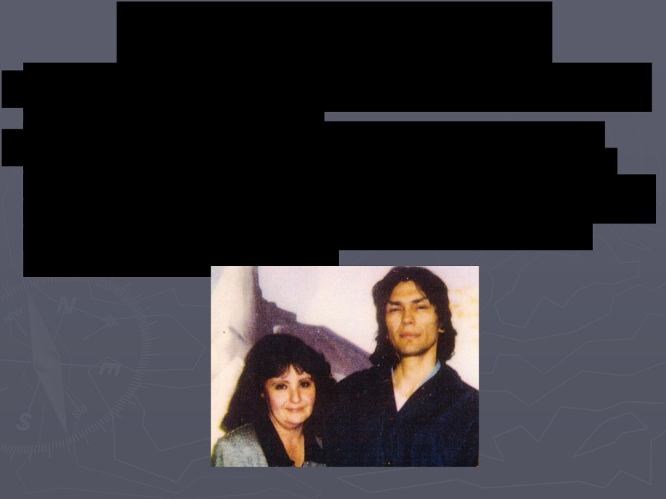

Marriage Behind Bars

► In 1996, Ramirez tied the knot with one of his groupies. She   
 is 4 ye old Doree Lio .

► Doreen believes her husband is innocent of the charges   
 against him Lio , who was raised as a Catholic, respects

Ramirez's Satanic worship. This was demonstrated when she

gave him a silver wedding band to wear, since Satanic   
worshipers do not wear gold.

► On November 7, 1989, Ramirez received 19 death   
sentences, to which he responded, "No big deal.   
Death always comes with the territory. I'll see you in

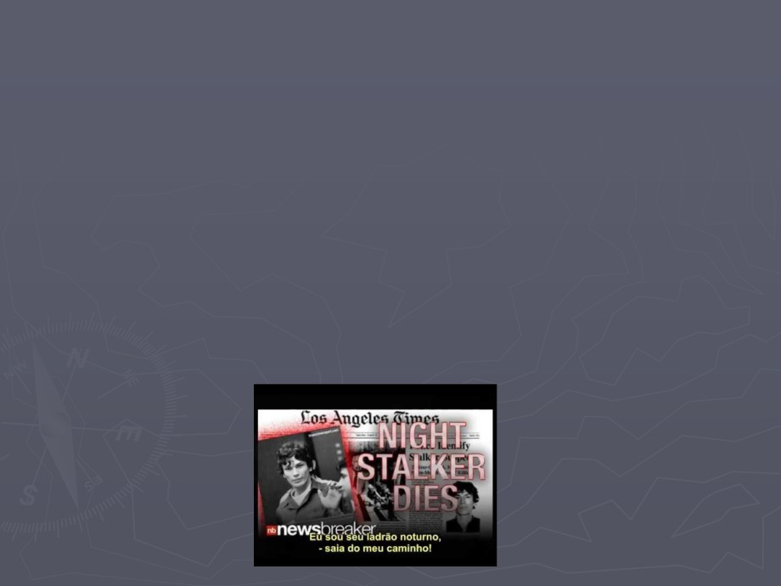

Disneyland." He was subsequently transferred to San

Quentin Prison in California.

► After 23 years on death row, Richard Ramirez died on   
June 7, 2013, at the age of 53, reportedly of natural

causes. According to San Quentin corrections officers,   
Ramirez's death came shortly after he was taken to   
Marin General Hospital in Greenbrae, California.

