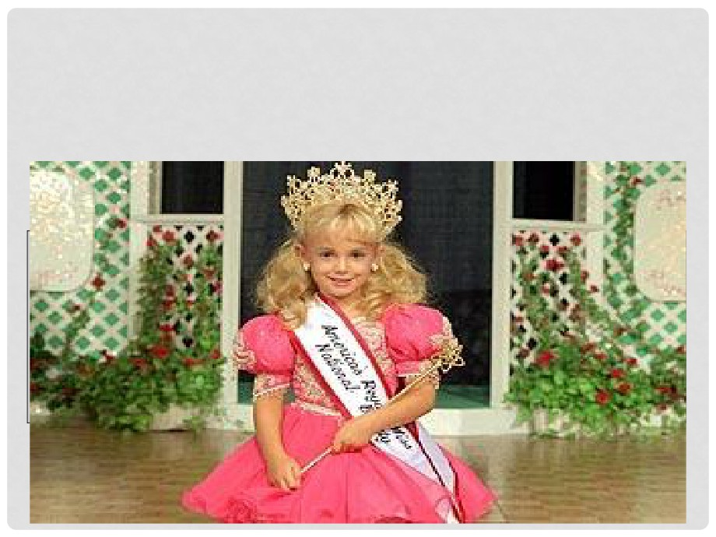

THE CASE OF JONBENET

RAMSEY

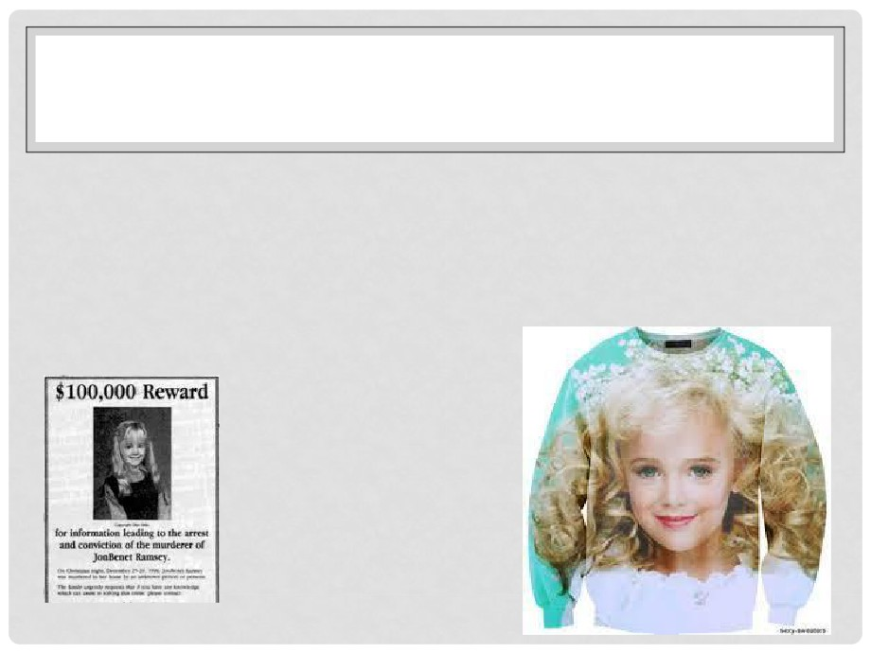

• JonBenét Patricia Ramsey (August 6, 1990 -

December 26, 1996) was murdered in her home in

Boulder, Colorado in 1996.

• The case had consumed American attention to the   
point of bizzarre fan worship…

IF JONBENET HAD LIVED, SHE'D BE IN



COLLEGE.

• 21 years have passed since the

murder and her case continues to

baffle investigators.

• In late 1996, the tragic, brutal murder   
of a 6-year-old girl rocked the nation.

• She would be 27 this year, and   
graduating from college.

• Patsy, a former Miss West Virginia,

encouraged her young daughter to

enter beauty pageants. She was an

original toddler in tiaras.

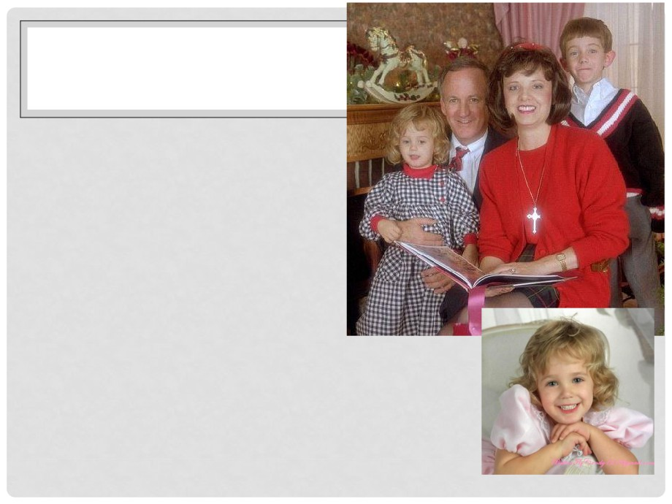

• JonBenet was born in   
Atlanta, Georgia, the   
younger of two children

of Patricia Ann "Patsy"

and John Ramsey.

• She had an older

brother, Burke (born

1987).

• Her first name is a

portmanteau of her

father's first and middle   
names, John Bennett.



• Ramsey's father, John was the president of Access

Graphics, a business computer system company which   
later became a subsidiary of Lockheed Martin.

• In 1991, the family relocated to Boulder, Colorado

where Access Graphics' headquarters were located.

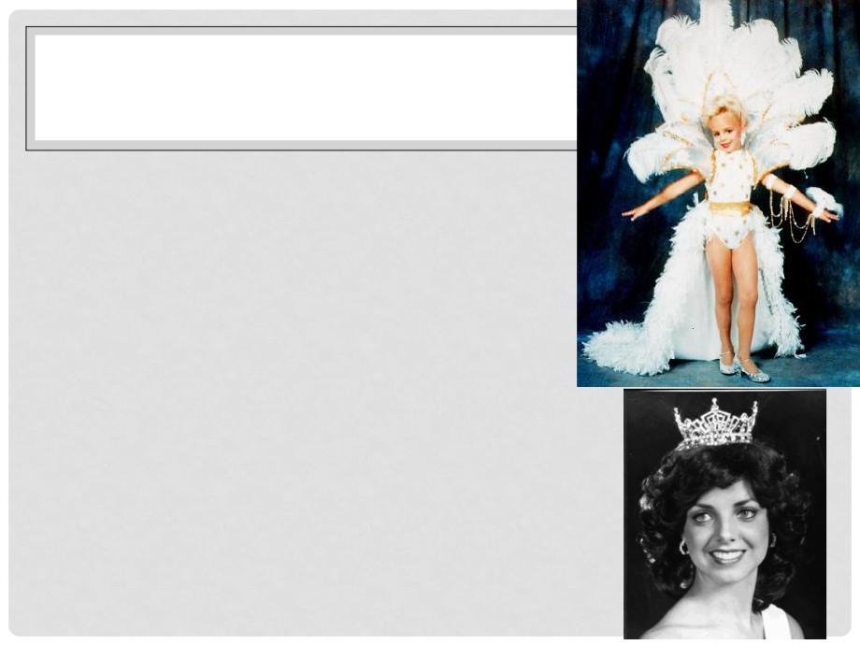

• It was there that Patsy Ramsey

began enrolling her daughter in a

variety of different beauty pageants

in several states.

• JonBenét Ramsey went on to win   
the titles of America's Royale Miss,

Little Miss Charlevoix, Little Miss

Colorado, Colorado State All-Star   
Kids Cover Girl, and National Tiny   
Miss Beauty.

• JonBenét's active role in pageants   
as well as Patsy Ramsey's reported   
"pageant mother" behavior was

highly scrutinized by media following

the murder.

• At the time of her death, Ramsey   
was in kindergarten.

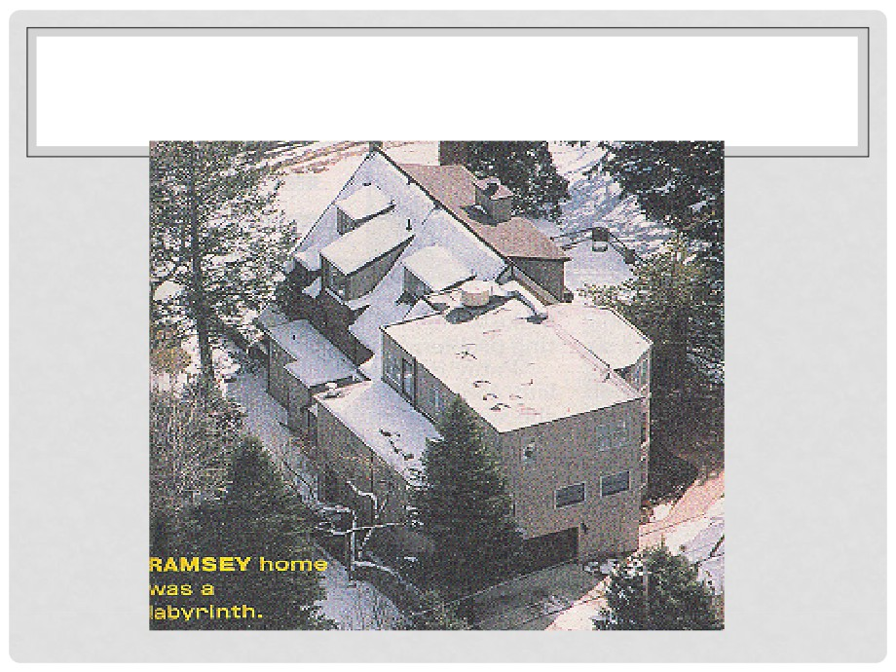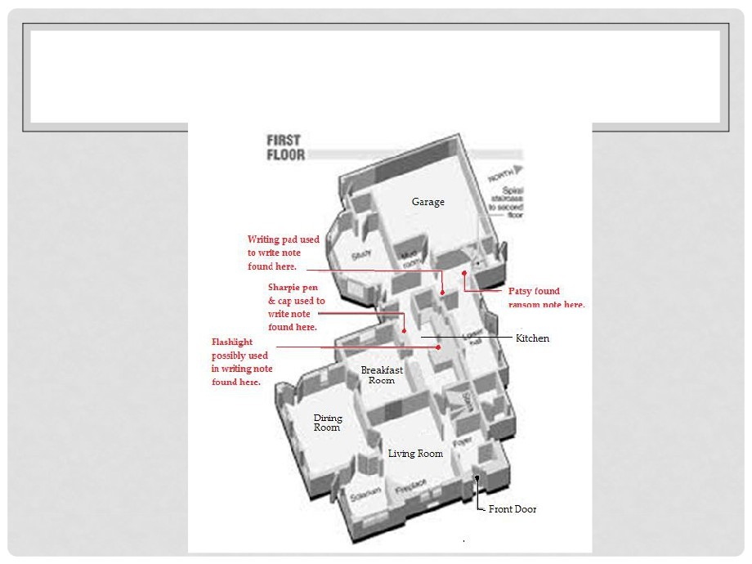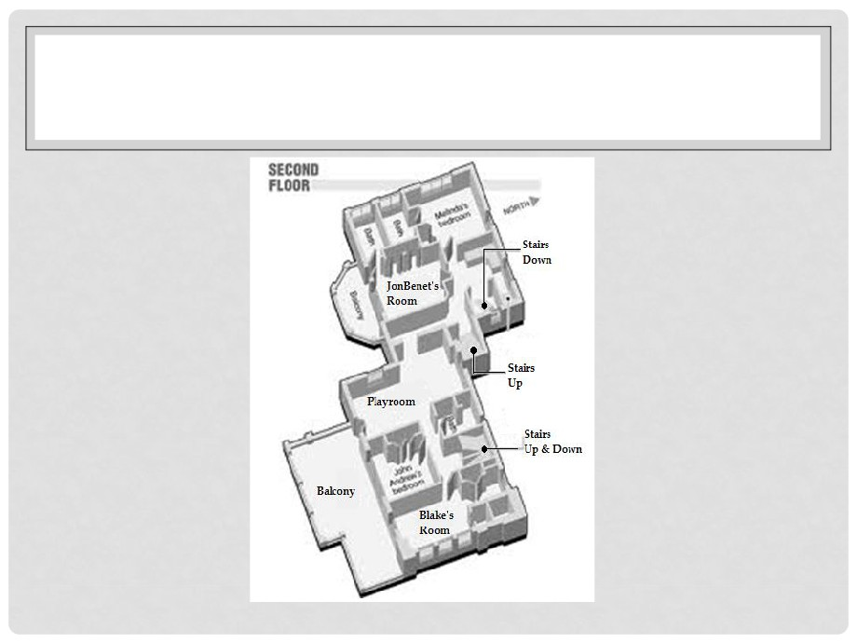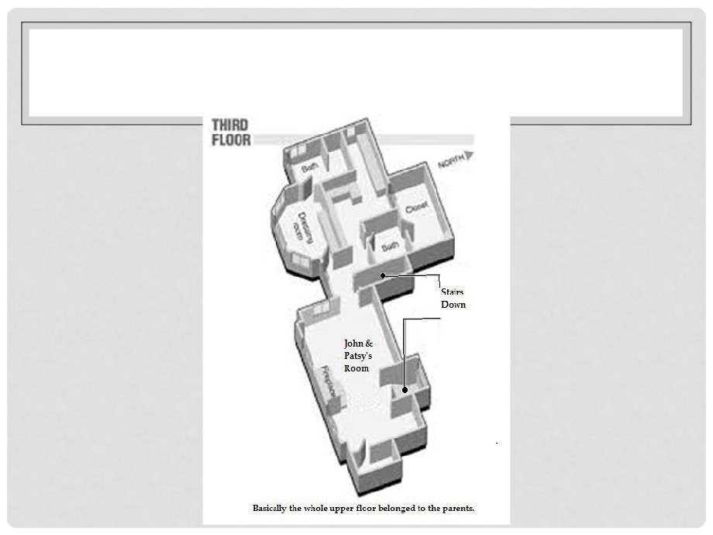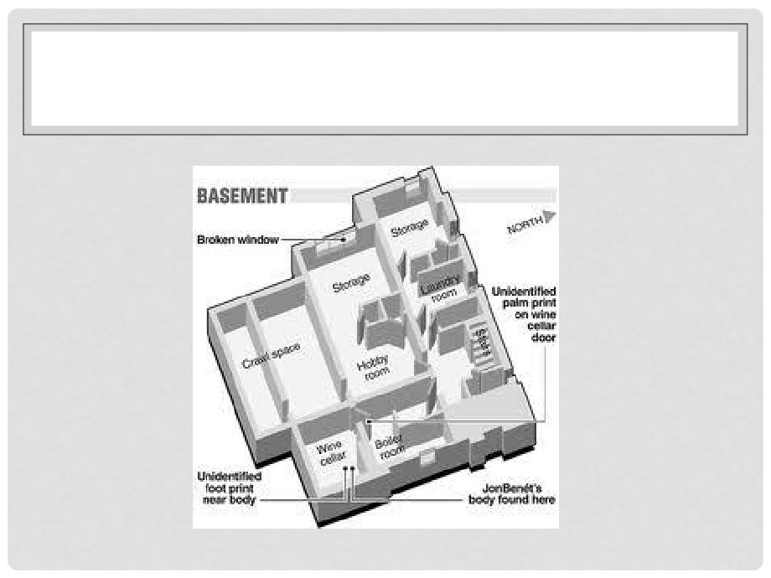

• The Ramsey family enjoyed a normal Christmas Day in 1996.

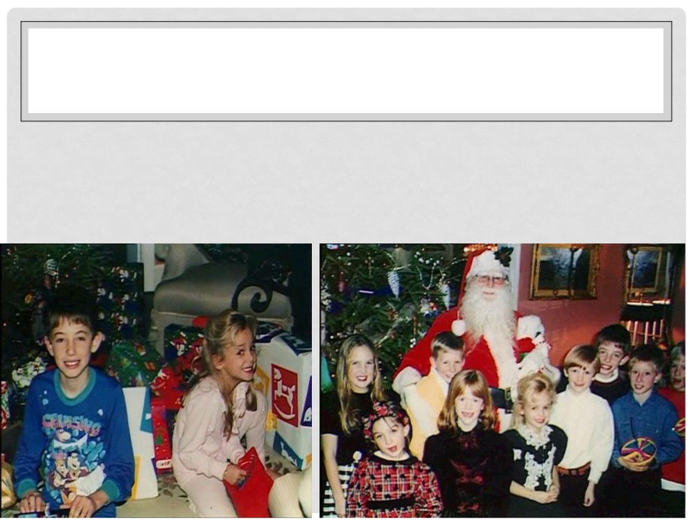

• The children gleefully opened their presents on Christmas   
morning.

• Later, the family had dinner with their friends, the Whites.

• After leaving for home, they stopped at a few other houses to   
drop off more presents.

• By the time they got home, JonBenet was sound asleep. They   
carried her upstairs and put her to bed without waking her up.

• According to her account,

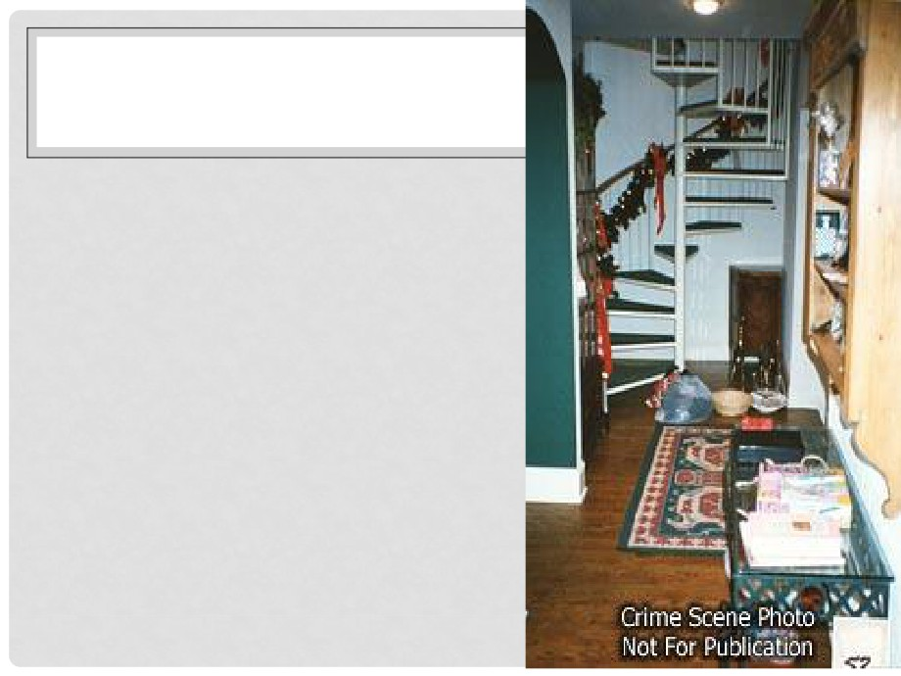

Patsy awoke early next morning   
to prepare for the family's flight

to Michigan.

• the spiral staircase, she found a note. It was a ransom letter for JonBenet.

• Patsy panicked upon finding

JonBenet's room empty and called 911 at 5:52 a.m.

• Police officer Rick French arrived

about 18 minutes after her call and

immediately searched the house for the girl, but he didn't find her.

• Friends of the family, including their   
reverend, soon arrived at the house

and began consoling a hysteric   
Patsy. John, according to various   
accounts, was tense but calm

throughout the morning.

• The ransom note, unusually   
long and written on lined   
legal paper with a black

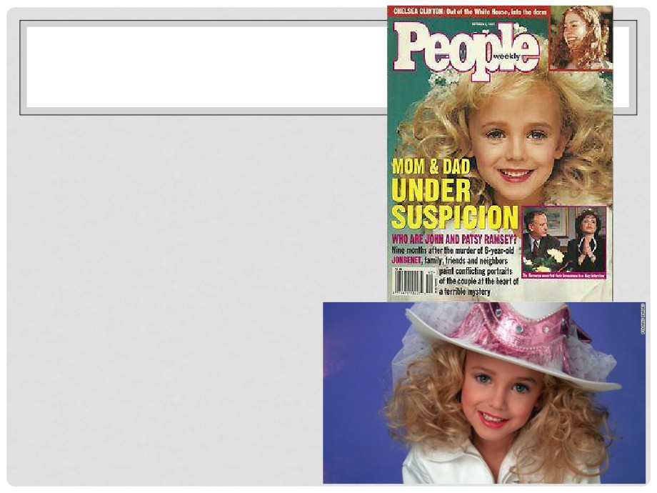

felt-tipped pen, claimed to   
be from a "group of

individuals that represent a   
small foreign faction."

• It demanded $118,000, a   
sum that has puzzled   
investigators as an odd

figure — and small

considering the Ramseys'   
wealth.

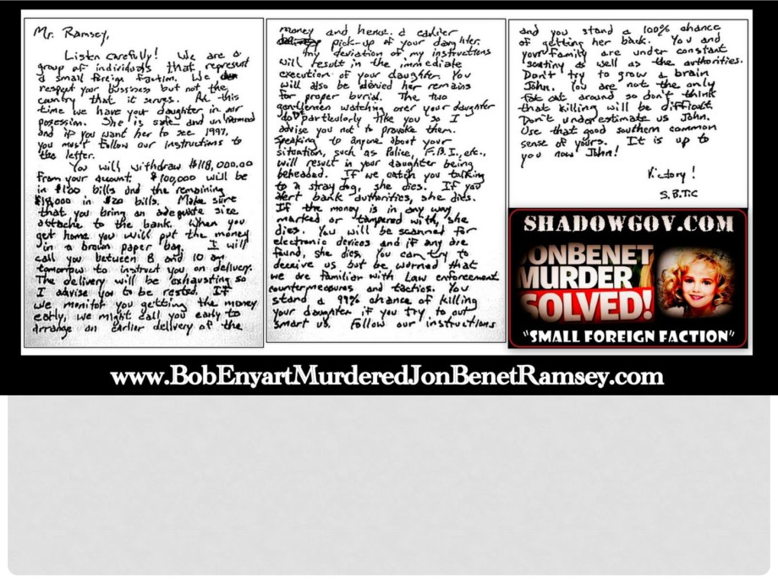

• The note indicated that the kidnappers would call

"between 8 and 10 am tomorrow" and told the Ramseys   
that if they informed authorities, it would "result in your   
daughter being beheaded." The letter was signed

"Victory! S.B.T.C."

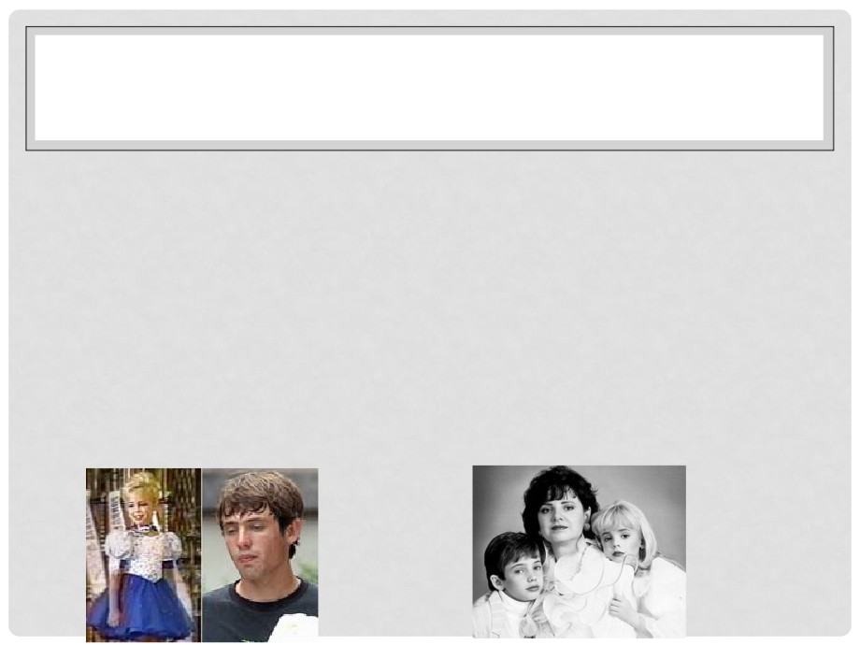

• A little after 8 a.m., detective Linda Arndt arrived at the   
house.

• When JonBenet's 9-year-old brother, Burke, woke up, his   
parents wanted him removed from the traumatic scene

and brought him to the Whites' house.

• Around this time, John's friend, Fleet White, took it upon

himself to do a search of the house, but he found nothing.

• A little before 10 a.m., John went down to the basement   
alone and found a broken window that had been left   
open. He shut it and went back upstairs.

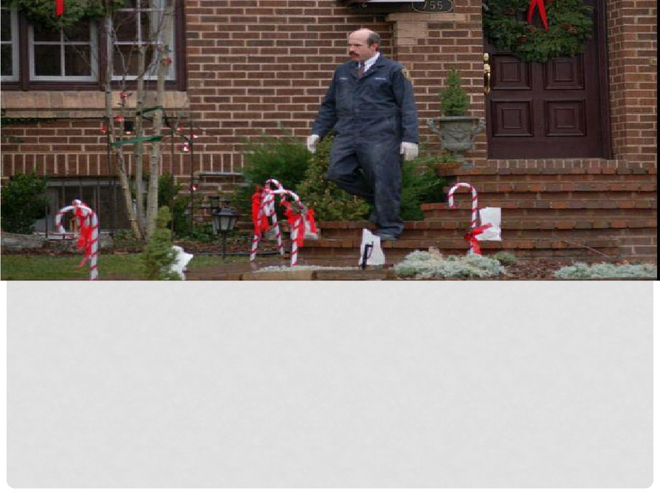

• 10:00 a.m. passed without a call from any kidnapper.

• Within the next few hours, several police officers left for   
the police station, leaving Arndt as the only officer in

the house.

• She had trouble containing the Ramseys and their   
guests into one room of the house to avoid further

contamination of the crime scene.



• At about 1 p.m., Arndt asked John Ramsey to take his

friend Fleet White around the house with him and look for

clues.

• John and Fleet planned to start in the basement and   
work their way up. When Fleet pointed out the broken

window in the basement, John explained that he himself

had broken it months ago when he accidentally locked   
himself out of the house.

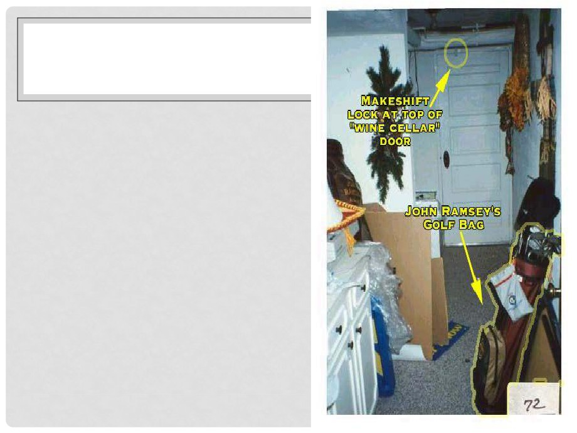

• After searching the room   
 with the broken window,   
 John went into the boiler   
 room and beyond it into a   
 small, windowless room.

• Though both police officer   
 Rick French and Fleet White   
 had looked in the

basement earlier, they

found the wine cellar dark,   
and failed to find the light   
switch and peer inside.

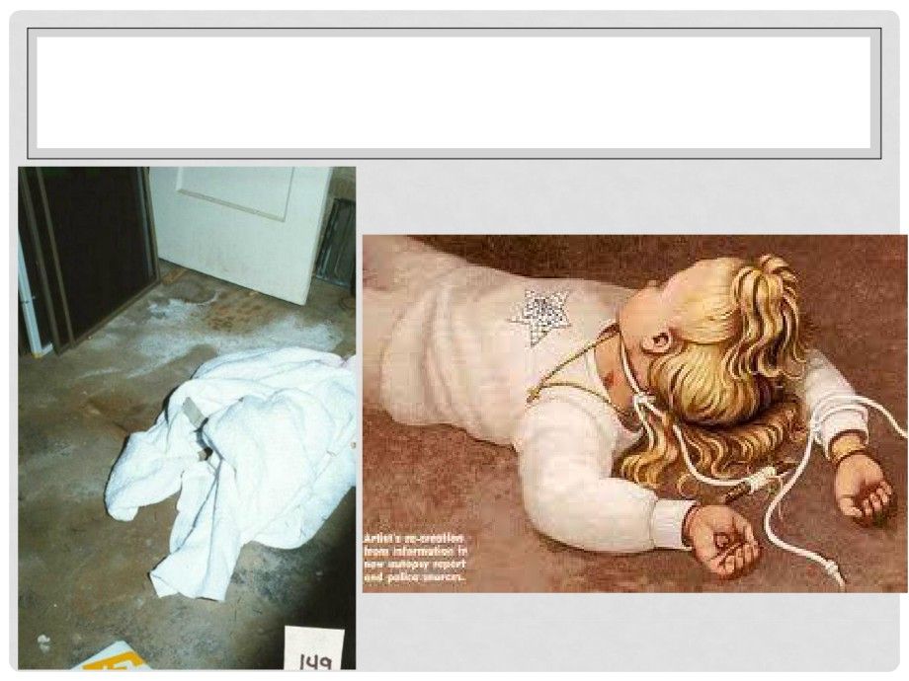

• But when John looked inside, he looked to left and

immediately noticed a white blanket in the center of   
the room. He turned on the light and saw JonBenet's

body sticking out from under the blanket.

• They found that her mouth

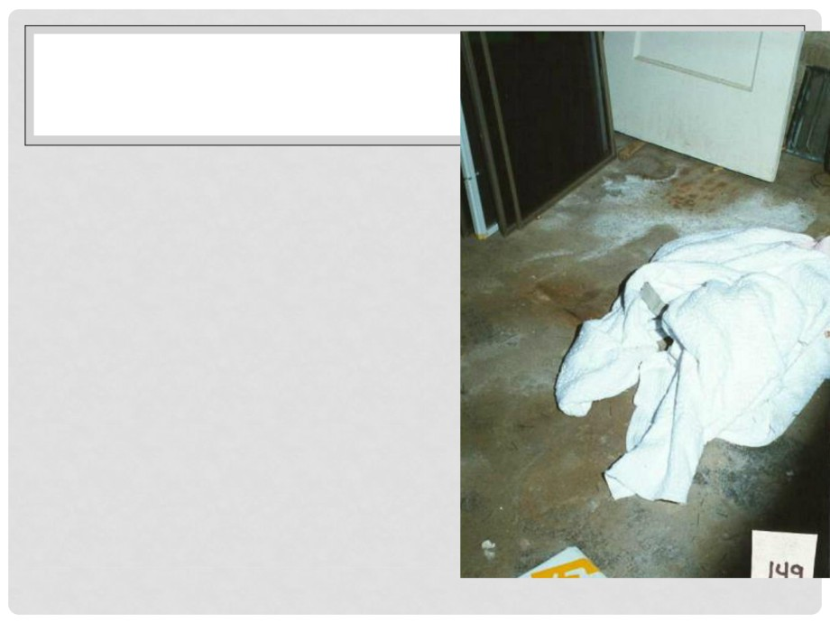

had been covered with duct   
tape and her wrists had

been tied.

• Worst of all, cord had been   
wrapped around her throat   
that dug deeply into her skin.

• He ripped the tape off and   
began untying her wrists.   
When Fleet came in, he

touched the girl's foot, which

was cold. John picked up his   
daughter's stiff, lifeless body

and carried her upstairs

screaming for help.



• Placing her body on the floor, John and Detective   
Arndt knelt over it and determined that the girl was

in fact dead. According to accounts, Patsy stayed

sitting in the other room for a moment amidst the   
shouting.

• When her friend took her by hand and led her to

the body, Patsy threw herself down on top of it and   
pleaded with their reverend to bring her back to   
life. But it was too late.

JOHN RAMSEY'S PSYCHOLOGICAL



PROFILE

• John Ramsey, father of murder   
victim JonBenet and husband of   
Patsy Ramsey, is a veteran of the   
U.S. Navy and a millionaire who   
was the CEO of the Lockheed-  
Martin subsidiary Access

Graphics. Once it was discovered

that JonBenet had been sexually

assaulted prior to her murder,

authorities began to suspect that

her father had abused her.

However, experts claimed that   
John didn't fit the profile of a sex   
abuser.



• So many details of this murder   
mystery fascinated the public

— the rich family, the quiet

neighborhood, the odd ransom   
note and, most particularly, the

beauty pageant pictures of a

dolled-up 6-year-old that

dominated the tabloids.

Considering the way the body

was found inside the house,

many who suspected the girl's   
parents. The Ramseys'

impression that the police also

suspected them sparked a

growing sense of tension   
between the family and   
investigators.

• After police gathered   
writing samples for   
John and Patsy, they   
discovered that the

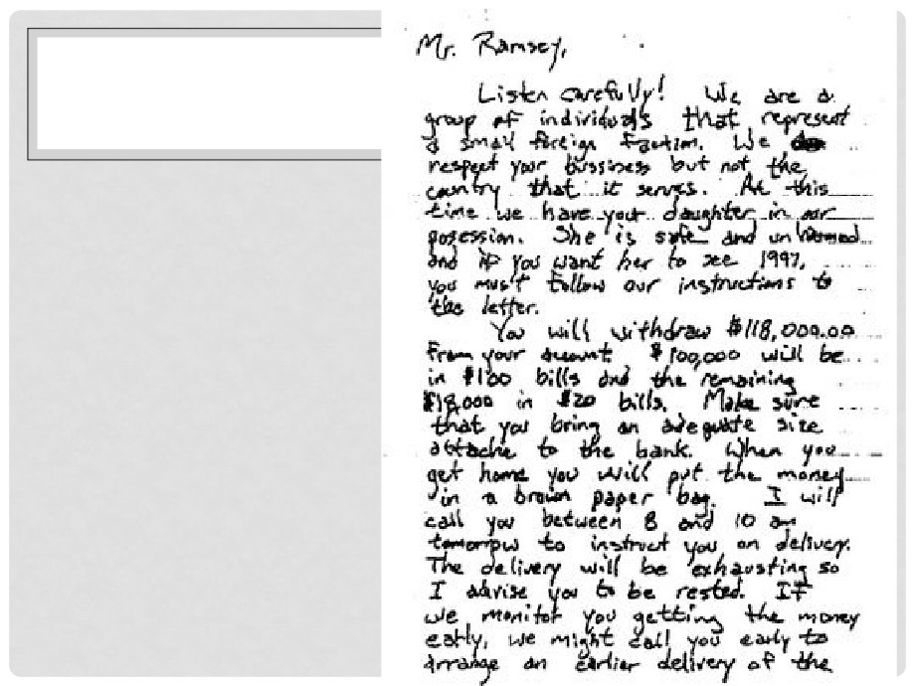

note was written

inside the house. The   
killer used a legal   
pad found in the

house and even

started a first attempt   
before discarding it.

What's also

interesting is what

investigators did not   
find in the house —

namely, a roll of duct

tape or cord that   
was used on the   
body.

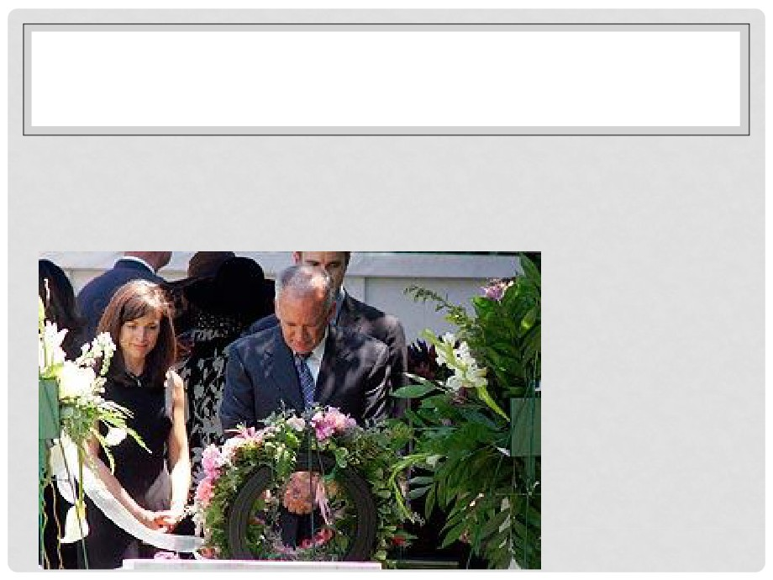

• Whether they were guilty or not, it's understandable that   
John and Patsy quickly felt they needed to defend   
themselves. Family friend Michael Bynum was an

attorney and warned them early that they'd be

considered suspects. It was Bynum who encouraged the   
Ramseys to decline to give full interviews to the police at   
first. However, this did not help their public image,

making it look like they were not uncooperating.



• Realizing that public

sentiment was turning

against them, they hired a

media consultant and, at

the encouragement of   
Fleet White, agreed to   
come on CNN on Jan. 1,

1997, to tell their story.

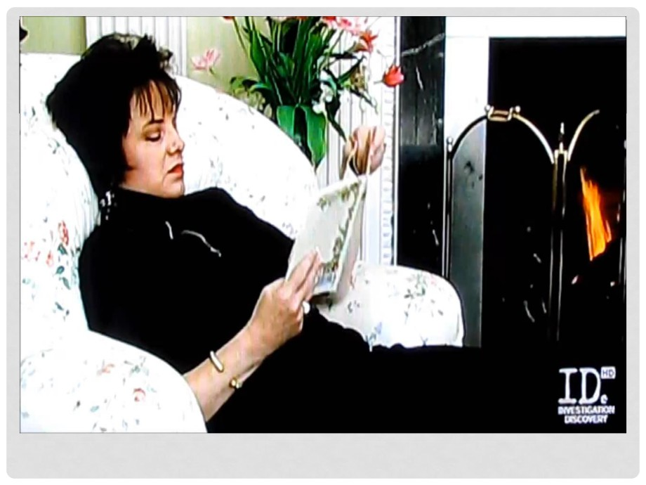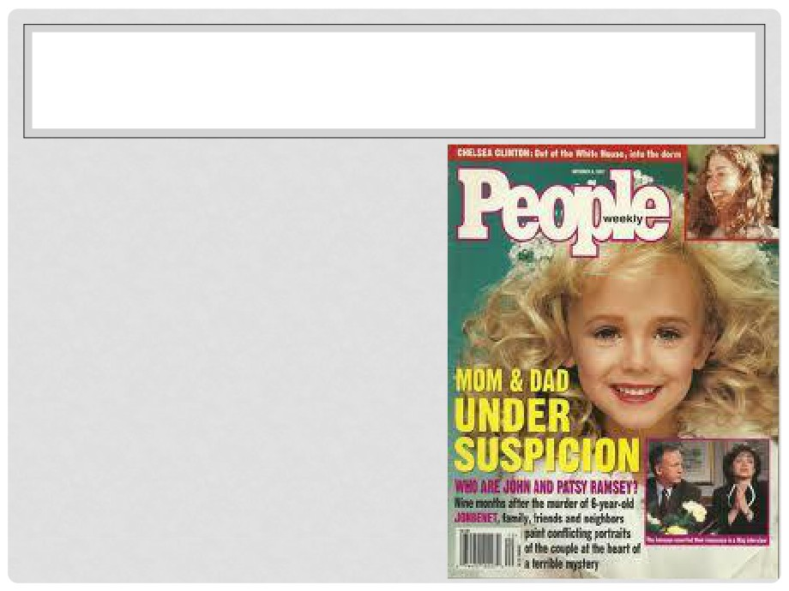

• The public was horrified at   
the details of the killing. The   
cord that was tied around

JonBenet's neck was tied to

a stick, which acted as a

garrote to pull it tight. It

became clear that the stick

was broken off a paintbrush

that was taken out of Patsy's   
kit that was found outside

the door of the wine cellar.

Investigators discovered

abrasions on her right cheek

and on the left side of her

neck.



• What made the case all the more disturbing is that the   
investigation of JonBenet's body uncovered evidence   
of sexual assault.

• The autopsy revealed a broken hymen, blood around   
the entrance to the vagina, and abrasions along the   
walls of the vagina.

• A large hemorrhage in the scalp revealed that she had   
been hit in head with a blunt object.

• Curiously, John and Patsy couldn't explain why   
evidence of partially digested pineapple was

discovered in JonBenet's intestine. A bowl of cut

pineapple with Patsy's and Burke's fingerprints on it was   
found on the kitchen counter in the house, but   
JonBenet's fingerprints were not on it.



THE QUESTIONS AND THE THEORIES

• Several theories developed to try to

explain the mound of seemingly

conflicting evidence. Some of the

most sensational theories involve the   
idea that Patsy killed her daughter.   
This could have been accidental,

perhaps becoming violent upon

discovering her daughter wet the

bed. This is a scenario suggested by

Detective Steve Thomas, who worked

on the case. Patsy would have then   
staged the rest of the evidence to   
make it look like a botched

kidnapping. The theory that Patsy was

responsible became more popular   
when handwriting analysis didn't rule   
her out as the author of the note.

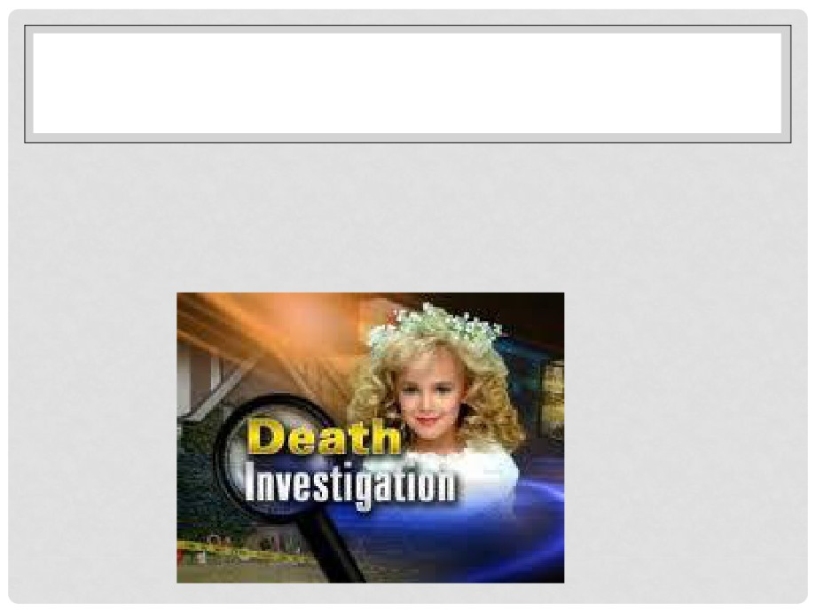

• However, no evidence exists that she ever so much as   
spanked her children. And many point to the fact that   
the handwriting analysis is far from conclusive. After

analysis of the ransom note, some find it hard to

accept the idea that Patsy would have written such a   
bizarre fake letter — or could have had the presence   
of mind to do so after killing her child.



• The idea that JonBenet was sexually assaulted leads   
some to fear that her father abused her.

• Evidence of an intruder did exist, such as traces of   
foreign DNA found under the girl's fingernails and in

her underpants. A boot print was also found on the   
floor of the wine cellar, as well as a handprint on the

wine cellar door, neither of which belonged to the

Ramseys.

• A scuff mark on the wall under the broken window   
suggests that it could have been left by an intruder.

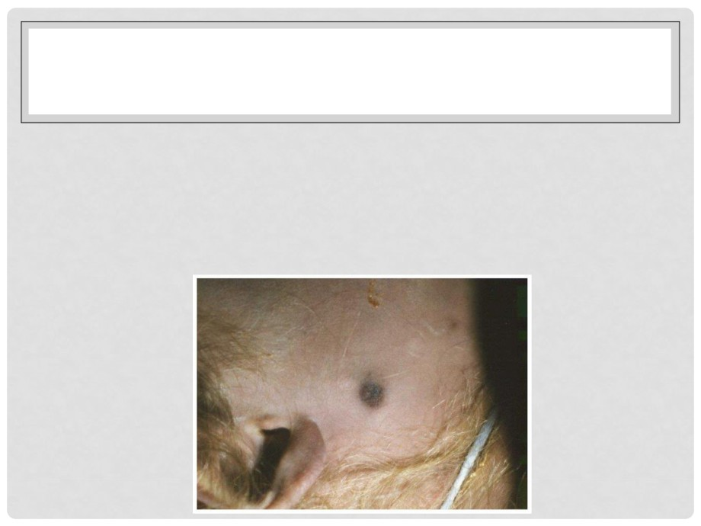

• Some have pointed out that marks on JonBenet's body   
match a particular brand of stun gun. Those who believe   
this theory say that the intruder probably brought a stun   
gun, duct tape and cord, as well as possibly a flashlight.

• The intruder was probably familiar with the house,

perhaps because he or she was an acquaintance. Or   
the intruder could have been a stranger who targeted

JonBenet from her pageant participation, and who

broke in while the Ramseys were out. He or she could

have taken that time to explore the house and write the   
note.



• Twenty years after JonBenet's murder, the case remains   
unsolved.

• In 2008, new "touch DNA" technology allowed

investigators to recover another DNA sample belonging

to an unknown male that matched the DNA found in   
her underwear. This was considered by many to be

conclusive enough evidence to exonerate John and

Patsy as suspects.

• A few skeptics remain, however, and say this DNA

evidence hasn't proved anything. The DNA could have   
been left on the clothes in the manufacturing process   
or even by morgue personnel.

• In any event, the DNA information has been entered in   
a national database, where perhaps it will one day be

matched to JonBenet's real killer.

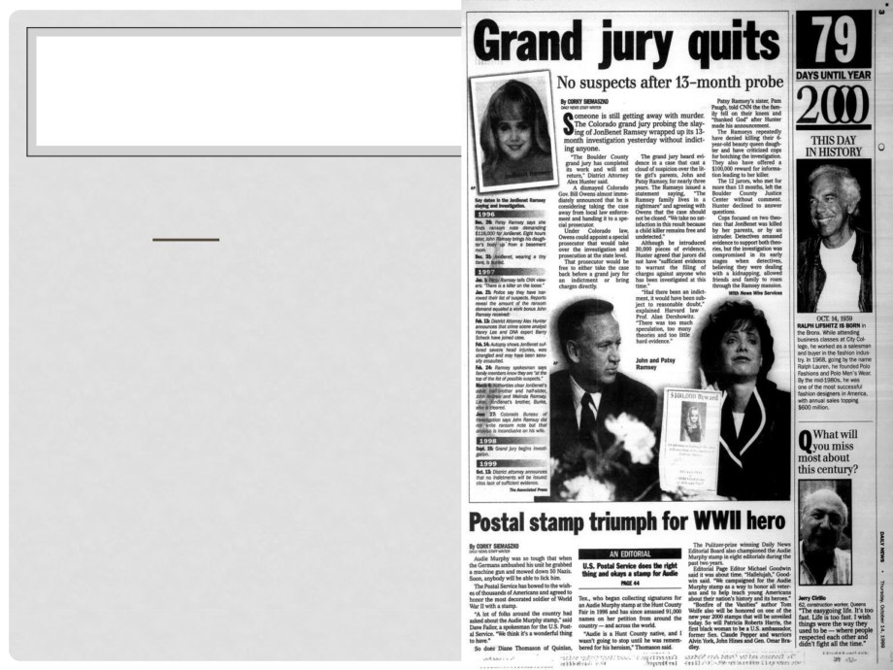

• Court documents released   
in October of 2013 reveal   
that a 1999 grand jury   
voted to indict John and   
Patsy Ramsey of child   
abuse resulting in death   
and being an accessory to

a crime, including murder,

in connection to their 6-  
year-old daughter   
JonBenét.

• However, a prosecutor

declined to sign it citing a   
lack of evidence.



• The grand jury's indictment papers did not indicate who   
killed the young beauty queen.

• The charges didn't directly accuse the Ramseys of killing   
their daughter, but alleged they “permitted JonBenét to

be placed in a dangerous situation that led to her

death,” and it accused them of helping the killer, who   
has never been brought to justice.

• The Ramseys were never officially indicted.

• In 2008 the girl's parents and immediate family were

exonerated after the new DNA evidence pointed to an

unknown male as JonBenét's killer.