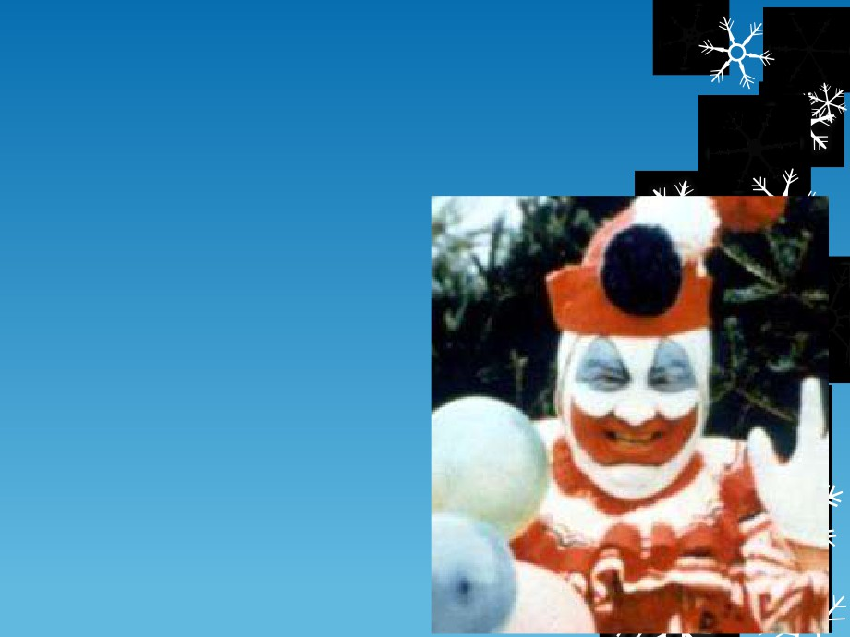

John Wayne Gacy

The Killer Clown



There are so many reasons to dislike clowns:

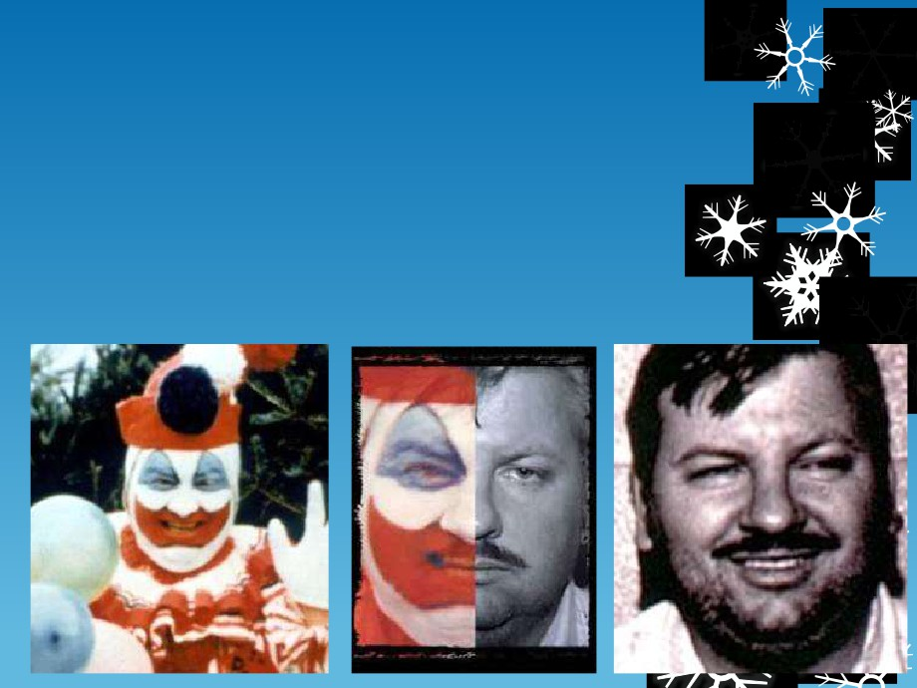

 Before the bodies of 29 young men and boys were discovered   
 on his property in 1978, Gacy was known around Chicago for   
 being nothing more than a friendly neighbor. He dressed up as   
 Pogo the Clown and was the chaplain of the Jaycees. Because   
 of his reputation, many people failed to consider that he was   
 arrested for sodomy with a minor during the ’60s.

 Background

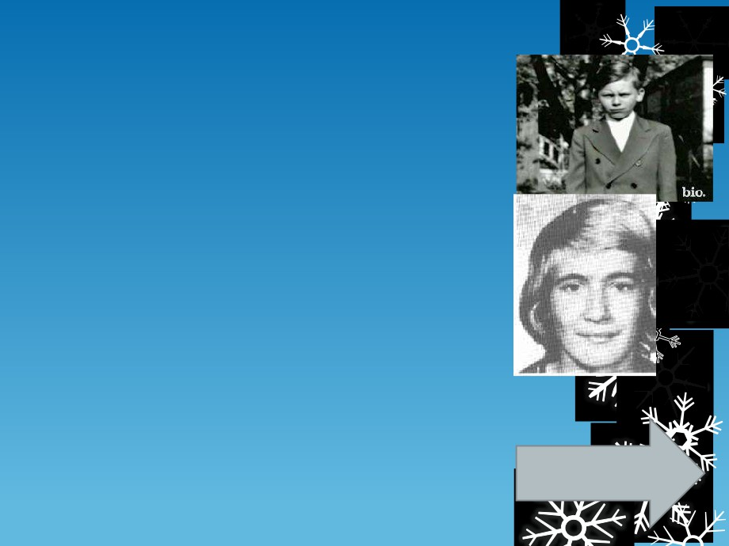

 Gacy was raised by an abusive, alcoholic father,   
 who referred to him as "sissy", and a passive

mother. He was close to his sisters and his mother, who called him "Johnny".

 After attending four different high schools, Gacy   
 dropped out before completing his senior year   
 and left his family, heading west. After running   
 out of money in Las Vegas, Nevada, he worked   
 long enough to earn money to travel back home   
 to Chicago.

 Without returning to high school, he enrolled in   
 and eventually graduated from Northwestern   
 Business College. A management trainee   
 position with the Nunn-Bush Shoe Company   
 followed shortly after graduation, and in 1964,   
 Gacy was transferred to Springfield, Illinois.

 There he met coworker Marlynn Myers, and they   
 married in September 1964. He became active   
 in local Springfield organizations, joining the   
 Jaycees and rising to vice-president of the   
 Springfield chapter by 1965.

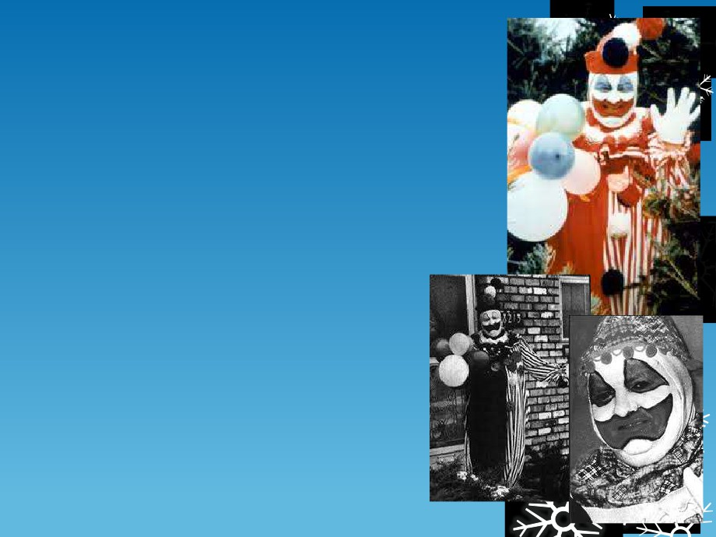

 Gacy would later become involved in

political activism, construction, and

several other fields, all the while racking

up minor criminal charges.

 In 1975, Gacy created the character

"Pogo the Clown", which he used to

support himself. His habit of wearing the costume at charity events and parties

later led to him being nicknamed the

"Killer Clown". During this time, his

involvement in politics eventually landed   
him clearance by the U.S. Secret Service.   
Shortly thereafter, he would begin his

murders.

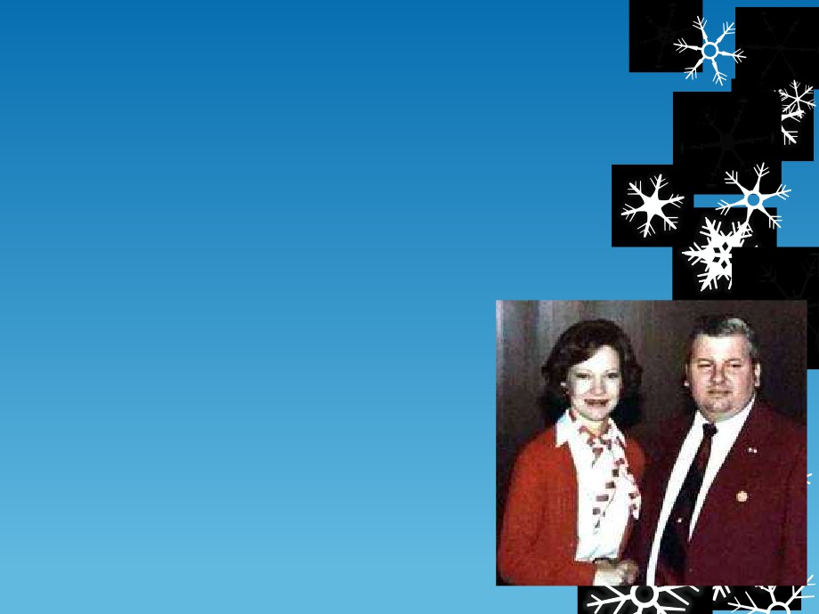

 Modus Operandi

 Gacy told the police that he would pick up   
 male teenage runaways or male prostitutes   
 from the Chicago Greyhound Bus station or   
 off the streets, take them back to his house   
 by either promising them money for sex,   
 offering them a job with his construction   
 company, or simply grabbing them by force.

 Once they got back to his house, he would   
 handcuff them or tie them up in another   
 way after intoxicating them with alcohol or   
 another drug. One of his most infamous

ways of binding his victims was convincing

them to allow him to handcuff them under   
the pretense that it was part of a magic   
trick.

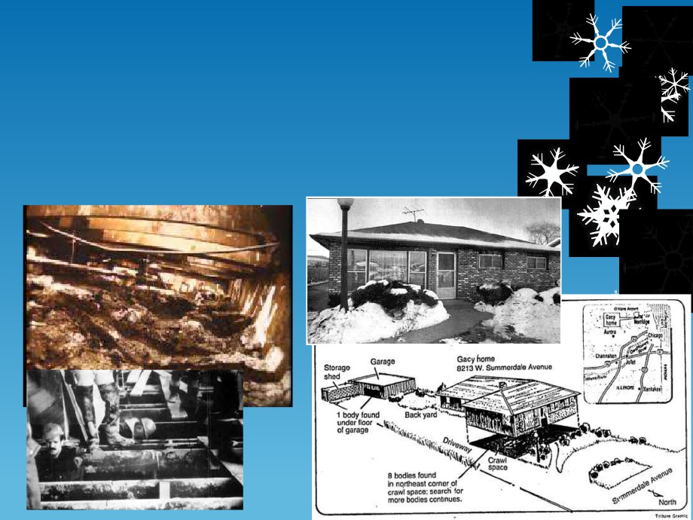

 Gacy would often stick clothing (even their own underwear) in   
 their mouths to muffle their screams. After this, he would choke   
 them with a rope or a board as he sexually assaulted them, then   
 bury the bodies in his crawlspace. Periodically, Gacy would pour   
 quicklime in the crawlspace to hasten the decomposition of the

bodies. Three victims were disposed of off the property by being

dropped into the Des Plaines River.

 Killings, Capture and Execution

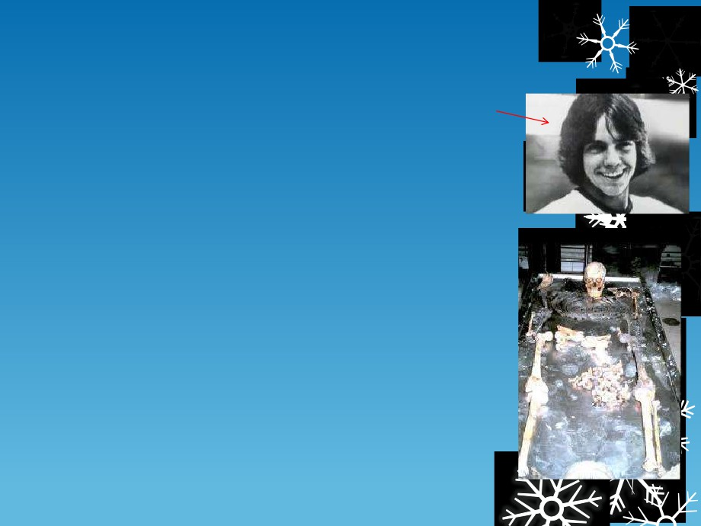

 He started with a young juvenile named Tim McCoy, whom he

allegedly killed in self defense. He soon murdered a co-worker name John Butkovich.

 After many years of murdering, Gacy was eventually

apprehended in Des Plaines following the disappearance of 15-

year-old Robert Piest who was last seen with Gacy, police had obtained a search warrant to search Gacy's home where they discovered a powerful odor and numerous items belonging to other missing young men.

 Authorities then suspected Gacy of murder and would soon

obtain a second search warrant, the second search would target

the crawlspace in which police ripped up the floorboards and

began to dig into the earth of the crawlspace during which the   
police would find human bones buried in the soil of the   
crawlspace and, at that point, they placed Gacy under arrest for   
murder.

 Gacy would admit to 25-30 murders in the 1970s. When police

searched his home, the remains of at least 29 people were

found buried in various places. The other remaining victims were found in the Des Plaines River. During his trial, and in order to lessen his sentence, Gacy began telling officials and prosecutors that he had an alter-ego personality named Jack, who was responsible for the murders. Psychiatric evaluation proved the claim to be false.

 Later, in an interview on Death Row shortly before   
 his execution, Gacy claimed himself to be   
 the 34th victim as he was innocent and had no   
 involvement with the murders and subsequent   
 burials. Gacy claimed that his employees set him   
 up. This proved to be false as he had already   
 claimed responsibility for the murders of the

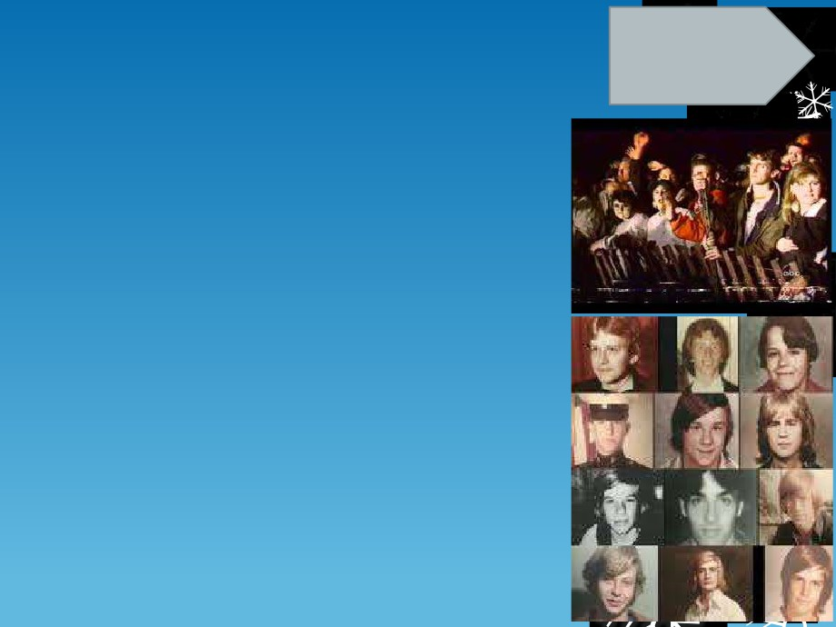

young men years prior.

 It is reported that Gacy killed 33 young men   
 between 1972 and 1978.

 He is also known to have raped two males of the   
 same age, one in 1968 and one in May, 1978,   
 both of whom were left alive.

 The nine unidentified victims were all buried in   
 individual graves with headstones reading "We   
 Are Remembered".

 Gacy was sentenced to execution by lethal

injection at Stateville Prison in Crest Hill, IL on May 10, 1994. When asked whether he had any last words during his execution, he reportedly snarled, "Kiss my ass." He was executed.

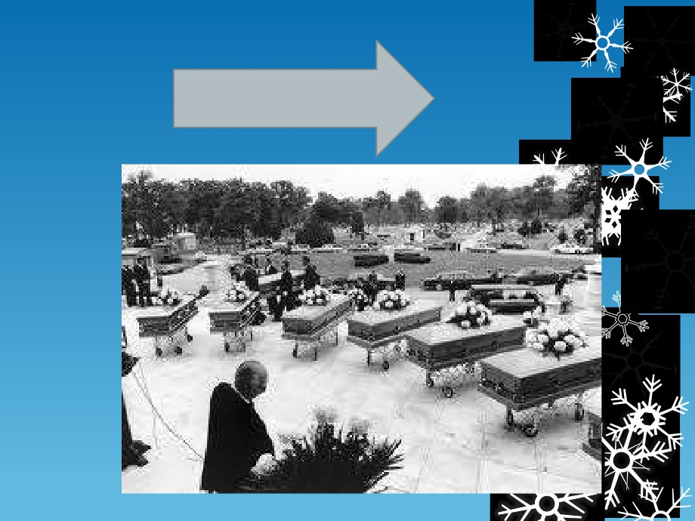

It all happened in an average neighborhood…