

The Whitechapel Murders

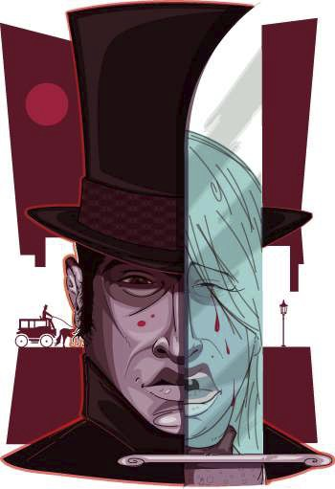

○ It was no longer safe to be walking the

streets of London's Whitechapel. A killer

was stalking and murdering prostitutes in

the area - five to begin with, between late   
August and early November, but would   
eventually kill a total number of seven   
women.

○ Jack The Ripper was the first modern

serial killer. Over ten weeks in the year

1888 he butchered women and the police   
couldn't catch him. This case was the first   
case that psychological profiling was used   
in an attempt to catch a serial killer.

○ All the things that we would do at a crime

scene now were not done back then. They   
didn't have fingerprints, blood groups or   
even blood types.

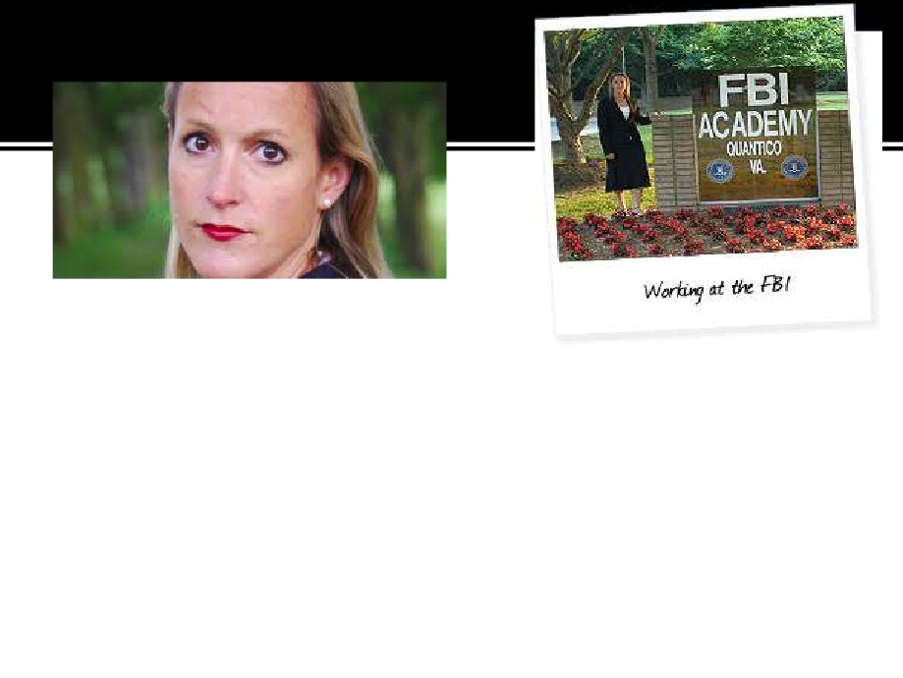

○ Laura Richards is a behavioral psychologist with the   
violent crime command at Scotland yard. She has   
agreed to reexamine the case that has been troubled   
by conspiracy theories and myths.

○ Laura brings the experience of a decade of studying   
the most dangerous criminals. She will bring together   
a team of experts using modern techniques to help her   
get inside the killer's mind. So the hunt for Jack the

Ripper has begun again.

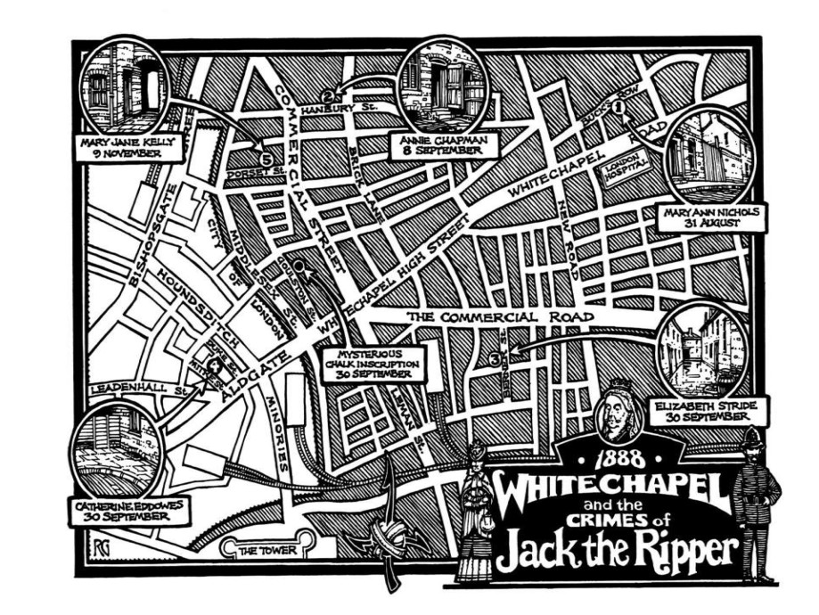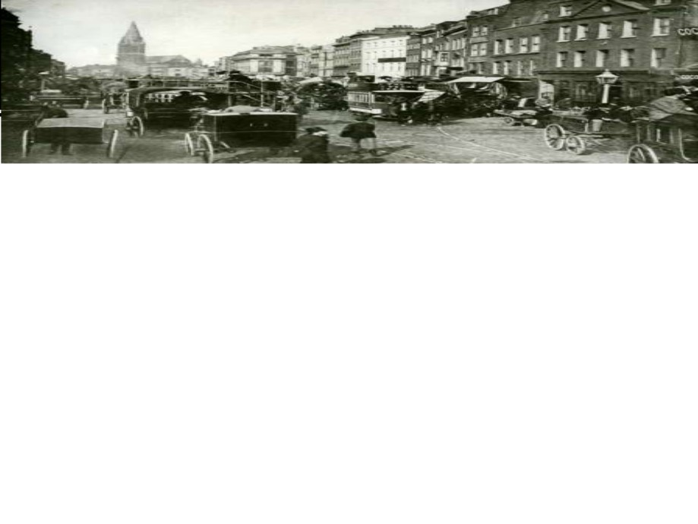

○ Laura says you have an offender who is prolific,   
predatory, and killing and mutilating women and

then leaving them out publicly displayed for the   
world to see.

○ Laura's job is behavioral analysis.

▪ A criminal reveals himself by his actions. Although the   
crimes are over a century old they can still be decoded.

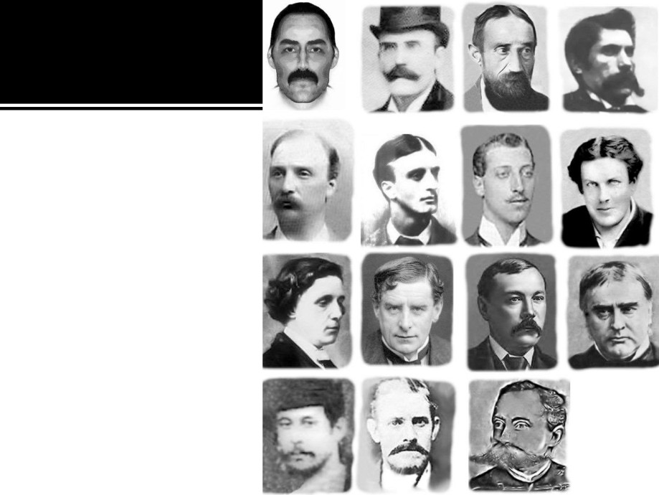

▪ Over the decades   
over 200 suspects   
have been named.

▪ The police of 1888   
were certain that   
these were the

crimes of a

madman. Later   
came the

conspiracy theories.

Was the killer Prince

Albert Edward,

Queen Victoria's   
grandson and the   
Heir to the throne?

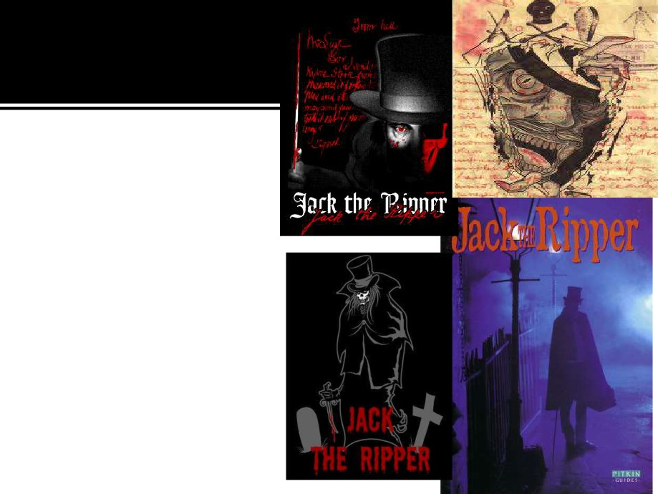

○ That, many believe is a   
complete pack of

nonsense as he had an   
alibi for every murder.   
Was it Victoria's

physician, William Gall,

as part of a Masonic

plot? No, he too had an   
alibi for the murders.   
○ The press made the   
killer a legend. The   
newspaper sold over a   
million copies with a

"Ripper" front page.

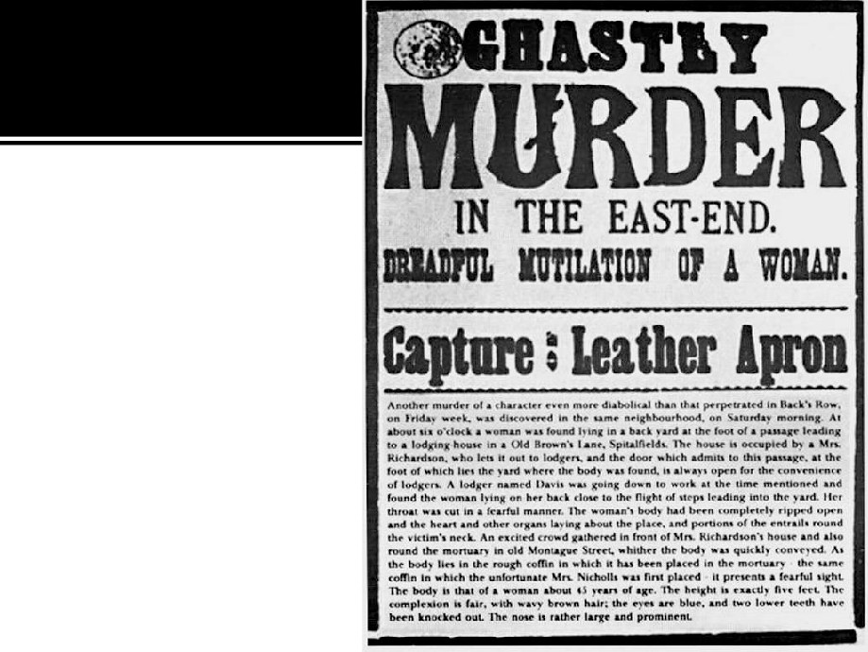

○ Since he was the   
first modern serial

killer the police   
were simply not

equipped to hunt

him down. They   
closed the

investigation after

four fruitless years.

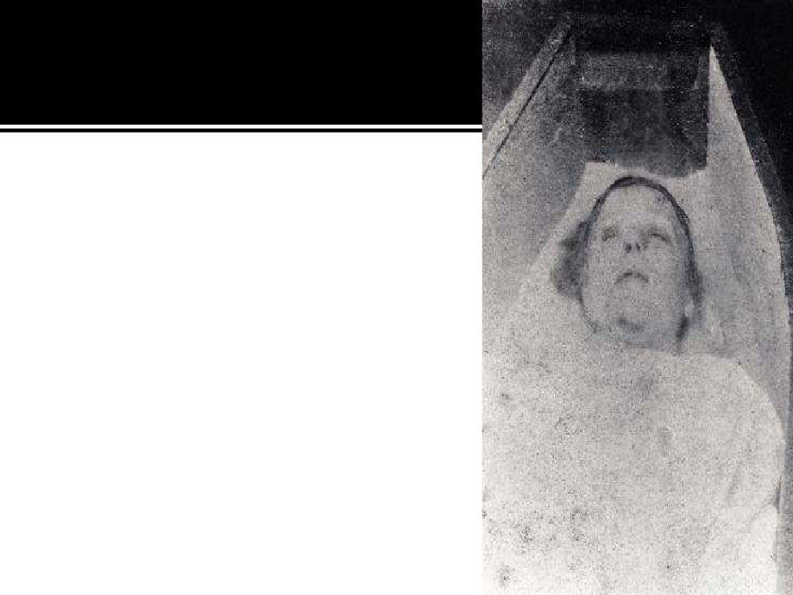

○ It's widely accepted that Polly Nichols   
 was the first victim.

▪ She was 43 years old with adult children   
and separated from her husband.

▪ She had no permanent home and was   
often on the streets.

▪ She was an alcoholic.

▪ Her death marked the beginning of what   
 would become known as "The Autumn of   
 Terror". She was killed in the early   
 morning hours of August 31, 1888.   
○ Ripper expert Don Rambelow knows   
 the streets the Ripper killed on better   
 than anyone.

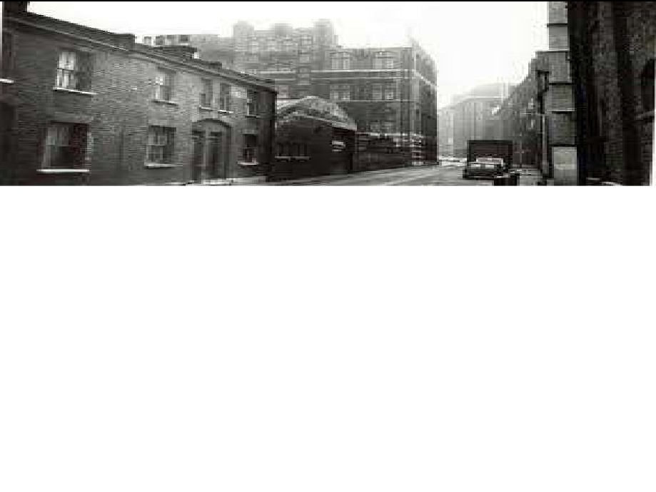

○ He took Laura to the place where the first victim was   
found. Of all the five murder sites this is the one that

has changed the least. The body was found by two

men on their way to work. It was only after she was   
taken to the mortuary did they discover the gashes in   
her abdomen. Polly's injuries went far beyond what

was necessary to cause death. Her sexual organs were

mutilated. Polly wasn't raped but the nature and the   
intensity of the attack say something about the state   
of mind of the killer. Laura thought it was a sexually

motivated crime even though she wasn't raped.



○ Laura then used a pattern of all of the Rippers attacks and   
the connections between the five victims and their killer

and formed a basic profile of The Ripper.

○ Laura needed to know two things.

▪ One, why the killer chose White Chapel as his killing ground and   
 ▪ Two, why he chose 43 year old Polly Nichols as his first victim.   
○ Polly was there that day probably because she was a   
prostitute and was looking for a customer. Polly Nichols   
lifestyle made her vulnerable. Even before she was killed

that area was the toughest area in London. All five of the

Ripper's victims lived in poor conditions in this community.   
In fact they all lived and died within a single square mile.



○ Selling sex was often the only way to get by. Some 5000

women worked a prostitutes in this area alone.

○ For a predatory killer like The Ripper, White Chapel with its of

targets made for easy pickings.

○ The question was whether the Ripper was what criminal

psychologists call a poacher or someone who came from

outside White Chapel just to hunt. Or was he attacking within

his own community?

○ Laura used a mapping technique called geographical profiling.

It is used by law enforcement agencies around the world to   
interpret crime scene locations. It was developed by Dr. Kim

Russmo, a geographical profiler who works out of the Dept. of

Criminal Justice in Texas. Dr. Russmo, who is a mathematician,   
uses a formula based on dozens of solved cases. Using data   
such as roads, homes, and business locations, he then   
calculates where the offender comes from.

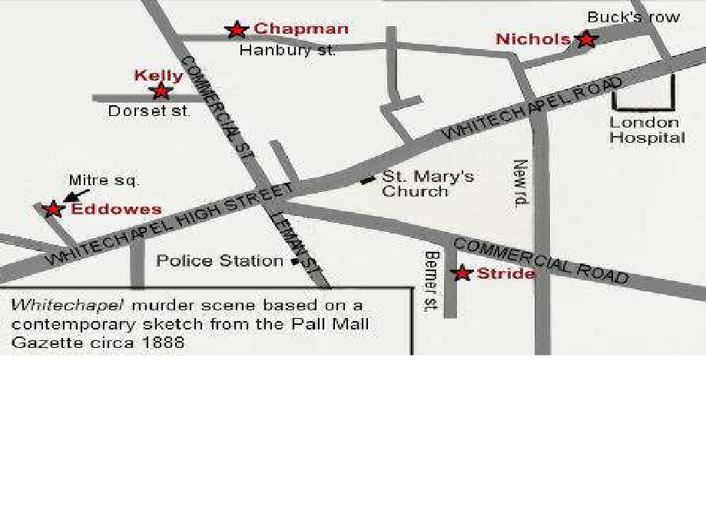

○ Using this method and given that the murders all   
occurred within one mile it should be possible for   
Dr. Russmo to be able to calculate what street the   
police should have started looking.

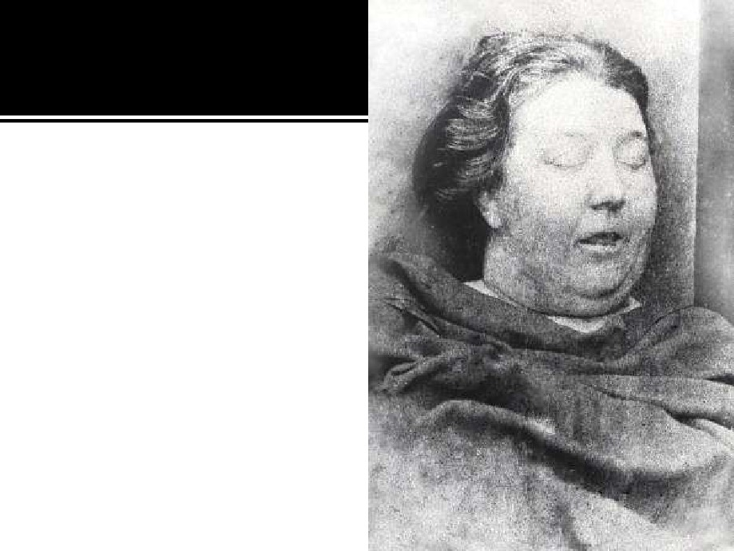

○ While waiting on the results,   
 Laura looked at the

circumstances of the second   
murder. It happened seven   
days after the first murder   
on Hanbury street. The

victim's name was Annie

Chapman.

○ Like Polly, Annie Chapman's   
 life was on a downhill spiral.   
 She too was an occasional

prostitute after her and her

husband both lost their jobs.   
The yard where Annie was   
killed doesn't exist anymore.

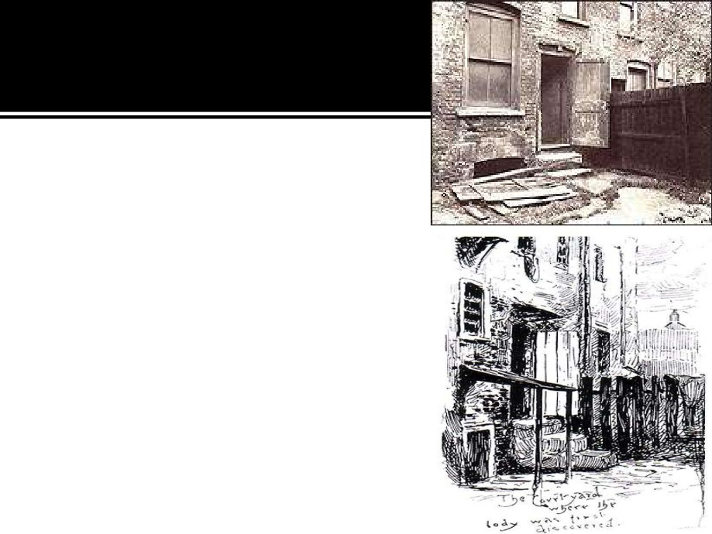

○ At around 6:00 AM on the morning   
of the 8th of September, John

Davis, a wagon driver, came down   
the stairs of number 29. He saw   
that the back door was slightly ajar

and went to investigate. He found

the body of Annie Chapman. The   
cut on Annie Chapman's neck was   
so severe that it almost cut off her

head, part of her uterus was

missing, and her intestines were

drawn out and thrown over her left   
shoulder.



○ Laura thought that even as he was killing Annie he was thinking

about the consequences, the shock, and that was part of the

thrill. He may have been calculating and cunning but he also put   
himself in a situation where the chance of being caught was very   
high.

○ No fewer than 23 people lived at 29 Hanbury Street coming and

going at all hours. He could easily have been disturbed. This told

Laura that The Ripper had a high degree of self control. He   
either can't resist the urge to kill regardless of what might   
happen to him or he is disciplined, confident, and playing out   
the odds.

○ It's Annie Chapman's behavior which points to the answer. She

almost certainly went with him of her own accord for if their had   
been a struggle it would have been heard. She probably thought   
he was a customer, thus he must have looked like a man who   
would do her no harm.



○ He also must have put her at ease, he managed to   
conceal what he was until the last second. Jack The

Ripper knew what he was doing.

○ Laura turned to Peter Dean who is a coroner and   
police surgeon for White Chapel. If the Ripper

struck today it would be on Peter Dean's watch. His

job is the interpretation of wounds. By looking

across the wounds of all the victims he was able to   
build a picture of how the Ripper claimed a victim.

He broke the attack down into distinct phases:

▪ Controlling,

▪ killing, and   
▪ mutilating.

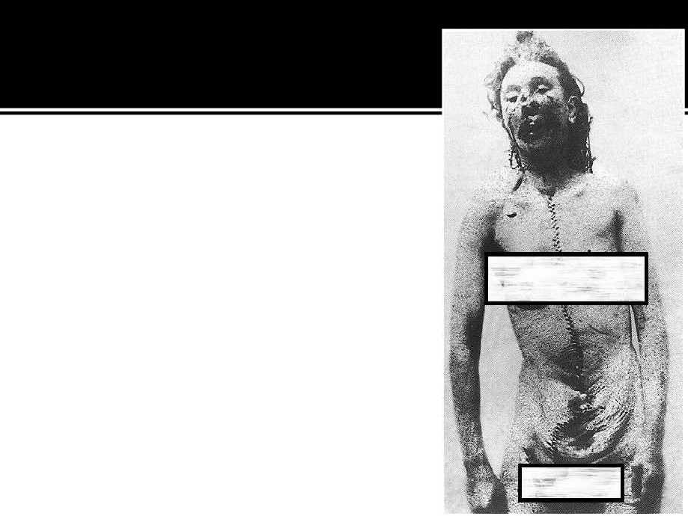

○ The myth that has grown around the   
Ripper centers around the way he

mutilated his victims.

○ But contrary to what most people

assume, that is not the way he killed   
them, he strangled them first. The

last phase, the mutilating, goes

beyond the normal realm of killing   
and is what satisfies him. In other   
words, he didn't kill by cutting, he

killed in order to cut.

○ This part of what he did has also given   
rise to one of the great myths about   
the case, that the perpetrator was a   
surgeon.



○ The ripper’s next two victims were taken in the space   
of an hour.

○ John Grieve is one of London's most senior and

respected retired policemen. He consulted with Laura   
and has news of a new development in the Ripper

case. It relates to the Rippers fourth victim, Kathryn

Eddowes.

○ It had been thought that no physical evidence

survived the case. But someone has come forth with

a shawl from Eddowe's body. If it is genuine it is the

last physical link to the case that anyone has. In any   
event a team of Forensic Scientists scan it for possible   
DNA and other clues.



○ Kathryn Eddowes was killed on the 13th of   
September 1888. It was also the day of the   
death of another Ripper victim, Liz Stride.

This was the most well documented night of

the Ripper's career.

○ At 8:00 AM on the 29th Kathryn Eddowes   
was seen leaving a pawn brokers shop. She

hocked a pair of work boots that belonged to   
her partner, John Kelly.



○ 6:00 PM -

▪ It is known that Kathryn Eddowes worked as a prostitute.   
Police reports place her at Aldgate High Street.

▪ A mile away, Liz Stride had been drinking. She was

spotted at the Queen's Head Public House and later at the

bar of the Bricklayer's Arms. Like Katheryn, Liz Stride was

a prostitute.

○ 8:00 PM -

▪ Katheryn Eddowes was arrested for being drunk and   
incapable.

○ 11:00 PM -

▪ Witnesses saw Liz Stride in the doorway of a pub with an   
unidentified man. In fact she was spotted with three   
different men over the course of the next couple of hours.

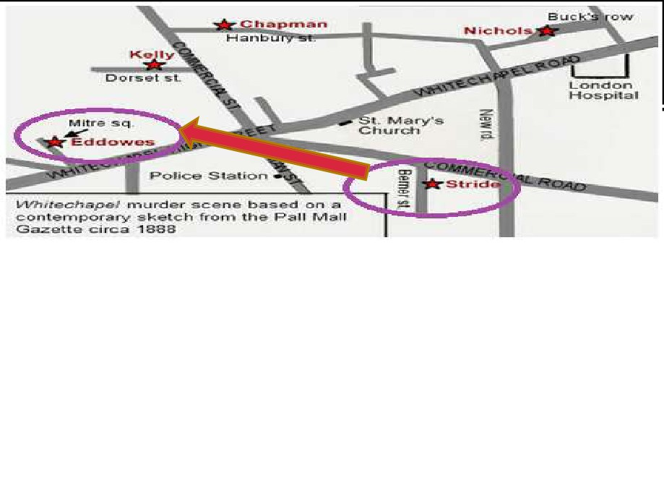

○ 12:45 AM -

▪ James Brown, a dock worker who was coming home, spotted Liz with a man   
 about 5'7" who was stocky and wearing a long overcoat. He appeared to be   
 standing in her way.

○ 1:00 AM -

▪ Kathryn Eddowes was safely locked up in Bishopsgate police station. At this   
 time, the duty officer felt she was sober enough to be released. She went

back towards Aldgate High Street.

▪ The Ripper had already found Liz Stride. Her body, on Berner Street, was

discovered between 12:45 and 1:00 AM. She had died less than five minutes before. There was no mutilation. People actually disturbed the Ripper doing his work but weren't quick enough to save her life.



○ 1:30 AM (roughly) -

▪ The Ripper went west from Berner Street to Mitre   
Square.

○ 1:45 AM -

▪ When the body of Kathryn Eddowes was found, it was   
obvious he had spent some time with it.

○ On Berner Street he had been interrupted and   
started hunting again and found Kathryn

Eddowes in Mitre's Square.

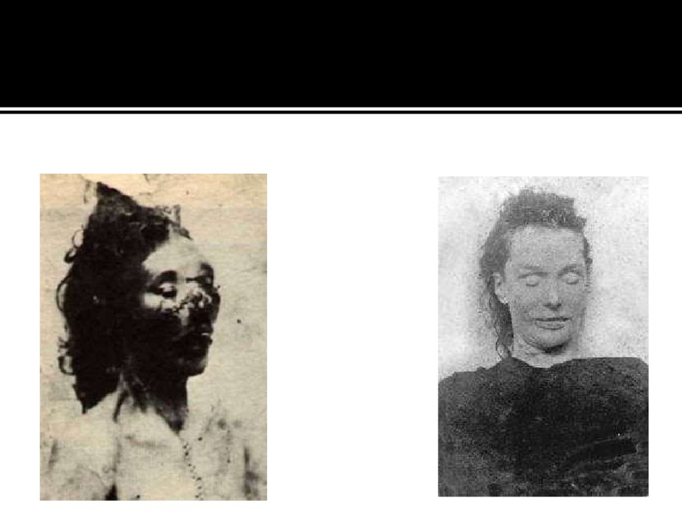

○ Eddowes Stride

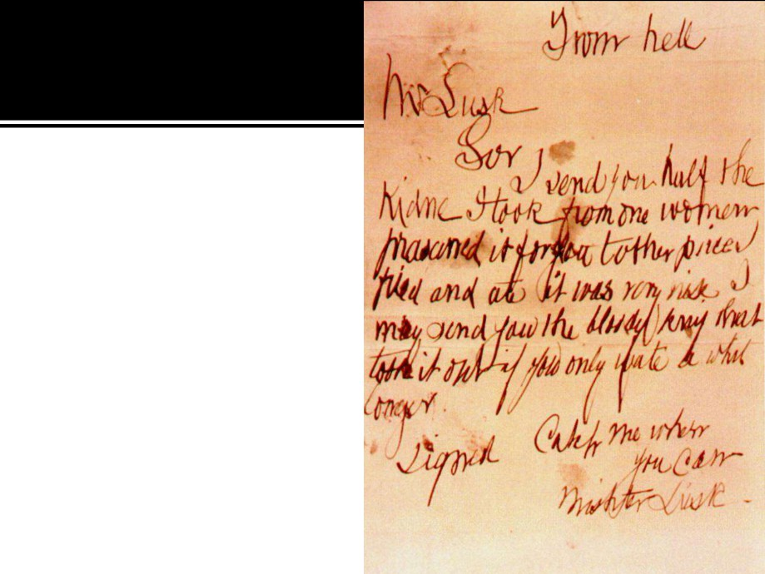

○ One week later a letter arrived

addressed to Mr. George Lusk.

He was chairman of the White

Chapel Vigilance Committee, a   
group of local men who   
patrolled the streets trying to   
catch The Ripper. The letter was

headed "From Hell" and came

with half a human kidney. It said   
"Mr. Lusk Sir, I sent you half a   
kidney I took from one woman. I   
preserved it for you, the other   
piece I fried and ate. It was very

nice. I may send you the knife

that took it out if you only wait a   
while longer." It was signed   
"Catch me when you can Mr.   
Lusk".



○ Laura turned to Forensic Linguist Dr. Francis Rock   
for help. Dr. Rock thinks that this letter was

written by somebody with less than a full

education. That puts him in the lower classes.   
○ For Laura, the letter offers two other clues.

▪ The author resorts to cannibalism and the fact that   
George Lusk was its recipient.

▪ Jack The Ripper didn't seek to have a national or global   
impact, his attention was focused on White Chapel. All   
the evidence says that The Ripper was a local man.

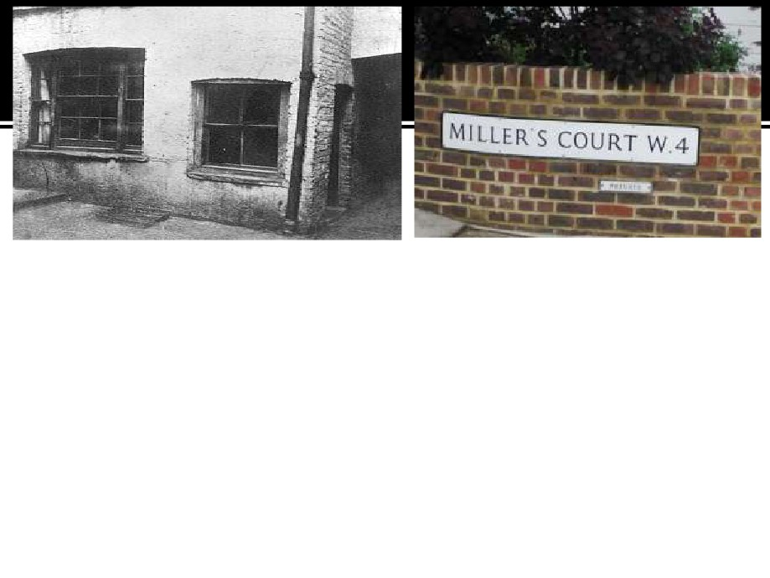

○ On the morning of the 9th of November, 1888, Thomas Boyer

went to Miller's court in White Chapel to collect rent from one of

his tenants.

○ When he received no answer at the door, he peered through the   
 window. He later told the press that what he had seen was the   
 work of the Devil.

○ The door to Mary Kelly's lodging was locked. When the door was   
 broken down, pieces of her lay around the room.

▪ She was younger than the rest of his victims, around 25.

▪ She was said to be pretty although no photograph of her in life exists.   
▪ She too was a prostitute, but she was the only victim who had a   
permanent address and the only one to be killed inside.

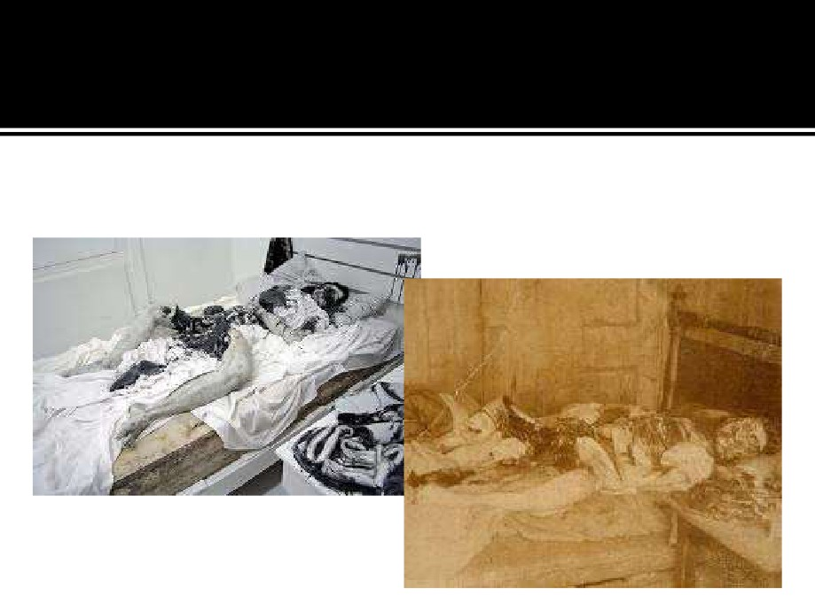

○ Mary Kelly

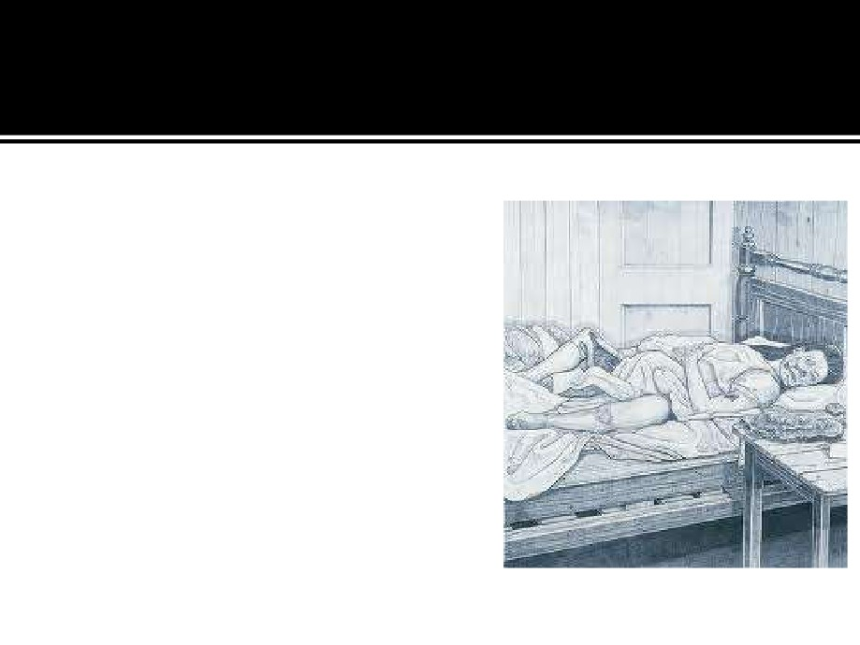

○ What The Ripper did to her was   
possibly the most extreme

violence that one human can   
inflict on another. Her face was   
gash filled, her nose, cheeks,   
eyebrows and ears had been

partially removed. Both breasts

had been removed by circular

incisions, more or less. The heart   
was absent. He may have spent

hours with the body. Most Ripper

experts say that this was the last   
murder, after Mary Kelly and for   
reasons that have never been   
explained, Jack stopped his killing

spree.

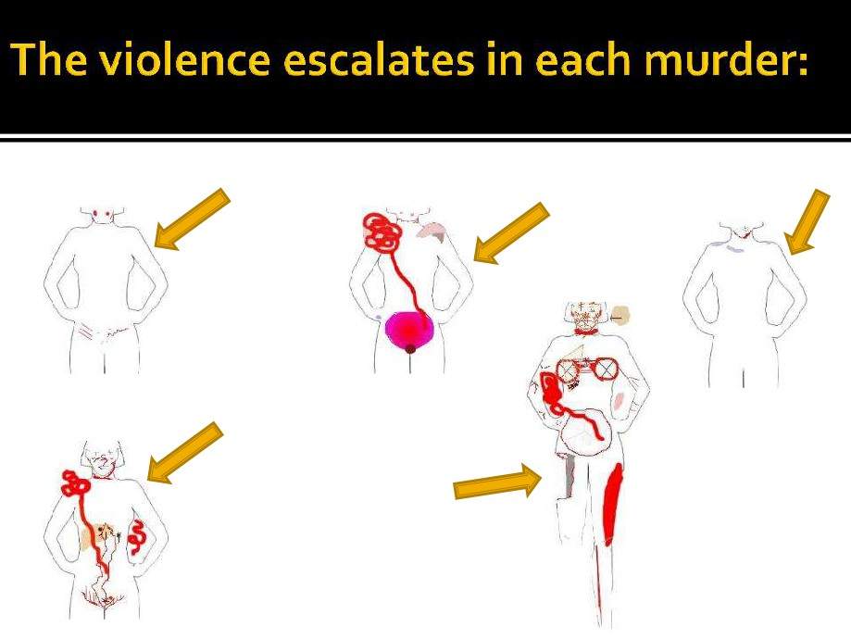

○ Polly Nichols Annie Chapman Liz Stride

○ Catherine Eddowes

Mary Kelly

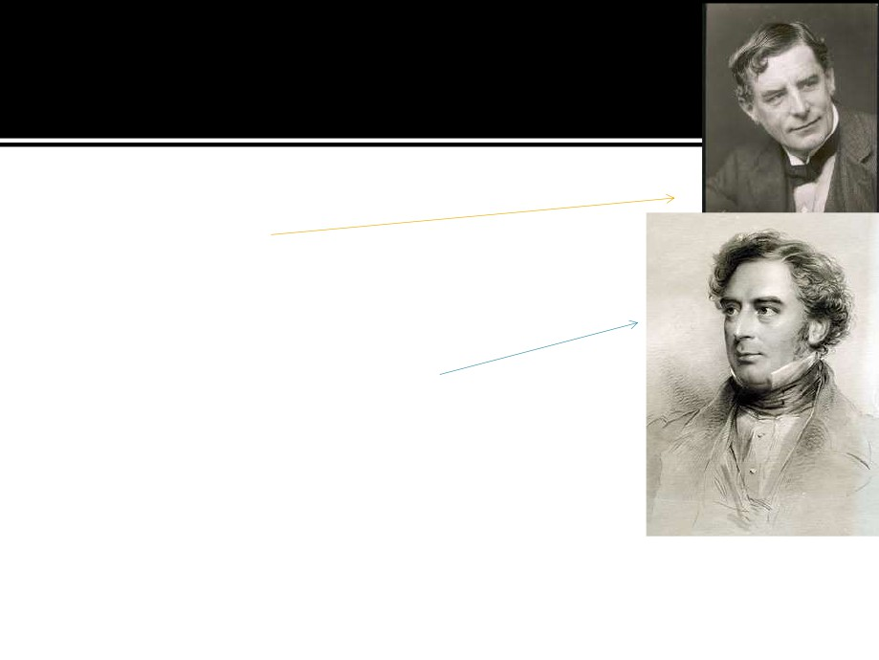

○ Some notable suspects that later   
investigations led to included

Walter Sickert, an Impressionist   
painter who released paintings of

murdered prostitutes 20 years

later, Robert Stephenson, the

army surgeon/occultist/magician   
and another man by the name of   
Thomas Cutbush. But to this day,   
the identity of Jack remains a   
mystery.



○ Finally after studying all five of the murders all the elements   
came together for Laura. With all the information including

the DNA test, the geoprofiling, the computer generated   
image of The Ripper's face, how close can she come to   
unmasking him?

▪ However, the tests on the shawl of Kathryn Eddowes revealed no   
useful DNA. 121 years after the murders all the physical evidence   
is gone or been contaminated making it worthless.

○ Yet there is still plenty of evidence left behind that doesn't   
decay. 13 different people gave descriptions of men seen

with the victims at or near the crime scenes shortly before   
the murders. Many of them are similar enough that they   
could well be talking about the same man

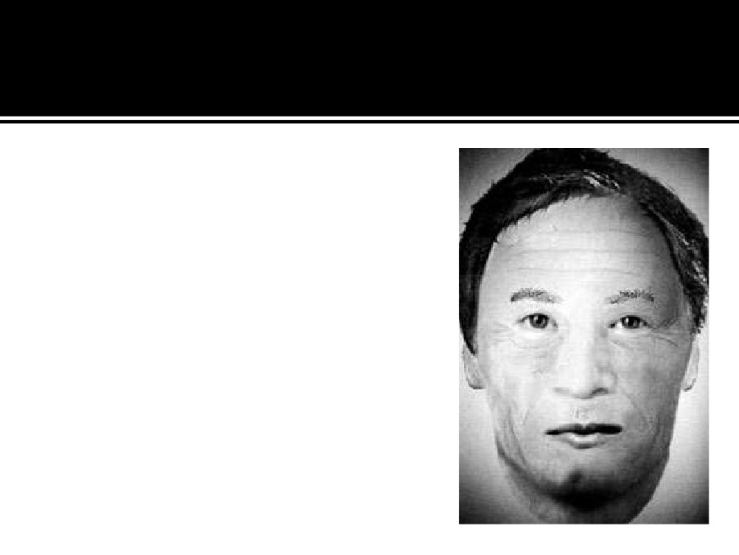

○ Working with the statements and   
police reports, a criminal artist

developed an image of what The   
Ripper might have looked like.

▪ 25 to 30 years of age, and   
▪ 5'5"to 5'7".

▪ The Ripper was socially skilled, which   
makes him efficient at targeting   
women.

▪ Beneath the surface, however, was a   
complete lack of normal emotion.

▪ The geographical profiler thought he   
could identify the street where The   
Ripper lived. The most likely were

Flower and Dean Streets.

