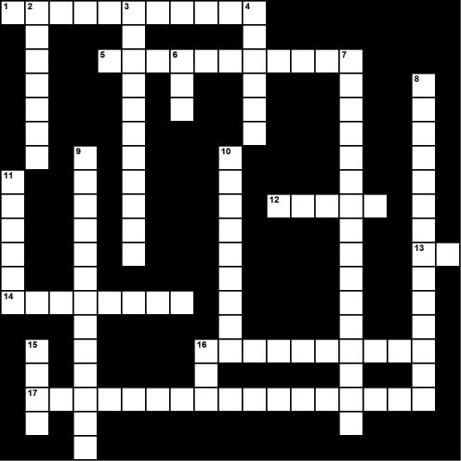

Introduction to Blood Name: ____________________________________________

Across

1. He discovered the ABO blood type system.

5. A relatively large type of blood cell that

transports oxygen from the lungs to all of the   
living tissues of the body and carries away   
carbon dioxide. It is also called a red cell.

12. An essential fluid in our bodies that

transports oxygen and nutrients to our cells and   
gets rid of carbon dioxide and other waste   
products. It is a highly specialized tissue   
composed of many different kinds of   
components produced in bone marrow.

13. The names given to the two main antigens   
responsible for ABO blood types. These   
antigens provide the signature for blood types.

14. A kind of protein produced by the body to

identify and neutralize or destroy alien antigens by binding to them. These proteins are involved in the rejection of mismatched blood   
transfusions and organ transplants.

16. The gas transporting protein molecule that   
normally makes up 95% of the volume of red   
cells in blood. The color of blood is primarily due   
to these molecules when they are chemically   
bound to oxygen.

17. The term for people who can receive blood   
transfusions from anyone, regardless of the   
donor’s ABO type. The blood of these fortunate

people does not contain antibodies to reject the A and B antigens because the surface of their red blood cells have both of these antigens.

Down

2. A kind of relatively large molecule found on the surface of red blood cells. These molecules provide the specific

signature or identity to blood—i.e., the blood type. When alien forms of these molecules are introduced into the body via a   
transfusion of the wrong type of blood, they stimulate the production or mobilization of other molecules to get rid of the   
alien blood.

3. A type of blood cell that coagulates and clots blood when there is an injury to a blood vessel. It is also called a platelet.

4. A serum containing anti-Rh+ antibodies given to women at high risk for having a baby with a life- threatening blood type incompatibility problem.

6. The number of principle Rh blood types.

7. A blood disease of fetuses and newborn infants caused by a mother- fetus Rh blood type incompatibility.

8. The term for people who can donate blood to anyone without the recipients’ blood rejecting it because of ABO type incompatibility. These people have type O blood. Their blood is not rejected by other types of blood because it does not normally have A and B antigens that could potentially mark it as being alien.

9. The clumping together of red cells in blood as a result of antibodies attaching to antigens on the surface of the cells. This occurs when blood of different types is mixed together.

10. A kind of blood cell that exists in variable numbers and types but makes up a very small part of human blood volume. Some of these cells provide a physiological defense against infection. As a result, their numbers increase when the body is under attack by bacteria and viruses. It is also called a white cell.

11. The relatively clear liquid medium in blood which carries the red cells, white cells, and platelets. Most of blood's volume is made up of this liquid.

15. The number of ABO blood types.

16. The name of the system of over 100 antigens on the surface of human body tissue cells that can be recognized by some kinds of white blood cells and potentially lead to the rejection of these tissues if they are alien.