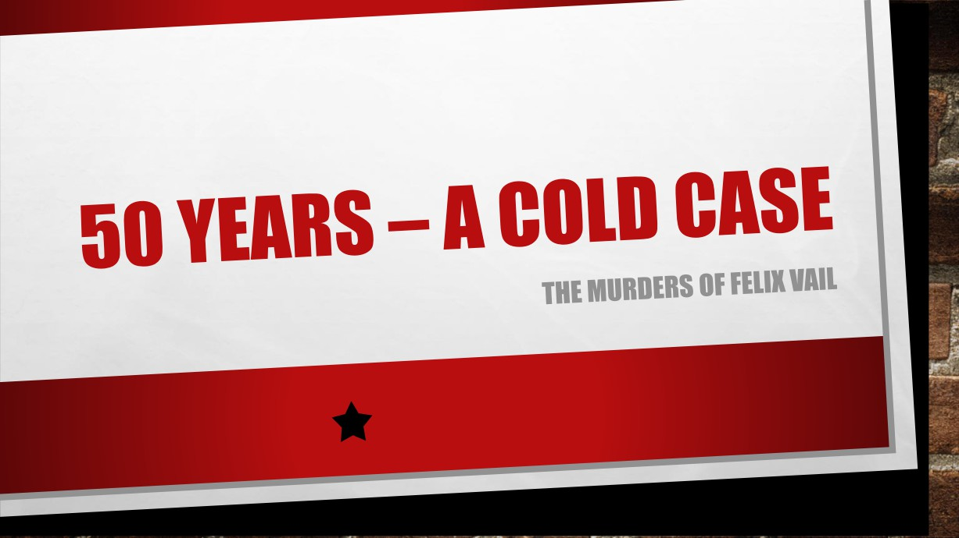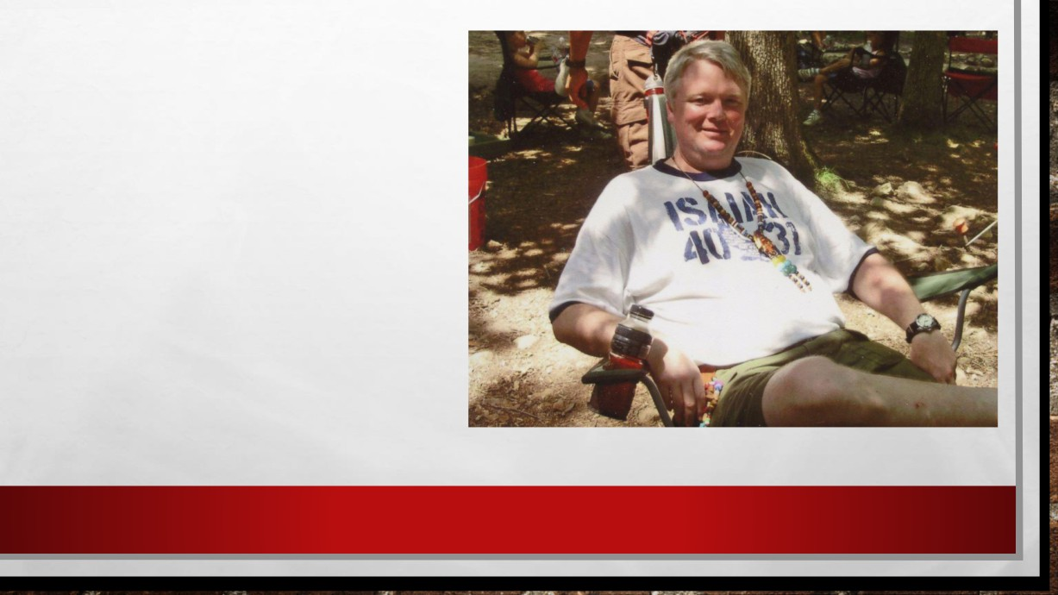

THIS IS BILLY VAIL

• BILLY TOLD AN IMPORTANT   
STORY FROM EARLY IN HIS   
LIFE ON A CHURCH PODCAST SHORTLY BEFORE HE DIED OF CANCER IN 2009.

• HE SAID IT WAS BECAUSE HE   
"WANTED THE TRUTH TO   
COME OUT FOR THE VICTIMS."

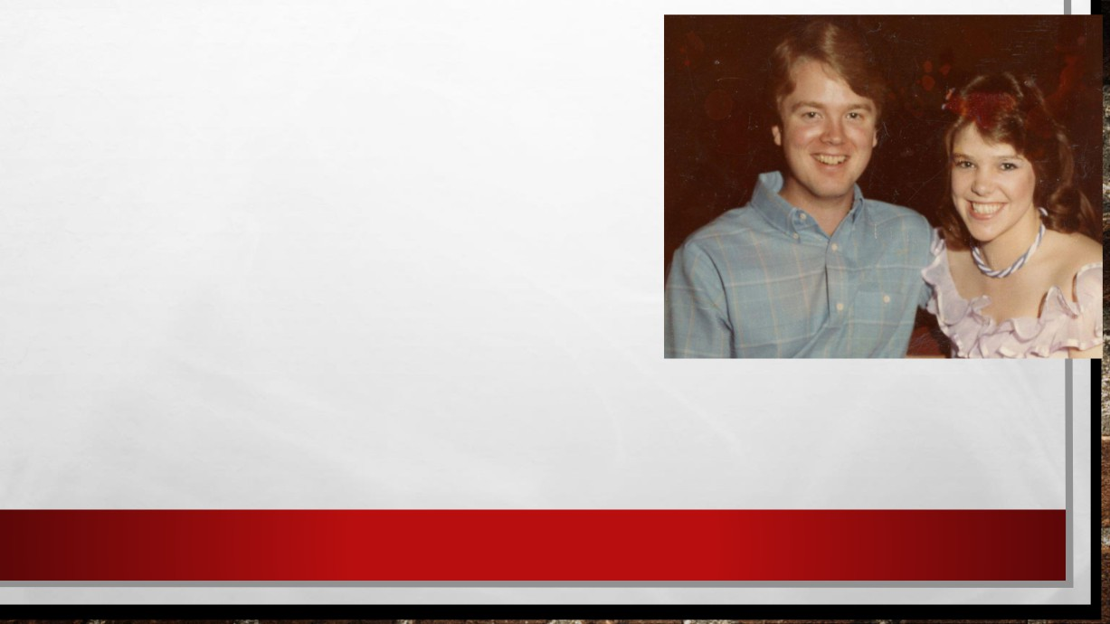

• ACCORDING TO BILLY: “[MY DAD] DIDN'T

EVEN KNOW I WAS IN THE HOUSE. I OVERHEARD

HIM JUST SOBBING, WHICH CAUGHT MY

ATTENTION, AND HE TOLD HER THAT ‘HE’

MURDERED MY MOTHER.” HE SAID, “THAT'S

WHEN I FOUND OUT THE TRUTH OF MY

MOTHER'S DEATH."

• FELIX AND MARY HORTON VAIL'S SON BILLY VAIL: SEEN HERE WITH HIS   
WIFE JANET VAIL.



• ACCORDING TO THOSE WHO KNEW   
HER, NO ONE CAN FORGET HOW   
BEAUTIFUL MARY HORTON VAIL WAS.

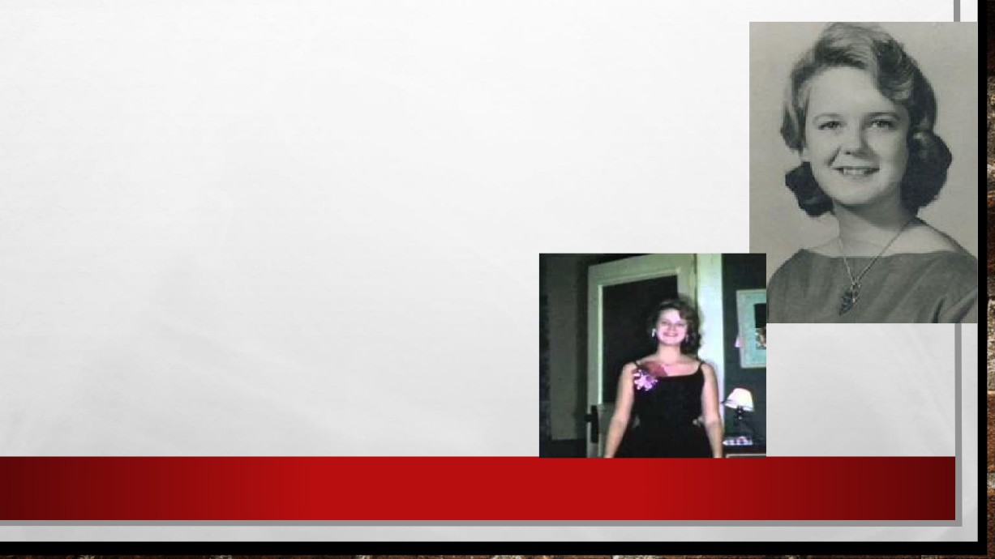

• SHE WAS ONE OF THOSE PEOPLE

WHO MADE EVERYBODY FEEL GOOD   
WHEN SHE WALKED INTO THE ROOM.

• SHE WAS A BEAUTY, NOT ONLY PRETTY ON THE OUTSIDE, BUT PRETTY ON THE INSIDE. PEOPLE WERE DRAWN TO HER.

• SHE WENT TO COLLEGE AT MCNEESE STATE UNIVERSITY, WHERE SHE WAS A MEMBER OF A SORORITY.

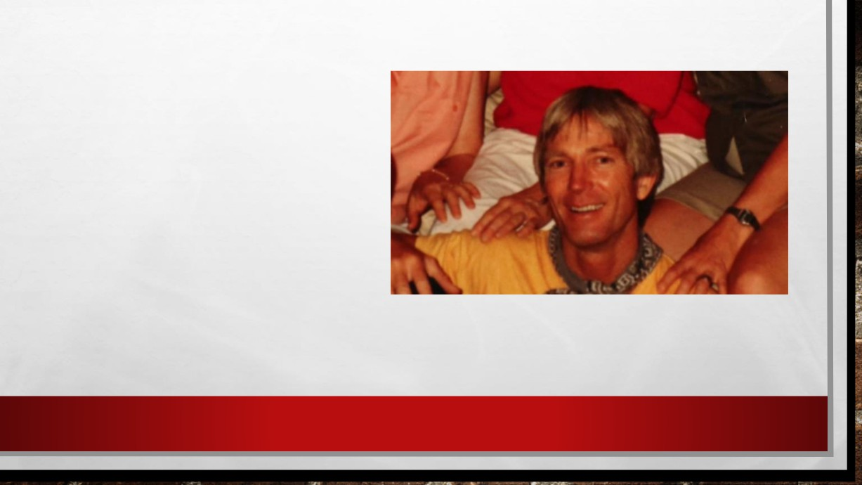

• THOUGH MANY MEN ON CAMPUS   
WERE ATTRACTED TO HORTON,

SHE ONLY HAD EYES FOR FELIX

VAIL, A CHEMICAL PLANT WORKER.   
SHE FELL IN LOVE FROM THE GET-

GO.

• BUT MARY'S FRIENDS SAID THEY   
DIDN'T LIKE FELIX VAIL, AND THEY   
CAN'T REMEMBER WHY. FELIX WAS

THE BAD BOY. • FELIX VAIL

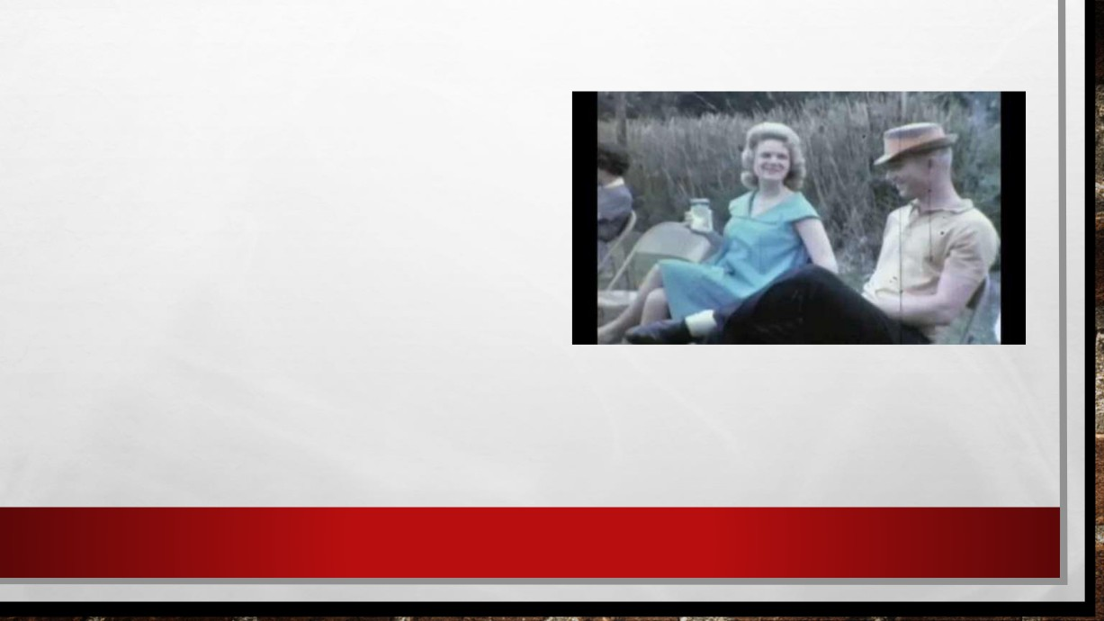

• MARY AND FELIX MARRIED IN 1961 AND STARTED THEIR LIFE TOGETHER IN LAKE CHARLES, LOUISIANA.

• THE MARRIAGE STARTED OUT HAPPILY.

• AFTER ONE YEAR OF MARRIAGE, THEY   
HAD A BABY BOY NAMED BILLY AND

MARY EVENTUALLY REVEALED THAT

THERE WAS ANOTHER BABY ON THE WAY.

• MARY AND FELIX VAIL.



• ON OCT. 28, 1962, FELIX SAYS HE TOOK HIS WIFE OUT FISHING IN THE RIVER, AND THE TWO STAYED OUT PAST DARK.

• IN A FREAK ACCIDENT, VAIL SAID MARY SPOTTED A

STUMP IN THE WATER. HE CLAIMS THAT HE SWERVED   
TO MISS IT AND THE JOLT THREW HIS WIFE INTO THE   
RIVER.

• VAIL SAID HE DOVE INTO THE WATER TO TRY TO SAVE

HER BUT COULDN'T.

• FELIX VAIL SAID HIS WIFE MARY HORTON   
 VAIL FELL INTO THE CALCASIEU RIVER,

PICTURED HERE.

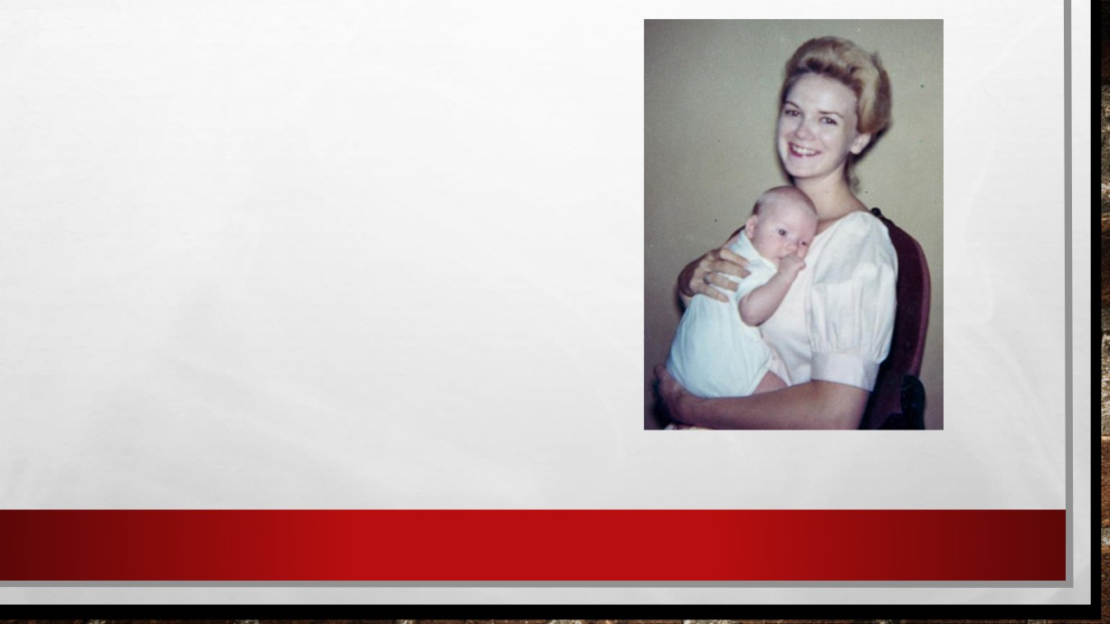

• TWO DAYS AFTER SHE DISAPPEARED, MARY'S BODY WAS DISCOVERED. THE CORONER AT THE TIME RULED THE DEATH AN ACCIDENT, BUT DEPUTIES AT THE TIME DOUBTED VAIL'S STORY.

• DEPUTIES POINT OUT THAT FELIX HAD WASTED

CRITICAL TIME TO GO SEVERAL MILES DOWNRIVER

BEFORE FINDING HELP. THERE WERE ALSO TWO LIFE   
INSURANCE POLICIES WORTH HALF A MILLION   
DOLLARS IN TODAY'S MONEY. ONE OF THEM WAS

TAKEN OUT AND PAID IN FULL JUST MONTHS BEFORE

HER DEATH.

• MARY HORTON VAIL, PICTURED HERE   
 WITH THEIR SON BILLY.

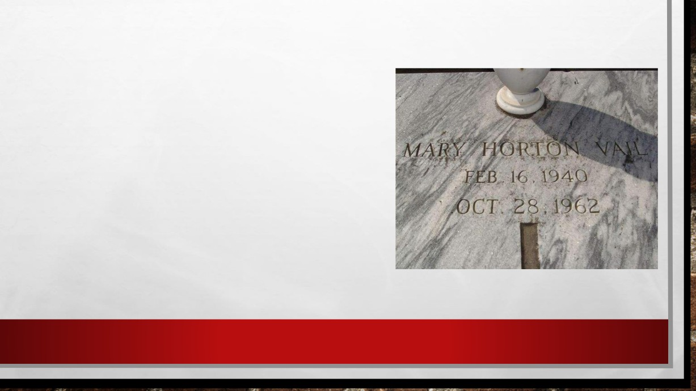

• LATER, JERRY MITCHELL, AN INVESTIGATIVE REPORTER FOUND THAT MOST OF THE POLICE RECORDS HAVE   
VANISHED.

• HOWEVER, THE MOST IMPORTANT EVIDENCE IN THE CASE- TWO GRUESOME PHOTOS OF MARY'S BODY -  
CAME FROM A CIVILIAN WHO WAS ON ONE OF THE BOATS THAT FOUND HER BODY.

• THE PHOTOGRAPHS RAISE SEVERAL QUESTION:

• MARY'S BODY WAS ODDLY POSITIONED, AND OIL STAINS ON HER CLOTHES DON'T SEEM TO FIT WITH A   
DROWNING.

• THERE WAS A BRUISE AT THE BACK OF MARY'S HEAD.



• MOST IMPORTANTLY, THE PHOTOS REVEAL SOMETHING QUITE DRAMATIC THAT, TO INVESTIGATORS TODAY, MAKE MARY'S "ACCIDENTAL" DEATH LOOK MORE LIKE

A MURDER.

• SHE HAS A SCARF PUSHED 4 INCHES INTO HER MOUTH.

• THIS SUPPORTS THE THEORY OF THE DEPUTIES AT THE TIME THAT FELIX VAIL MAY HAVE HIT HIS WIFE WITH AN OAR (ADDITIONAL EVIDENCE - BRUISE ON BACK OF THE HEAD).

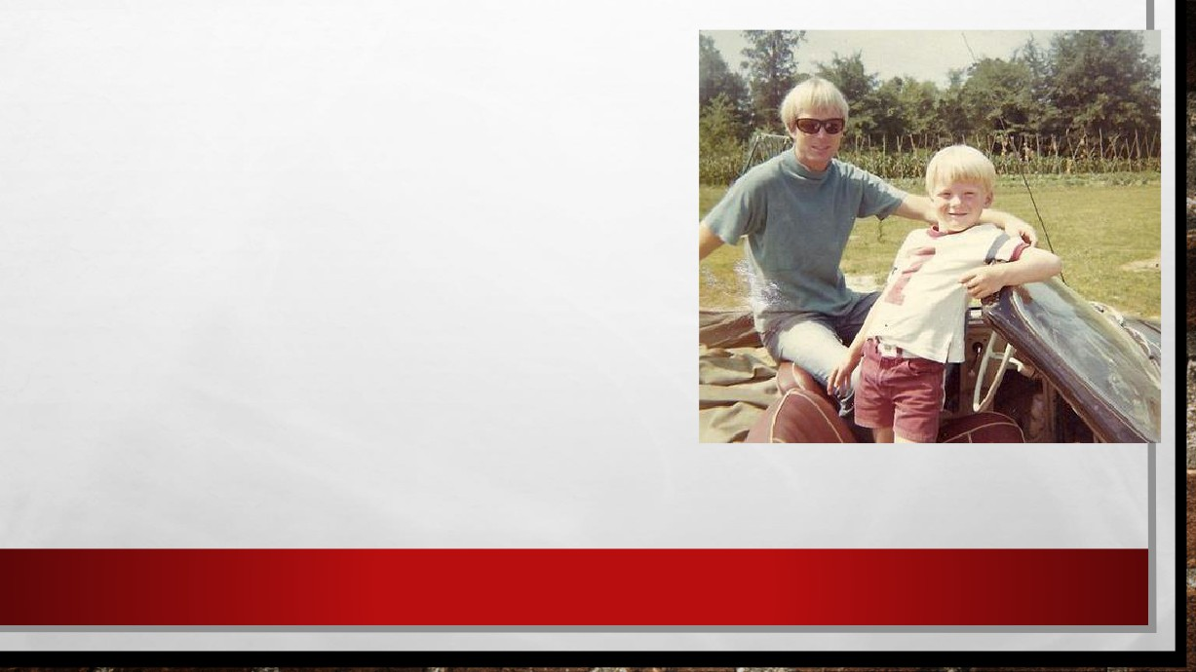

• FRIENDS AND FAMILY SAY VAIL SEEMED TO   
HANDLE MARY'S DEATH REMARKABLY WELL.

• EVEN AFTER HE COLLECTED INSURANCE MONEY, VAIL DIDN'T PAY THE FUNERAL HOME FOR THEIR   
SERVICE.

• MANY OF MARY’S FAMILY MEMBERS SUSPECTED   
FELIX OF CAUSING HER DEATH.

• VAIL WAS ARRESTED AND HELD FOR THREE DAYS.   
THE PROSECUTOR BROUGHT THE CASE TO A

GRAND JURY, BUT THEN DROPPED IT, AND VAIL MOVED ON WITH HIS LIFE.

• FELIX VAIL AND HIS SON BILLY.

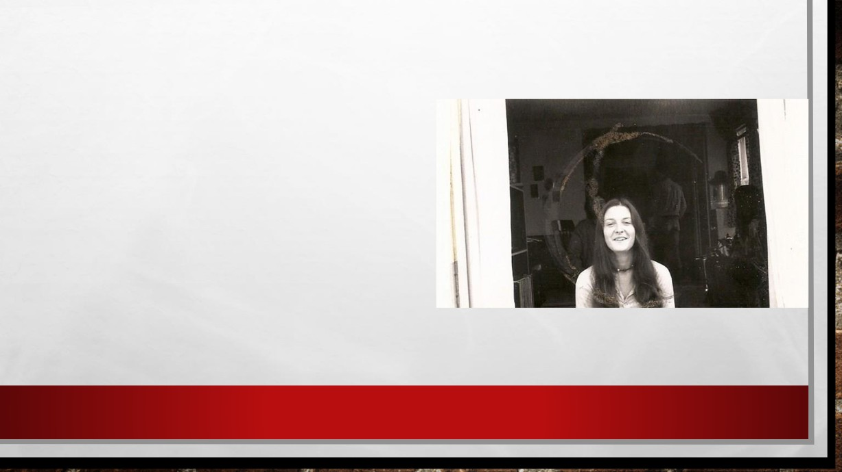

A NEW GIRL

• IN THE LATE 1960S, FELIX MET SHARON   
HENSLEY IN SAN FRANCISCO AT A POT

PARTY.

• NEITHER HAD JOBS, AND THE TWO

BROUGHT VAIL'S 8-YEAR-OLD SON BILL

WITH THEM AS THEY HITCHHIKED THE

CALIFORNIA COAST, STEALING FROM

ORCHARDS TO EAT AND DROPPING ACID.

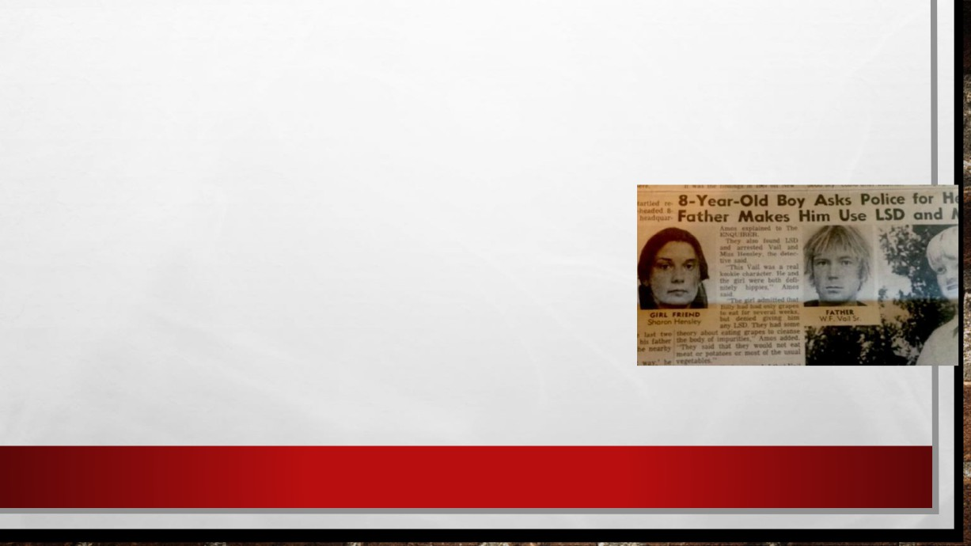

• AT THE TIME, BILL WAS NOT IN SCHOOL, RAN BAREFOOT, AND HIS ONLY POSSESSIONS WERE SHORTS AND A

SLEEPING BAG.

• ONE DAY BILLY MARCHES INTO THE POLICE DEPARTMENT   
AND TELLS THE POLICE, “MY DAD KEEPS GIVING ME DRUGS

AND I DON'T WANT DRUGS."

• BILLY ALSO TOLD POLICE THAT HIS FATHER CONFESSED   
TO SHARON THAT HE KILLED BILL'S MOM MARY HORTON

VAIL.

• TWO SHERIFF'S DEPUTIES FROM CALCASIEU PARISH,   
LOUISIANA, FLEW TO CALIFORNIA, BUT VAIL WOULDN'T

SPEAK AND NO MURDER CHARGES WERE FILED.

BROTHER, SAW THE STORY OF A YOUNG BILL GOING TO THE

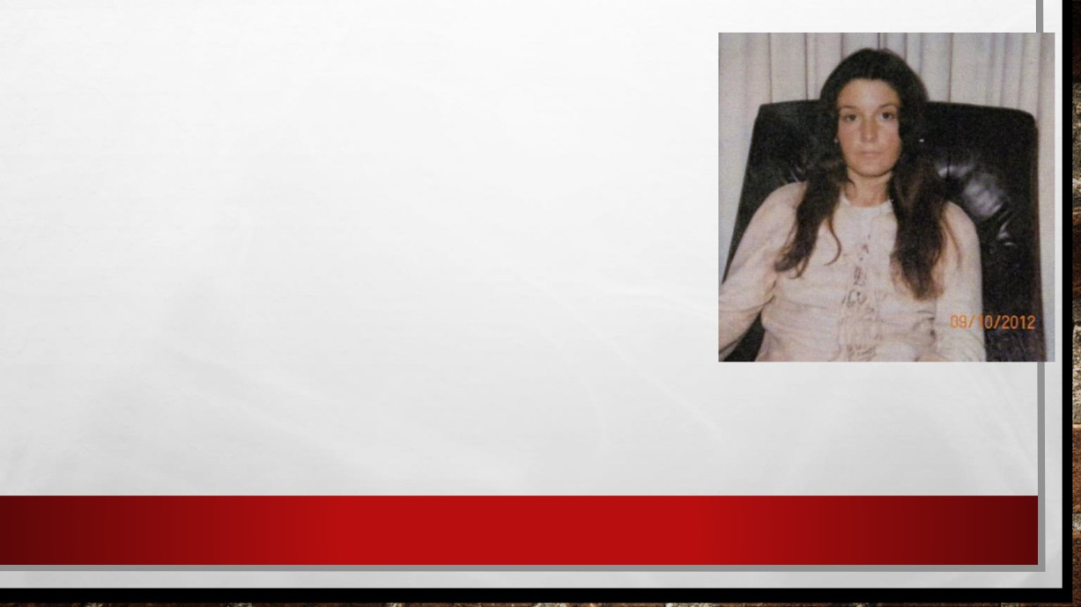

POLICE DEPARTMENT IN A NEWSPAPER AT A SUPERMARKET. HIS

SISTER HAD WASTED AWAY FROM BAD NUTRITION AND DRUGS. VAIL WAS IN TOTAL CONTROL OF HIS SISTER'S LIFE.

• SHE WAS WITH HIM OUT OF FEAR. SHE DIDN'T KNOW HOW TO GET   
 OUT OF THE SITUATION.

• SHARON HENSLEY CALLED HER PARENTS TO TELL THEM THAT   
 THEY WERE HITTING THE ROAD, POSSIBLY TO SOUTH AMERICA.

• THEY NEVER HEARD FROM SHARON HENSLEY AGAIN.

• ABOUT A YEAR LATER, FELIX WROTE A LETTER TO THE HENSLEY

FAMILY BASICALLY SAYING HE HADN'T SEEN SHARON FOR ABOUT A YEAR.

• THERE WAS NO INVESTIGATION, BUT WHEN VAIL RETURNED HOME   
 ALONE, BILL SAID HIS DAD TOLD HIM ANOTHER CHILLING STORY

ABOUT SHARON HENSLEY.

• "HE SAID SHE WOULD NEVER BOTHER ANYONE EVER AGAIN. I KNEW   
 WHAT THAT MEANT. I KNEW HE HAD MURDERED HER," BILL SAID ON

THE PODCAST.

• SHARON HENSLEY.



WIFE 2 - ANNETTE VAIL

• FELIX MET HIS SECOND WIFE, ANNETTE VAIL, IN 1982   
WHEN SHE WAS JUST 15 YEARS OLD, AND HE WAS 44.

• THE TWO FIRST SAW ONE ANOTHER IN TEXAS WHEN VAIL WAS DRIVING HIS MOTORCYCLE THROUGH HER NEIGHBORHOOD WHILE SHE WAS HAVING A YARD

SALE.

• THEN WHILE ANNETTE WAS AWAY AT AN OUT-OF-

TOWN SPECIAL MUSIC SCHOOL, ROSE LEARNED THAT • ANNETTE VAIL.

HER DAUGHTER AND VAIL WERE SECRETLY DATING.

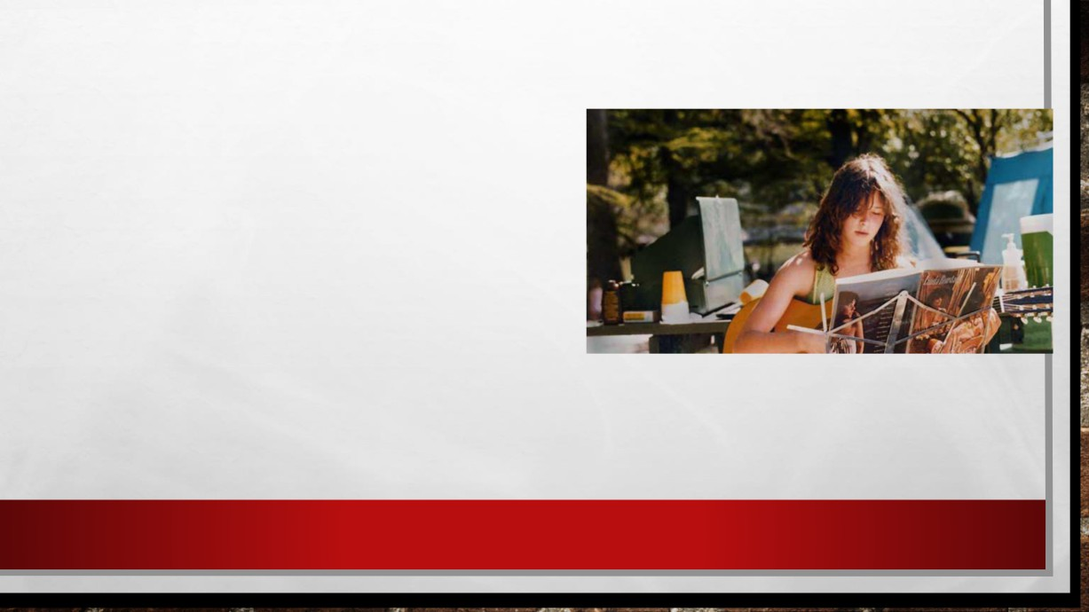

• THE COUPLE MARRIED IN 1983. SINCE

ANNETTE WAS ONLY 17, SHE HAD TO HAVE

HER MOTHER'S PERMISSION TO MARRY HIM.

• "WHAT I DID THEN BY LETTING HER GO OFF   
WITH FELIX IS NOT SOMETHING I'M PROUD

OF. YEAH, AND I TRUSTED HER. AND I

REALLY THOUGHT SHE WAS IN LOVE WITH

HIM AND I DIDN'T KNOW HE WAS A BAD GUY,"

ROSE SAID. "I'VE STRUGGLED WITH IT

TREMENDOUSLY."

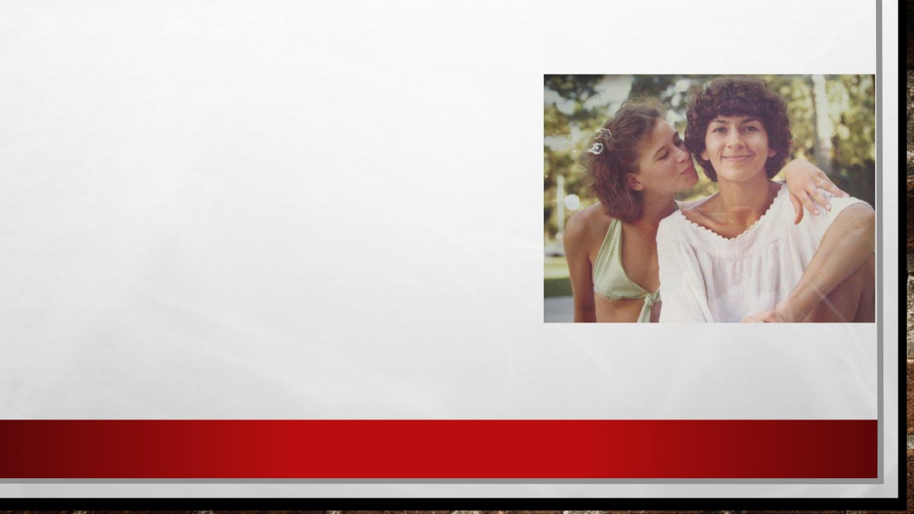

• AFTER ANNETTE GRADUATED, THE COUPLE TOOK OFF OF A CROSS-COUNTRY MOTORCYCLE   
ADVENTURE. THE TRIP LASTED SEVERAL MONTHS, AND ANNETTE RETURNED WITHOUT VAIL. SHE   
TOLD HER MOTHER THAT SHE HAD A PAINFUL   
ABORTION AND WANTED A DIVORCE AND TO MOVE BACK IN WITH HER.

• "IT WAS NOT AT ALL LIKE HER TO THAT EASILY GET

RID OF A BABY," ROSE SAID. • ANNETTE AND HER MOTHER ROSE.

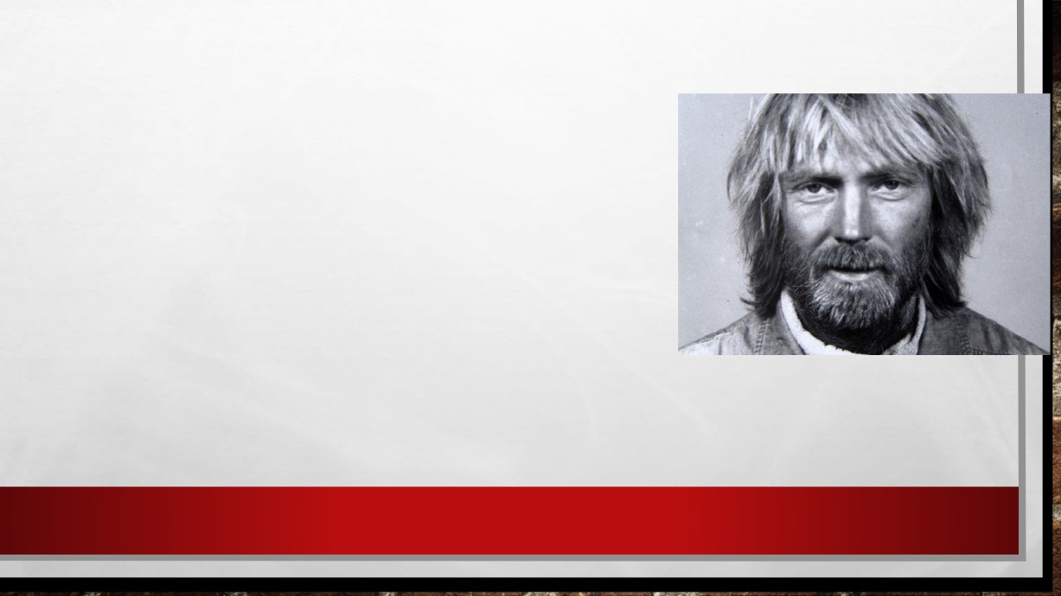

• ANNETTE ISOLATED HERSELF IN A ROOM AT HER   
MOTHER'S HOME, CALLING IT "SILENT THERAPY".

• ROSE BROUGHT HER FOOD AND WATER, BUT ANNETTE   
SPOKE TO NO ONE, INCLUDING VAIL, WHO REPEATEDLY

CALLED ON THE PHONE.

• WHEN ANNETTE TOLD HER MOTHER THAT SHE WAS   
GOING TO EMERGE FROM THE ROOM SOON, VAIL

SOMEHOW HEARD ABOUT IT AND SHOWED UP AT THE

HOME.

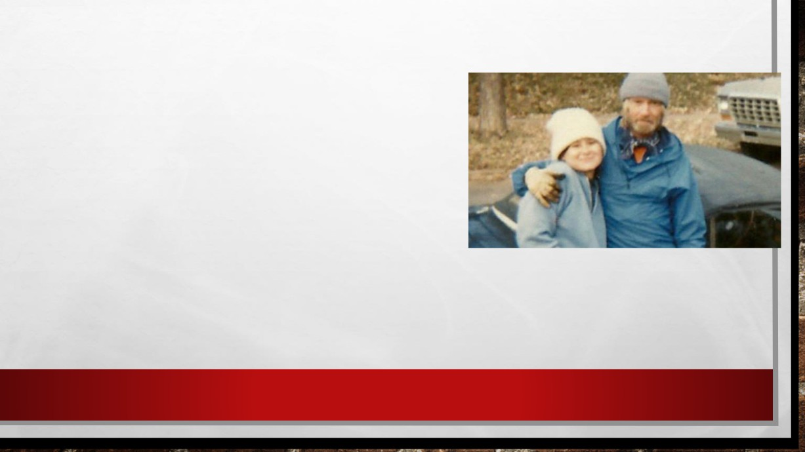

• HE CONVINCED THE YOUNG WOMAN TO LET HIM   
BACK IN HER LIFE AND TO PUSH HER MOM OUT.

• ROSE SAID HER DAUGHTER AND VAIL ALL BUT   
DEMANDED THAT SHE VACATE THE PROPERTY.

THE HOUSE AND PROPERTY WERE BOTH

BOUGHT WITH LIFE INSURANCE MONEY LEFT TO

ANNETTE WHEN HER FATHER DIED.

• SUDDENLY, ANNETTE ACTUALLY DEEDED THE   
 HOUSE OVER COMPLETELY TO FELIX.

• ANNETTE AND FELIX.

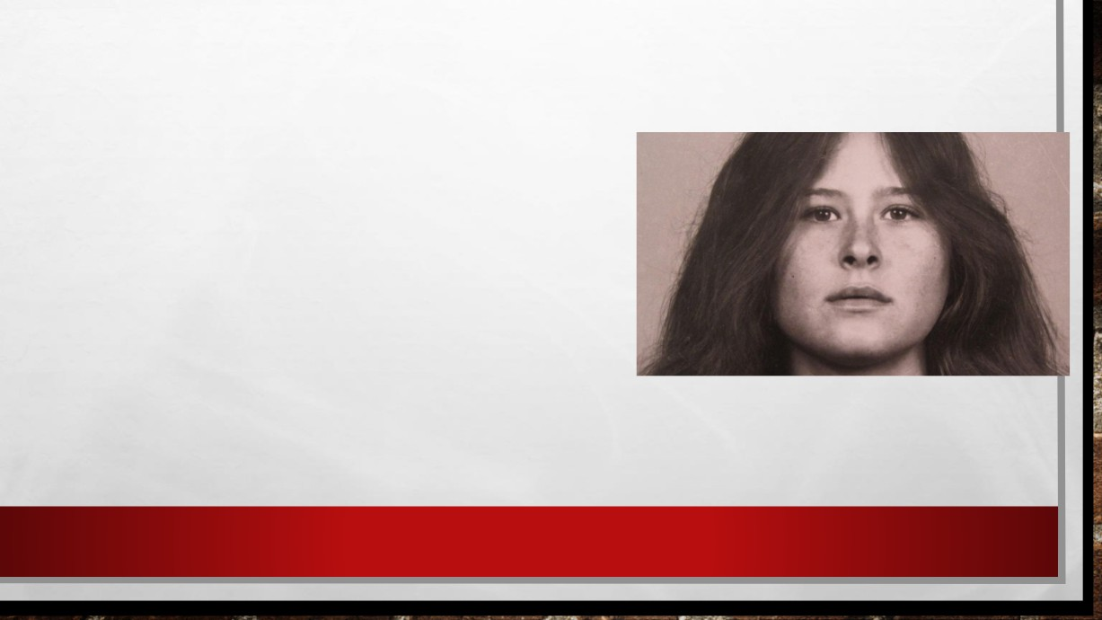

• VAIL THEN HAD HIS WIFE BACK, HER HOUSE AND   
$98,000 SHE HAD LEFT FROM HER FATHER’S LIFE

INSURANCE PAYOUT. THE TWO THEN LEFT FOR

ANOTHER TRIP THROUGH THE MIDWEST. BUT THIS TIME, ANNETTE DIDN'T COME BACK.

• HIS STORY IS THAT THEY WERE IN ST. LOUIS   
CAMPING AND SHE DECIDED TO GO BACK TO   
MEXICO AND LEAVE HIM IN ORDER TO RETURN   
TO A MUCH YOUNGER EX-LOVER. SO, HE PUT

HER ON A TRAILWAYS BUS, AND SAID THAT IS

THE LAST HE SAW OF HER.

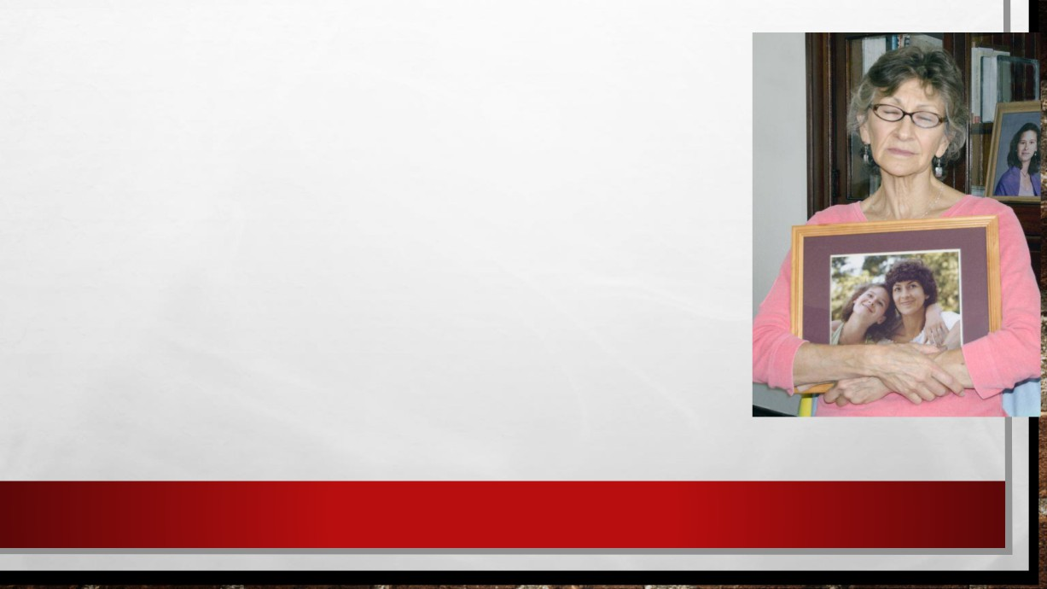

• FOR MORE THAN 20 YEARS, WENT TO PROSECUTORS, POLICE,

PRIVATE INVESTIGATORS AND EVEN PSYCHICS TO TRY TO TURN HER SUSPICIONS INTO A CASE AGAINST VAIL. SHE NEVER GAVE UP HOPE.

• IT WASN'T UNTIL 2010 WHEN ROSE MET CLARION LEDGER

REPORTER JERRY MITCHELL THAT SHE FOUND SOMEONE TO HELP HER.

• ROSE DECIDED TO GO TO MISSISSIPPI AND CONFRONT FELIX.

• AT VAIL'S TRAILER IN MISSISSIPPI, ROSE, THEN 64, CLIMBED IN   
THROUGH A BROKEN WINDOW TO LOOK FOR EVIDENCE. INSIDE,

SHE SAID SHE FOUND A NUMBER OF MACHETES. HARDLY

PROOF OF MURDER.

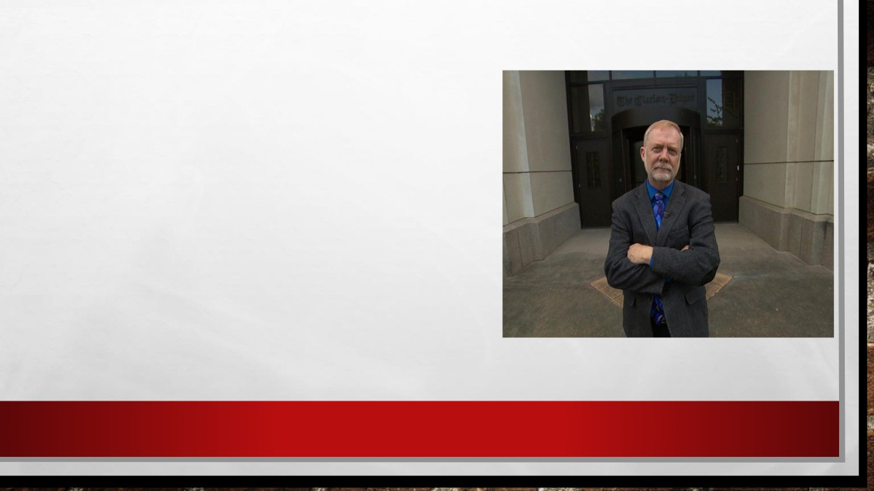

THE NEW INVESTIGATION

• FIFTY YEARS AFTER MARY VAIL'S DEATH, JERRY   
MITCHELL FOUND WESLEY TURNAGE IN 2012.

• TURNAGE TOLD HIM THAT VAIL CONFESSED THAT   
HE WAS A MURDERER.

• HE SAID, 'WELL, THAT DAMN WOMAN WANTED

ANOTHER BABY. SHE THOUGHT IT MIGHT HELP

SAVE OUR MARRIAGE. BUT SAID I DIDN'T WANT THE ONE I GOT, AND I SURE DIDN'T WANT ANOTHER

ONE. BUT I FIXED THAT DAMN B****. SHE WON'T

NEVER HAVE ANOTHER ONE.”

• JERRY MITCHELL.



• MITCHELL FOUND OTHER WITNESSES WHO SAY VAIL CONFIDED IN THEM AS WELL. ROBERT FREMONT, WAS FRIENDS WITH VAIL IN CALIFORNIA IN THE LATE 1960S.

• "HE TALKED ABOUT SOMETHING ABOUT A LAKE AND A BOAT AND ALL THIS STUFF AND   
 HE HAD KILLED HIS FIRST WIFE. I THOUGHT IT WAS MAYBE SOME KIND OF B.S. STORY.

THE SECOND TIME HE TOLD ME, IT WAS VERY GRAPHIC, AND IT REALLY TROUBLED ME.

IT SOUNDED LIKE HE WACKED HER ON THE HEAD AND THREW HER IN THE WATER."

• BUT NEITHER TURNAGE NOR FREMONT REPORTED THEIR CONVERSATIONS WITH VAIL TO POLICE AT THE TIME, AND VAIL WENT ON TO MARRY AGAIN.



GATHERING EVIDENCE

• GINA FRENZEL, A PRIVATE INVESTIGATOR WHO GOES BY THE NICKNAME "BATGIRL," OFFERED TO HELP JERRY   
MITCHELL WITH HIS STORY, AFTER READING MITCHELL'S BOOK, "GONE."

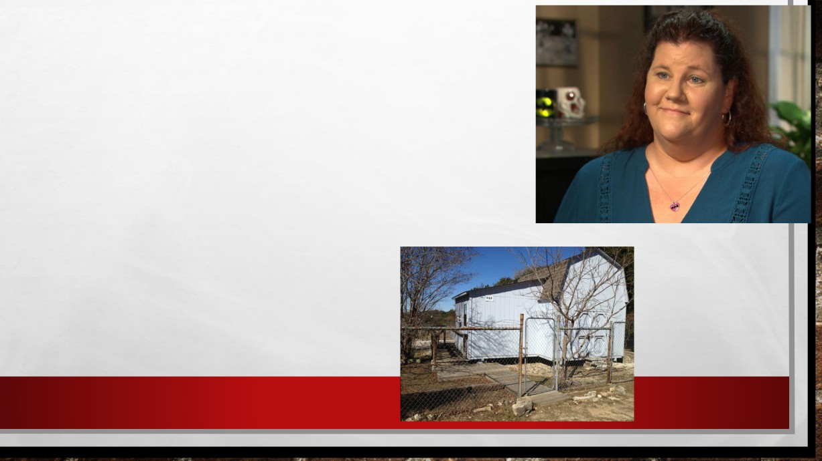

• WHEN SHE FOUND OUT VAIL LIVED JUST   
AN HOUR AND A HALF AWAY, SHE WENT   
TO SEE HIM. HE WAS LIVING IN A SHACK

WITH NO RUNNING WATER.

• THE YEAR BEFORE HE LIVED THERE,   
THERE HAD BEEN A SUSPICIOUS FIRE

NEXT DOOR.

• FRENZEL TOLD VAIL SHE WAS THERE TO   
 INVESTIGATE THE FIRE, AND HE

ALLOWED HER TO WALK AROUND.

• SHE TOOK PHOTOS AROUND THE

PROPERTY, INCLUDING A RARE IMAGE

OF VAIL IN HIS 70’S.

• GINA FRENZEL, "BATGIRL".

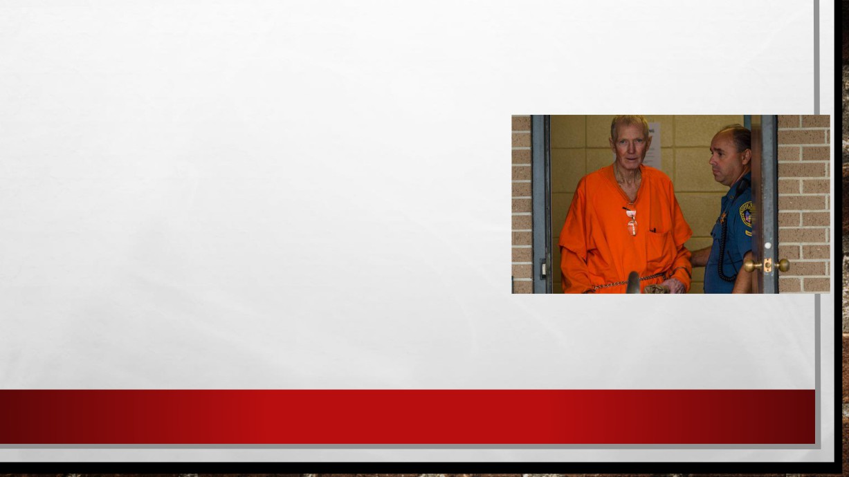

• FRENZEL RETURNED A WEEK LATER, TELLING VAIL SHE NEEDED TO TAKE MORE PHOTOGRAPHS. WHILE WITH VAIL, SHE HAD HER AUDIO RECORDER ROLLING AND HIDDEN IN HER BRA.

• THEY SPENT THE NEXT SIX HOURS SIPPING WINE AND   
TALKING ABOUT HIS PHILOSOPHY OF LIFE. THEIR   
CONVERSATION INCLUDED A MOMENT WHEN HE   
SEEMED TO ADMIT HE KNEW A LOT ABOUT MURDER.

• IN ANOTHER ALARMING MOMENT, FRENZEL SAID HE THOUGHT VAIL WAS VAGUELY SPEAKING ABOUT THE STILL MISSING ANNETTE.



• FRENZEL GOT TO KNOW HIM OVER THE COURSE OF FOUR SEPARATE VISITS.

LATER, VAIL ASKED HER TO DO SOME CHORES FOR HIM WHILE HE RAN ERRANDS. SHE USED THE OPPORTUNITY TO SNOOP AROUND HIS HOUSE AND FOUND A   
COLLECTION OF WOMEN'S EARRINGS.

• "HE'S PROBABLY GOT 13, 14 PAIRS OF EARRINGS THERE, AND KIND OF MAKES YOU   
 WONDER WHOSE WERE THEY AND WHY DOES HE KEEP 'EM?" FRENZEL SAID.

• SHE ALSO DISCOVERED A BIN FILLED WITH MORE THAN 20 JOURNALS. FRENZEL

METICULOUSLY PORED OVER THE 2,000 PHOTOGRAPHS SHE TOOK OF THE JOURNALS.

• THERE WERE NO CLUES, EXCEPT FOR WHAT HE WROTE ABOUT HOW HE MIGHT HANDLE CERTAIN SITUATIONS INCLUDING A MURDER.



LUCKY GIRLFRIEND

• HE ALSO WROTE ABOUT BETH FIELD, AN EX-GIRLFRIEND FROM THE LATE 1980’S.

• SHE AND VAIL GOT TOGETHER AFTER ANNETTE WENT MISSING.

• SHE WAS IMMEDIATELY ATTRACTED TO HIM. BUT ONE DAY HE BECAME VIOLENT.

• HE JUST TURNED AROUND AND STARTED HITTING HER. HE ACTUALLY BROKE HER EAR DRUM, GAVE HER A BLACK EYE AND BRUISES ON HER ARMS.

• SHE WAS ALSO WARNED BY HIS OWN FAMILY THAT THEY BELIEVED HE HAD KILLED HIS FIRST WIFE.

• FIELD SAYS AFTER A SECOND BEATING SHE ENDED THE RELATIONSHIP REALIZING THAT VAIL WAS A SICK MAN.

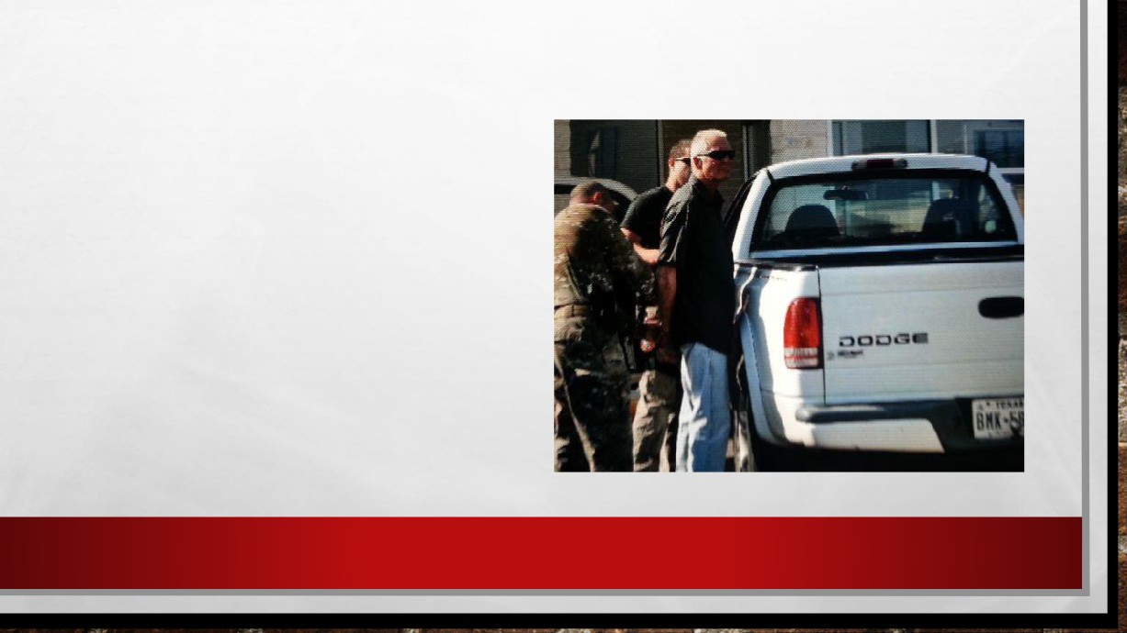

THE ARREST

• ON MAY 17, 2013, VAIL WAS ARRESTED BY POLICE, ACCUSED OF KILLING HIS WIFE MARY HORTON VAIL.

• TODAY, VAIL IS 76 YEARS OLD. HE IS

AWAITING TRIAL IN CALCASIEU PARISH JAIL ON CHARGES OF MURDER. AND   
THE DISAPPEARANCES OF HIS   
COMPANION SHARON HENSLEY AND HIS WIFE ANNETTE LOOM LARGE.

• THE THING THAT ALL THREE WOMEN HAVE IN COMMON IS THE FACT THEY WERE ALL LAST WITH FELIX VAIL.

• WITHOUT MITCHELL, THE CASE MAY NEVER HAVE REACHED WHERE IT IS TODAY.

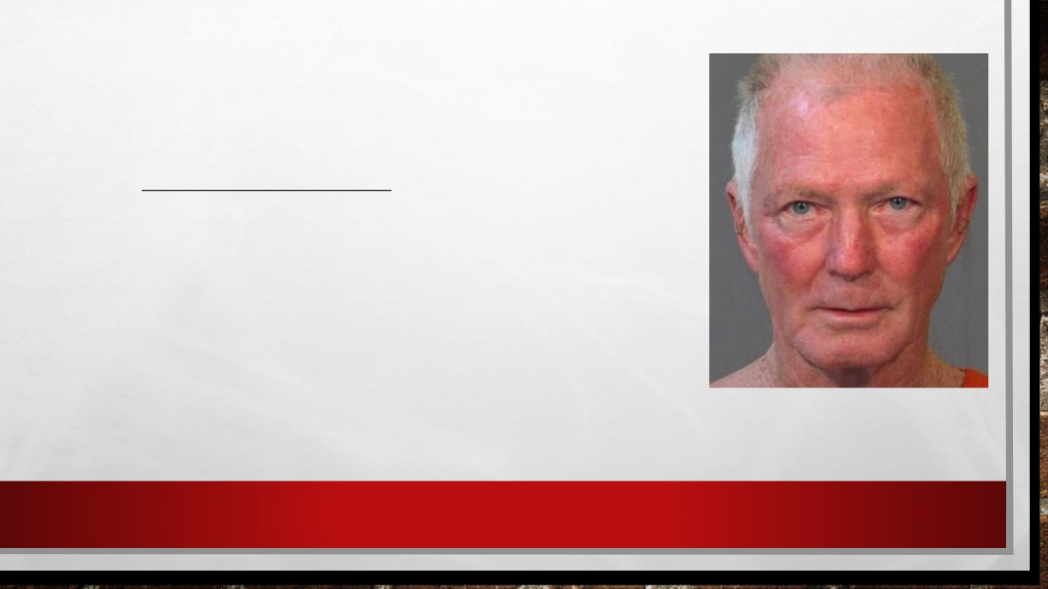

• THE TRIAL COURT WILL ALLOW THE DISAPPEARANCES OF THE TWO OTHER WOMEN AS EVIDENCE IN THIS TRIAL, WHICH IS HIGHLY UNUSUAL. IT IS BECAUSE OF WHAT WE CONSIDERED TO BE THE DOCTRINE OF CHANCES.

• IF SOMETHING EXTRAORDINARY HAPPENS ONE TIME, IT CAN   
HAVE HAPPENED TO ANYBODY. THE MORE IT HAPPENS TO A

SINGLE PERSON, THE LESS LIKELY IT IS THAT IT'S EITHER AN ACCIDENT OR CHANCE.

• VAIL PLEADED NOT GUILTY, AND BLAMES ALL OF THIS ON JERRY MITCHELL. HE FEELS THE TWO MISSING WOMEN COULD STILL JUST SHOW UP SOME DAY.

• "WHEN JUSTICE COMES, IT BRINGS JOY. THIS'LL BE 50-  
SOMETHING YEARS LATER AND THEY'RE EXPERIENCING JUSTICE FOR THE FIRST TIME," MITCHELL SAID. "THAT'S INCREDIBLE."



•THIS CASE WAS FINALLY SOLVED AFTER 50 YEARS…

THESE KILLERS HAVE YET TO BE FOUND:



[Alphabet murders](https://en.wikipedia.org/wiki/Alphabet_murders) [Monster of Florence](https://en.wikipedia.org/wiki/Monster_of_Florence) [Redhead murders](https://en.wikipedia.org/wiki/Redhead_murders) [Paraquat murders](https://en.wikipedia.org/wiki/Paraquat_murders)

[Ann Arbor Hospital Murders](https://en.wikipedia.org/wiki/Ann_Arbor_Hospital_Murders) [Freeway Phantom](https://en.wikipedia.org/wiki/Freeway_Phantom) [Santa Rosa hitchhiker murders](https://en.wikipedia.org/wiki/Santa_Rosa_hitchhiker_murders) [Paturis Park murders](https://en.wikipedia.org/wiki/Paturis_Park_murders)

[Atlanta murders of 197](https://en.wikipedia.org/wiki/Atlanta_murders_of_1979%E2%80%9381) [81](https://en.wikipedia.org/wiki/Atlanta_murders_of_1979%E2%80%9381) [Gypsy Hill killings](https://en.wikipedia.org/wiki/Gypsy_Hill_killings) [Servant Girl Annihilator](https://en.wikipedia.org/wiki/Servant_Girl_Annihilator) [February 9 Killer](https://en.wikipedia.org/wiki/February_9_Killer)

[Atlanta Ripper](https://en.wikipedia.org/wiki/Atlanta_Ripper) [Hammersmith nude murders](https://en.wikipedia.org/wiki/Hammersmith_nude_murders) [Frankford Slasher](https://en.wikipedia.org/wiki/Frankford_Slasher) [Fl Tire murders](https://en.wikipedia.org/wiki/Flat-Tire_murders)

[Axeman of New Orleans](https://en.wikipedia.org/wiki/Axeman_of_New_Orleans) [Highway of Tears murders](https://en.wikipedia.org/wiki/Highway_of_Tears_murders) [South County car bomber](https://en.wikipedia.org/wiki/South_County_car_bomber) [Oakland County Child Killer](https://en.wikipedia.org/wiki/Oakland_County_Child_Killer)

[B1 Butcher](https://en.wikipedia.org/wiki/B1_Butcher) [Honolulu Strangler](https://en.wikipedia.org/wiki/Honolulu_Strangler) [Smiley face murder theory](https://en.wikipedia.org/wiki/Smiley_face_murder_theory) [Ohio prostitute killer](https://en.wikipedia.org/wiki/Ohio_prostitute_killer)

[Beer Man](https://en.wikipedia.org/wiki/Beer_Man) [Hwaseong serial murders](https://en.wikipedia.org/wiki/Hwaseong_serial_murders) [Stoneman](https://en.wikipedia.org/wiki/Stoneman) [Original Night Stalker](https://en.wikipedia.org/wiki/Original_Night_Stalker)

[Bowraville murders](https://en.wikipedia.org/wiki/Bowraville_murders) [Jack the Ripper](https://en.wikipedia.org/wiki/Jack_the_Ripper) [Texarkana Moonlight Murders](https://en.wikipedia.org/wiki/Texarkana_Moonlight_Murders) [Doodler](https://en.wikipedia.org/wiki/Doodler)

[Charlie Cho off](https://en.wikipedia.org/wiki/Charlie_Chop-off) [Jeff Davis 8](https://en.wikipedia.org/wiki/Jeff_Davis_8) [Texas Killing Fields (location)](https://en.wikipedia.org/wiki/Texas_Killing_Fields_(location)) [Eastbound Strangler](https://en.wikipedia.org/wiki/Eastbound_Strangler)

[Female homicides in Ciudad Juárez](https://en.wikipedia.org/wiki/Female_homicides_in_Ciudad_Ju%C3%A1rez) [Bible John](https://en.wikipedia.org/wiki/Bible_John) [Toronto hospital baby deaths](https://en.wikipedia.org/wiki/Toronto_hospital_baby_deaths) [Edgecombe County serial killer](https://en.wikipedia.org/wiki/Edgecombe_County_serial_killer)

[Claremont serial murders](https://en.wikipedia.org/wiki/Claremont_serial_murders) [70 Killer](https://en.wikipedia.org/wiki/I-70_Killer) [West Mesa Bone Collector](https://en.wikipedia.org/wiki/West_Mesa_Bone_Collector) [Novosibirsk Serial Murders](https://en.wikipedia.org/wiki/Novosibirsk_Serial_Murders)

[Cleveland Torso Murderer](https://en.wikipedia.org/wiki/Cleveland_Torso_Murderer) [New Bedford Highway Killer](https://en.wikipedia.org/wiki/New_Bedford_Highway_Killer) [Zodiac Killer](https://en.wikipedia.org/wiki/Zodiac_Killer) [La Degolladora](https://en.wikipedia.org/wiki/La_Degolladora)

[Colonial Parkway Killer](https://en.wikipedia.org/wiki/Colonial_Parkway_Killer) [Lisbon Ripper](https://en.wikipedia.org/wiki/Lisbon_Ripper) [Monster of Udine](https://en.wikipedia.org/wiki/Monster_of_Udine) [Daytona Beach killer](https://en.wikipedia.org/wiki/Daytona_Beach_killer)

[Connecticut River Valley Killer](https://en.wikipedia.org/wiki/Connecticut_River_Valley_Killer) [Long Island serial killer](https://en.wikipedia.org/wiki/Long_Island_serial_killer)