Name ________________________________ Date _________ Class __________

Organic Chemistry Basics Worksheet

- How many bonds does carbon form?

- What type of bond does carbon form?

- Describe the bonding between organic molecules containing only carbon and hydrogen

- Describe the solubility in water of organic molecules containing only carbon and hydrogen

- Why do organic molecules have low melting points (mp) and boiling points (mp)

- As the size of an organic molecule increases, its bp and mp will (increase/decrease)

- Both butter and vegetable oil are composed mainly of a type of organic compound of a type called a lipid. Butter is solid at room temperature while oil is a liquid. Which has stronger forces between its molecules? Explain your answer.

- Draw the following molecules

  - Methane

  - Ethane ethene

  - Propane propene

  - Heptane heptyne

  - Octane octyne

  - Decane decene

1. | 5.
2. | 6.
3. | 7.
4. | 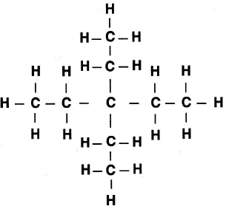 8.

