Name: _______________________ Class________________

Honors Chemistry: Dalton’s Law of Partial Pressure

Directions: Solve each of the following problems. Show your work.

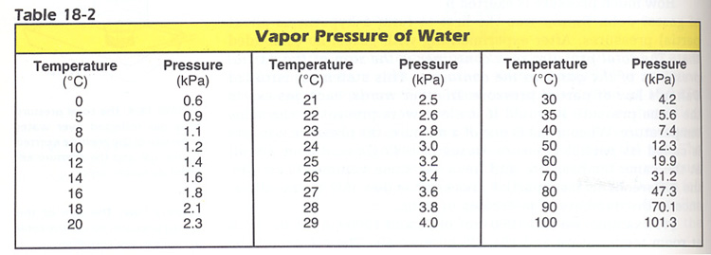

1. A 250 ml sample of oxygen is collected over water at 25C and 760.0 torr pressure. What is the pressure of the dry gas alone? ( Vapor pressure of water at 25C is on chart above)

2. A 32.0 ml sample of hydrogen is collected over water at 20C and 750.0 torr pressure. What is the volume of the dry gas at STP?

3. A 54.0 ml sample of oxygen is collected over water at 23C and 770.0 torr pressure. What is the volume of the dry gas at STP?

4. A mixture of 2.00 moles of H₂ , 3.00 moles of NH₃ , 4.00 moles of CO₂ and 5.00 moles of N₂ exerts a total pressure of 800.torr. What is the partial pressure of each gas?

5. A container holds three gases: oxygen, carbon dioxide, and helium. The partial pressures of the three gases are 2.00 atm, 3.00 atm, and 4.00 atm, respectively. What is the total pressure inside the container?

6. A container with two gases, helium and argon, is 30.0% by volume helium. Calculate the partial pressure of helium and argon if the total pressure inside the container is 4.00 atm.

7. If 60.0 L of nitrogen is collected over water at 40.0 °C when the atmospheric pressure is 760.0 mm Hg, what is the partial pressure of the nitrogen?

8. 80.0 liters of oxygen is collected over water at 50.0 °C. The atmospheric pressure in the room is 96.00 kPa. What is the partial pressure of the oxygen?

9. A tank contains 480.0 grams of oxygen and 80.00 grams of helium at a total pressure of 7.00 atmospheres. Calculate the following.
a) How many moles of O₂ are in the tank?
b) How many moles of He are in the tank?
c) Total moles of gas in tank.
d) Mole fraction of O₂.
e) Mole fraction of He.
f) Partial pressure of O₂.
g) Partial pressure of He.

10. A tank contains 5.00 moles of O₂, 3.00 moles of neon, 6.00 moles of H₂S, and 4.00 moles of argon at a total pressure of 1620.0 mm Hg. Complete the following table
O₂ Ne H₂S Ar Total
Moles 18.00

Mole fraction 1

Pressure fraction 1

Partial Pressure 1620.0

11. A mixture of 14.0 grams of hydrogen, 84.0 grams of nitrogen, and 2.0 moles of oxygen are placed in a flask. When the partial pressure of the oxygen is 78.00 mm of mercury, what is the total pressure in the flask?
12. A flask contains 2.00 moles of nitrogen and 2.00 moles of helium. How many grams of argon must be pumped into the flask in order to make the partial pressure of argon twice that of helium?

13. The partial pressure of F₂ is 300. torr in a mixture of gases where the total pressure is 1.00 atom. What is the mole fraction of F₂?

