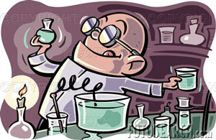
Date: _________________________

Neutralization Reactions Worksheet

1. Write the balanced chemical equations for the neutralization reactions between:

- HI and NaOH

- H₂CO₃ and Sr(OH)₂

- Ca(OH)₂ and H₃PO₄

- hydrobromic acid and barium hydroxide

- zinc hydroxide and nitric acid

- aluminum hydroxide and hydrochloric acid

2. Complete and balance the following equations representing neutralization reactions:

- CsOH + H₂CO₃  +
- HF + Mg(OH)₂  +
- HNO₃ + Al(OH)₃  + Al(NO₃)₃
- +  H₂O + KCl
- +  + LiBrO₃

3. Give the name and the formula of the ionic compound produced by neutralization reactions between the following acids and bases:

Acid and Base reactants | Name of ionic compound | Formula
- nitric acid
and sodium hydroxide
- hydroiodic acid
and calcium hydroxide
- magnesium hydroxide
and hydrosulfuric acid
- ammonium hydroxide
and hydrofluoric acid
- barium hydroxide
and sulfuric acid
- chloric acid
and rubidium hydroxide
- calcium hydroxide
and carbonic acid

4. For each of the following ionic compounds, identify the acid and base that reacted to form them.

Salt |  | Acid | Base
a) | NaCl
b) | Ca₃(PO₄)₂
c) | Zn(NO₃)₂
d) | Al(ClO)₃
e) | NH₄I

