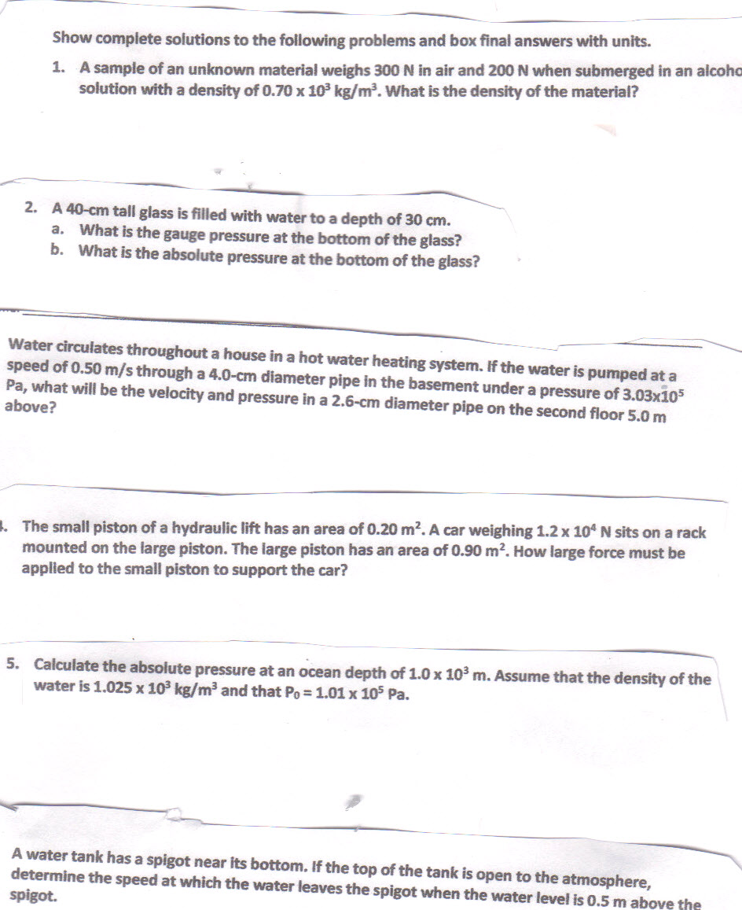
Archimedes’ Principle, Pascal’s Law and Bernoulli’s Principle

