LABORATORY: MITOSIS and MEIOSIS
OVERVIEW
In this laboratory, you will investigate the process of mitosis and meiosis. The first part is a study of mitosis. You will use prepared slides of onion root tips to study plant mitosis and to calculate the relative duration of the phases of mitosis in the meristem of root tissue. Prepared slides of the whitefish blastula may be used to study mitosis in animal cells and to compare animal mitosis with plant mitosis.
INTRODUCTION
All new cells come from previously existing cells. New cells are formed by the process of cell division which involves both replication of the cell's nucleus (karyokinesis) and division of the cytoplasm (cytokinesis). It is imperative that the DNA be moved in an extremely efficient manner during division. If the DNA were to be moved in a way that jeopordizes the integrity of it's code the resulting cells would have defective information that would likely lead to the new cells death. Biologists have been amazed by the beauty and accuracy of cell division. The preparations made by the cell in advance of and during division required millions of years to perfect. Without the many intricate steps that occur during division the chance of growth without disease is all but impossible. It has been demonstrated in many experiments that certain chemical substances, both legal as well as illegal, disrupt one or more of these intricate processes and results in either cell death or the formation of defective cells.
There are two types of nuclear division: mitosis and meiosis. Mitosis typically results in new somatic (body) cells. Formation of an adult organism from a fertilized egg, asexual reproduction, regeneration, and maintenance or repair of body parts are accomplished through mitotic cell division. Meiosis results in the formation of specialized reproductive cells, either gametes (in animals) or spores (in plants). These cells have half the chromosome number of the parent cell. You will study meiosis in Exercise 3B.
Quickly read through the first three pages of the web site shown below to become more familiar with the mechanics and intracacies of mitosis before you begin exercise 3A.1.
http://www.biology.arizona.edu/cell_bio/tutorials/cell_cycle/cells1.html
EXERCISE 3A.1: Observing Mitosis in Plant and Animal Cells Using Prepared Slides of the Onion Root Tip and Whitefish Blastula
Where does one find cells undergoing mitosis? Plants and animals differ in this respect. In higher plants the process of forming new cells is restricted to special growth regions called meristems. These regions usually occur at the tips of stems or roots (growth in length) and in many is also found in a circular band of the stem allowing secondary growth (growth in width). In animals, cell division occurs anywhere new cells are formed or as new cells replace old ones. However, some tissues in both plants and animals rarely divide once the organism or tissue is mature (ie: vascular tissues in plants, brain neurons in animals).
To study the stages of mitosis, you need to look for tissues where there are many cells in the process of mitosis. This restricts your search to the tips of growing plants such as the onion root tip or, in the case of animals, to rapidly dividing tissue such as developing embryos.
Roots consist of different regions. The root cap functions in protection. The apical meristem is the region that contains the highest percentage of cells undergoing mitosis. The region of elongation is the area in which growth occurs. The region of maturation is where root hairs develop and where cells differentiate to become xylem, phloem, and other tissues (Figure 3.1)
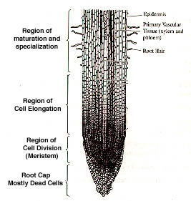 | 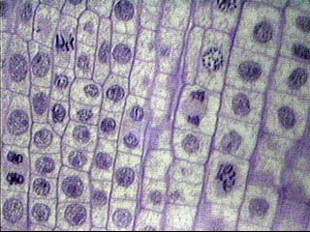  Cells of the Apical Meristem Close up.

The whitefish blastula is excellent for the study of cell division. It is a sperical mass of cells that represents a stage in the development of most animals. As soon as the egg is fertilized it begins to divide, and nuclear division after nuclear division follows. You will be provided with a slide that contains many whitefish blastula which have been sectioned in various planes in relation to the mitotic spindle. You will be able to see side and polar view of the spindle apparatus.
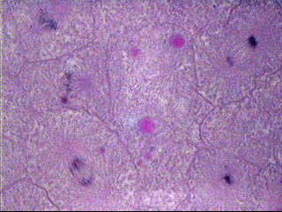
Cells of the Whitefish Blastula close up
PROCEDURE
Examine prepared slides of both the onion root tips and whitefish blastulas. Locate the meristematic region of the onion root tip to find all the various stages of the cell cycle. Looking at 2 or more whitefish blastulas should reveal every stage in the cell cycle as well. In both cases start with the 10X objective first, locate the blastula or the meristematic region of the root tip, and then use the 40X objective to study individual cells. The cells in the root tip will be clearly defined while the cells in the blastula may be a bit faint. In either case, the stained DNA will be very obvious and enable you to identify the specific dstages in the cell cycle. For convenience in discussion, biologists have described certain stages, or phases, of the continuous mitotic cell cycle, as outlined below. Identify one cell which clearly represents each phase. Sketch and label the cell in the box provided.
- The nondividing cell is in a stage called interphase. The nucleus may have one or more dark-stained nucleoli and is filled with a fine network of threads, the chromatin. During interphase, DNA replication occurs. Interphase is actually divided into three different stages.
G1 - first growth phase. increasing organelle content of cell
S - synthesis of more DNA (replication)
G2 - second growth phase, forming specific cytoplasmic structures needed for mitosis & cytokinesis
- The first sign of division occurs in prophase. There is a thickening of the chromatin threads, which continues until it is evident that the chromatin has condensed into chromosomes. With somewhat higher magnification you may be able to see that each chromosome is composed of two chromatids joined at a centromere. As prophase continues, the chromatids continue to shorten and thicken. In late prophase the nuclear envelope and nucleoli are no longer visible, and the chromosomes are free in the cytoplasm. Just before this time the first sign of a spindle appear in the cytoplasm; the spindle apparatus is made up of microtubules, and it is thought that these microtubules may pull the chromosomes toward the poles of the cell where the two daughter nuclei will eventually form.
- At metaphase, the chromosomes have moved to the center of the spindle. One particular portion of each chromosome, the centromere, attaches to the spindle. The centromeres of all the chromosomes lie at about the same level of the spindle, on a plane called the metaphase plate. At metaphase you should be able to observe the two chromatids of some of the chromosomes.
- A the beginning of anaphase, the centromere regions of each pair of chromatids separate and are moved by the spindle fibers toward opposite poles of the spindle, dragging the rest of the chromatid behind them. Once the two chromatids separate, each is called a chromosome. These daughter chromosomes continue poleward movement until they form two compact clumps, one at each spindle pole
- Telophase; the last stage of division is marked by a pronounced condensation of the chromosomes, followed by the formation of a new nuclear envelope around each group of chromosomes. The chromosomes gradually uncoil to form the fine chromatin network seen in interphase, and the nucleoli and nuclear envelope reappear. Cytokinesis may occur. This is the division of the cytoplasm into two cells. In plants, a new cell wall is laid down between the daughter cells. In animal cells, the old cell with pinch off in the middle along a cleavage furrow to form two new daughter cells
ANALYSIS QUESTIONS
- Why is it more accurate to call mitosis "nuclear replication" rather than "cellular division"?

- Explain why the whitefish blastula and onion root tip are selected for a study of mitosis.
- In what way are the proteins Cdk (cyclin dependent kinase) and p53 different? In what way are they similar?
Before you begin exercise 3A.2 check your ability of identifying onion root tip cells in the various stages of the cell cycle by using the web site shown below
http://www.biology.arizona.edu/cell_bio/activities/cell_cycle/01.html
EXERCISE 3A.2: Time for Cell Replication
OVERVIEW
To estimate the relative length of time that a cell spends in the various stages of cell replication, you will examine the mereistematic region of a prepared slide of the onion root tip. The length of the cell cycle is approximately 24 hours or 1440 minutes for cells in actively dividing onion root tips.
PROCEDURE
It is hard to imagine that you can estimate how much time a cell spends in each phase of cell replication from a slide of dead cells. yet this is precisely what you will do in this part of the lab. Since you are working with a prepared slide, you cannot get any information about how long it takes a cell to divide. What you can determine is how many cells are in each phase. From this, you can infer the percent of time each cells spends in each phase.
- Create a table like the one shown below in your lab write up.
- In an onion root tip slide observe every cell in one high power field of view (50 or more cells) and determine which phase of the cell cycle it is in. This is best done in pairs. The partner observing the slide calls out the phase of each cell while the other partner records. Then switch so the recorder becomes the observer and vice versa. View the cells in columns and simply count the various stages as you move down the rows. Count at least two full fields of view. If you have not counted at least 200 cells, then count a third field of view.
- Record your data in Table 3.1
Table 3.1
 | Number Of Cells |  |  |  | Percent of Total Cells Counted | Time in Each Stage
 | Field #1 | Field #2 | Field #3 | Total | Percent of Total Cells Counted | Time in Each Stage
Interphase
Prophase
Metaphase
Anaphase
Telophase
Total Cells Counted |  |  |  |  | 1440 min = 1 complete cycle
4. Calculate the percentage of cells in each phase. Considering that the average complete cycle in onion root tip cells requires approximately 1440 minutes to complete,
calculate the amount of time spent in each phase of the cell cycle from the percent of cells in that stage.
5. In your lab write up make a Pie Chart that reveals the amount of time the cell spends in each of the five major stages of the cell cycle .

Questions:
1- If your observations had not been restricted to the area of the root tip that is actively dividing. how would your results been different?
2- Based on the data in Table 3.1, what can you infer about the relative length of time an onion root tip cell spends in each stage of the cell cycle? (What is the significance in the time spent in a particular stage)

EXERCISE 3B: Melosis
INTRODUCTION
Meiosis involves two successive nuclear divisions that produce four haploid (one of each chromosome - half the diploid number) cells. Melosis I is the reduction division. It is this first division that reduces the chromosome number from diploid to haploid and separates the homologous pairs. Meiosis II, the second division, separates the sister chromatics. The result is four haploid gametes. Mitotic cell division produces new cells genetically identical to the parent cell. Meiosis increases genetic variation in the population. Each diploid cell undergoing meiosis can Produce 2n different chromosomal combinations, where n is the haploid number. In humans the Number is 2to the 23 power, which is more than eight million different combinations. Actually, the potential variation is even greater because, during meiosis I, each pair of chromosomes (homologous chromosomes) comes together in a process known as synapsis. Chromatids of homologous chromosomes may exchange parts in a process called crossing over. The relative distance between two genes on a given chromosome can be estimated by calculating the percentage of crossing over that takes place between them.
EXERCISE 3B.1: Simulation of Melosis
In this exercise you will study the process of meiosis using chromosome simulation kits. Your kit should contain two strands of beads of one color and two strands of another color. A homologous pair of chromosomes is represented by one strand of each color, with one of each pair coming from each parent. The second strands of each color are to be used as chromatics for each of these chromosomes.
Interphase. Place one strand of each color near the center of your work area. (Recall that chromosomes at this stage would exist as diffuse chromatin and not as visible structures.) DNA synthesis occurs during interphase and each chromosome, originally composed of one strand, is now made up of two strands, or chromatics, joined together at the centromere region. Simulate DNA replication by bringing the magnetic centromere region of one strand in contact with the centromere region of the other of the same color. Do the same with its homolog (Figure 3.4).
Interphase: Place one strand of each color near the center of your work area. In interphase recal that the DNA is relaxed and in the form of threadlike Chromatin. (We will be unable to model the chromatin phase but can simulate what happens to the total number of DNA molecules) DNA synthesis occurs during Interphase (S-stage). At the conclusion of the S stage each strand of DNA has bee copied (Replication) and when chromosomes are formed in Prophase they will be actually double stranded (Two identical DNA chains). Each strand is called a Chromatid and they are held together by a mass of protein called the Centromere. Simulate DNA replication by bringing the magnetic centromere region of one strand in contact with the centromere region of the other of the same color. Do the same with its homolog.  Summary: DNA Replication | 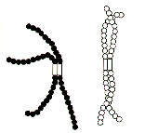

Prophase I: Homologous chromosomes come together and synapse along their entire length. Synapsis does not occur in mitosis and therefore this is the first big difference between Mitosis & Meiosis.. (In mitosis homologous chromosomes line up independently of one another) A Tetrad consisting of four chromatids is formed. Entwine the two chromosomes to simulate synapsis and the process of crossing over. Crossing Over can be simulated by popping some beads apart on one chromatid at the fifth bead or "Gene" and doing the same with the other chromatid. Reconnect the beads to those of the other color. Proceed through Prophase I of meiosis and note how crossing over results in recombination of genetic information.  Summary: Synapsis & Crossing Over | 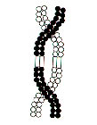

Metaphase I  The Crossed Over Tetrads line up in the center of the cells. Position the chromosomes near the middle of the cell.  Summary: Tetrads Align On The Equator | 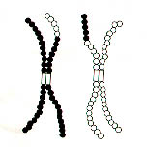

Anaphase I  During Anaphase I, the hmologous chromosomes are separated and pulled to opposite sides of the cell. This represents a second significant difference between the events of mitosis and meiosis.  Summary:Tetrads Separate Chromosome number reduced | 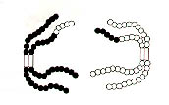

Telophase I: Place each chromosome at opposite sides of the cell. Centriole duplication is completed in Telophase in preparation for the next division. Formation of a nuclear envelope and division of the cytoplasm (cytokinesis) often occur at the same time to produce two cells, but this is always not the case. Some cells are large and depend upon many nuclei to control metabolism (cardiac muscle cells). In their case Mitosis can occur that is not accompanied by cytokinesis. Notice in your simulated cell that each chromosome within the two daughter cells still consists of two chromatids.  Summary:Two Haploid Cells Formed, each chromosome composed of two chromatids | 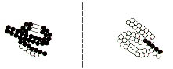

Meiosis II
A second meiotic division is necessary to separate the chromatids of the chromosomes in the two daughter cells formed by the first division. This will reduce the amount of DNA to one strand (chromatid) per chromosome. This second division is called Meiosis II. It resembles mitosis except that it begins with only one homolog from each homologous pair of chromosomes.
The following simulation procedures apply to haploid nuclei produced from Meiosis I.
Interphase II (Interkinesis): The amount of time spent "at rest" following telophase I depends upon the type of organism which will impact the formation of new nuclear envelopes, and the degree of chromosomal uncoiling. Because Interphase II does not necessarily resemble Interpahse I, it is often given a different name - interkinesis. DNA replication does not occur during Interkinesis. This represents the Third difference between mitosis & meiosis.
Prophase II: No DNA replication occurs. replicated centrioles (not shown) move to opposite sides of the cell. Double stranded chromosomes formed during Meiosis I become attached to the developing spindle fibers.
Summary: nuclear envelope disappears, chromatids condense to chromosomes, centrioles move to opposite sides, spindle attaches to centromere of chromosomes.
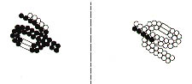

Metaphase II:Chromosomes are moved so that are centered in the middle of each daughter cell
Summary: Chromosomes are moved to the center of the cell (cells typicaly have many chromosomes , humans have 23 homologs, at this stage of meiosis the chromosomes move independently of one another just like in Mitosis)
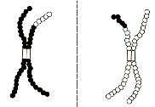
Anaphase II: The centromere regios of the chromatids split. separate the chromatids of the chromosomes and pull the daughter chromosomes toward the opposite sides of each daughter cell. Now that each chromatid has its own visibly separate centromere region it can be called a chromosome.
Summary : Chromatids Separate
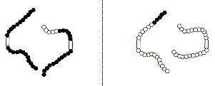
Telophase II: After the single chromatids have reached the opposite sides of the cell a nuclear envelope is reformed, spindle fibers break down, chromosomal DNA uncoils and forms chromatin, the cytoplasm divides and cleaves the cell into two separate cells each having one of each type of chromosome.
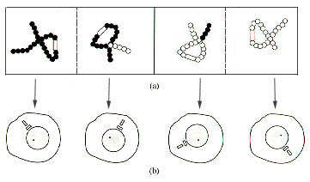
Check your understanding of Meiosis by using the web site shown below.
http://www.biology.arizona.edu/cell_bio/tutorials/meiosis/problems.html
Before moving on to the analysis questions use the pop it beads to construct four single stranded chromosomes. Use one hmologous pair to represent a cell going through mitosis use the other homologous pair to represent a cell going through meiosis. Move the beaded chromosome models to simulate mitosis in the one cell and meiosis in the other. Compare the two and look for major differences.

Analysis & Investigation
1. List three major differences between the evnts of Mitosis & Meiosis.

2. Compare mitosis and meiosis with respect to each of the following.
 | Mitosis | Meiosis
Chromosome number of
parent cell
Number of DNA
Replications
Number of Divisions
Number of Daughter cells
produced
Chromosome number in
daughter cells
Purpose of division

3. How are meiosis I and Meiosis II different?

4. Oogenesis (formation of the egg) and spermatogenesis (formation of the sperm) have some differences. Refer to your text to identify what these differences are and explain their significance?

5.Why is meiosis important for sexual reproduction?

