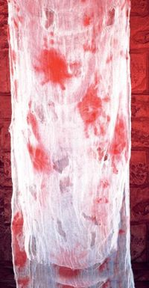
Prepared Fiber Slides Name ________

There are two prepared slides
- Natural Textile Fibers (Wards # 94W9113)- it has 4 threads on it
  - Cotton (green, far left)
  - Linen
  - Hemp
  - Silk

- Fiber Comparison (Wards # 94W0150)- dyed and bloodstained

Your Task:

- Obtain one of each slide.
- Examine the Textile Fibers slide under the 10 x objective lense of the microscope. Draw each of the four fibers. Pay attention to the texture (whether it is smooth or if there are little fibrils “sticking out” down the sides).
- Examine the Comparison slide under the microscope. Draw the dyed fiber and the bloodstained fiber.
Textile Fibers: 10x lens
Cotton, Linen, Hemp, Silk
(Draw all 4 fibers– use colored pencils and label each fiber)
Red Fibers: 10x lens
Dye vs. Blood Stain
(Draw both fibers– use colored pencils and label each fiber)
Questions:

- What is the total magnification under the 10x lens? ______________

- What differences did you observe between the four fibers on slide one?

________________________________________________________________

________________________________________________________________

________________________________________________________________

________________________________________________________________

________________________________________________________________

________________________________________________________________

- Explain how you decided which fiber on Slide 2 was dyed and which was bloodstained.

________________________________________________________________

________________________________________________________________

________________________________________________________________

________________________________________________________________

________________________________________________________________

________________________________________________________________

4. Prepare a wet mount of the unknown fiber. Draw what you see and explain how you decided the most likely material, based on your observations from step 2 of the lab.

________________________________________________________________

________________________________________________________________

________________________________________________________________

________________________________________________________________

________________________________________________________________

________________________________________________________________

________________________________________________________________

