Handwriting Analysis Name __________________

©2005, 2004, 2002, 1993 by David A. Katz. All rights reserved

Handwriting is unique to each individual. Although some peoples’ handwriting may have similar styles and characteristics in common, acquired when these people learned to write by copying letters and words, they tend to take on individual styles with age. Also, as a person ages, their handwriting will show additional changes.

Generally, one cannot determine the age or sex of a suspect or whether they are left-handed or right-handed from a normal writing sample. Certain types of flourishes and embellishments in writing styles and detailed examination of an original document may give hints at some of these characteristics.

In handwriting analysis, one should look for similarities in the shapes, styles, alignment, and spacing of letters.

**Part 1 – Analyzing Your Handwriting:**

In the space below, ***have your partner*** write the following paragraph in your normal handwriting.

“The quick brown fox jumped over the lazy dog. I am a student at Penfield High School learning about different techniques scientists use to solve crimes. Jack and Jill went up the hill.”

Next, ***have your partner*** sign their name on one of the lines below.

Then, your partner should find 4 *other* people to forge their name on the remaining lines, trying to make it look as much like their own as possible.

1. __________________________________________
2. __________________________________________
3. __________________________________________
4. __________________________________________
5. __________________________________________

Finally, analyze the signatures on your page. Which signature belongs to your partner? ______

What criteria did you use to decide? (describe below)

**Part 2**

Study the ransom note in Figure H-1. Note some of the unique characteristics of the individual’s handwriting.

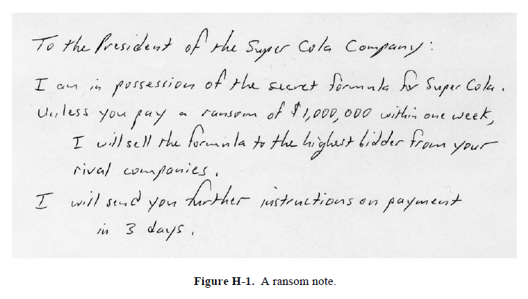

1. List your observations and measurements of the handwriting sample:

Spacing of words and letters:

Are there any pen lifts and separations?

Are there any unusual letter formations?

Is there any slant to the writing? Describe

Describe placement of diacritics:

Are there any flourishes or embellishments?

Figure H-2 contains samples of handwriting from 5 suspects. Can you determine who wrote the ransom note shown in Figure H-1?



**Figure H-2.** Handwriting samples from five suspects

1. Who wrote the Ransom? ____________________________ Explain:

Part III- Try this:

Write your signature five times in the spaces below:

_______________________________________________

_______________________________________________

_______________________________________________

_______________________________________________

_______________________________________________

Now, try to write your signature **exactly** as you did in the 5th sample above:

______________________________________________

Ask your lab partner to write your signature **exactly** as you did in the 5th sample above:

______________________________________________

1. Are your five signatures the same? Explain
2. Is your 6th signature identical to the signature you tried to copy? Explain
3. Was your lab partner able to copy your signature? Explain similarities and differences.