Name: _______________________________________________ Period: _____

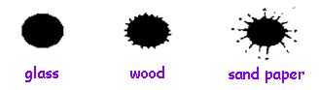
Bloodspatter Lab
—Day One & two

Vertical Drip Patterns and Surface Textures

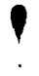
Part 1: Vertical Drip Pattern Recognition

Part A: Single Drop Pattern

- Hold the bottle of Drip and Projected Blood upside down (not tilted) so that the end of the dropper is 15 cm from the target surface (index card).
- Squeeze gently so that one drop falls from the 15 cm. height.
- Mark the specimen as vertical drop at 15 cm.
- Move the bottle so that it is 30 cm. from the surface. Release a drop next to the previous drop.
- Continue generating the remaining blood drops at the vertical heights listed in the data table, using this same procedure.
- Briefly allow the drops to dry.
- Measure the circular part of the drop in millimeters. If there are spines or protrusions on the drop, disregard them as part of the measurement.
- Record all measurements.
- Make a sketch of the drop including spines or protrusions.

Part B: Multiple Blood Drips Patterns

- Hold the bottle of Drip and Projected Blood so that the tip is 30 cm. above the target surface (index card).
- Release one drop and DO NOT move your hand!! Drop a second drop onto the first. Note any change in the pattern after the second drop has fallen onto the first. Use Data Table B.
- Drop a 3rd blood from the same position so that it lands on the same spot with the other two drops.
- Again, note the changes.
- Do one more time so that there are now 4 drops on the same spot.
- Obtain a clean target at least the size of looseleaf paper (multiple cards can be taped, or use larger paper). Place 2-3 ml. of blood into a 10 ml. cylinder. Hold above the target at 30 cm. and pour the entire volume all at once onto the target.
- Observe the pattern and record the results. Label This “Large Volume Vertical Drip”.

Data Table A

Height of Blood Drop  (cm) | Diameter of Blood Drop (mm) | Sketch of Blood Drop
15 cm

30 cm

45 cm

60 cm

75 cm

100 cm

150 cm

Data Table B
Blood Drips | Observations- in Words and Picture
One
Two
Three
Four
Large Volume

Assessment Questions
- How are the blood drops at different heights alike? ____________

________________________________________________________________

________________________________________________________________

________________________________________________________________

________________________________________________________________

________________________________________________________________

- How do they differ? ______________________________________

________________________________________________________________

________________________________________________________________

________________________________________________________________

________________________________________________________________

________________________________________________________________

- How do the large volume and the multiple drops patterns compare?

________________________________________________________________

________________________________________________________________

________________________________________________________________

________________________________________________________________

________________________________________________________________

________________________________________________________________

- Using the following graph paper, create a graph that illustrates Drop Height vs. Diameter for the blood drops in Part 1. What kind of curve is produced?

- Given the following diameters of blood drops, from what height, approximately, did these drops fall?
  - 8 mm

  - 14 mm

  - 18 mm

- Predict: How does the blood drop pattern differ between smooth and rough surfaces?

________________________________________________________________

________________________________________________________________

________________________________________________________________

________________________________________________________________

________________________________________________________________

________________________________________________________________

________________________________________________________________

________________________________________________________________
Blood Spatter Lab –Day 3

Relationship Between Shape and Impact Angle for Bloodstains

Part 1
1. Assembling the Impact angle apparatus
Tape one end of the clipboard to the table by making a hinge out of tape. The clipboard should be right at the edge of the table. Hold the protractor to the edge of the clipboard so that the protractor is perpendicular to the table top and aligned so that the center of the protractor is at the edge of the hinged-end of the clipboard. See Figure 2.

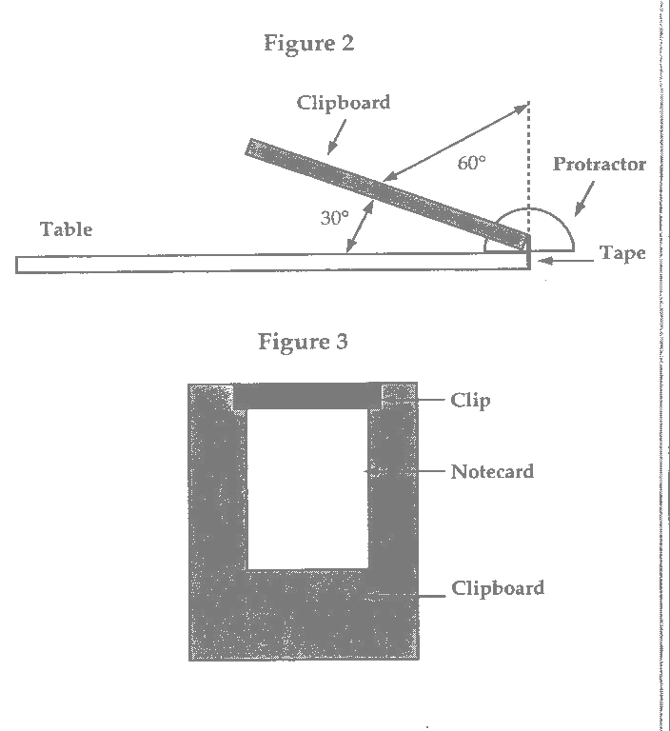

2. Data Table A includes angles from 10° to 90°. Test all angles. Once you have selected an impact angle, indicate the angle on the card and then attach the card to the board (Figure 3). Set the angle of the board using the protractor so that the board will have the correct impact angle. You may need to use a partner for this. To obtain the desired impact angle, set the impact angle board to a protractor setting of 90° minus the desired impact angle. For example, to obtain a 60° impact angle, set the board at a protractor setting of 30° (Figure 2).

3. Using the Simulated Drip and Projected Blood, place the dropper at approximately 30 cm above the impact angle board.

4. Allow two to three drops to fall sequentially onto the card. Move your hand so that the drops don’t overlap. Using multiple drops will allow you to see the variation that single drops may display when striking the surface. Leave the card in position for 2-3 minutes before carefully removing it.

5. Allow the drops to dry and then store the cards in your notebook or in some other safe place.

Data Table A

Impact Angle | 10° | 20° | 30° | 40° | 50°
Sketch

Description

Data Table A (continued)

Impact Angle | 60° | 70° | 80° | 90°
Sketch

Description

Assessment Questions

- How does the shape and size of a blood drop change as the impact angle is increased?

__________________________________________________________

________________________________________________________________________

________________________________________________________________________

________________________________________________________________________
- Draw a sketch of what a drop would look like at (Predict from data, don’t collect data!)

15º
35º
55º
75º

