You Won’t Find This File Baked IN A CAKE

Name: _____________________________________

It is very important for the police to keep extensive, easy to use identification files. If an accurate and complete description of a person is provided, a quick search of the files might result in identification. In this exercise, you will make a file of all the members of your class and learn a quick classification system used to track down a person’s name from a description.

Police make extensive use of computers these days which allows them to store and quickly find large amounts of information. The file you make will contain only a relatively small amount of information, but by making it you should be better able to understand how information can be handled efficiently.

In the 1800’s, before fingerprinting was used, criminal identification was accomplished by making a number of measurements, some of which are illustrated below. The technique was known as the Anthropometric System, and was originated by a Frenchman named
_________________________. The use of body measurements for identification is called
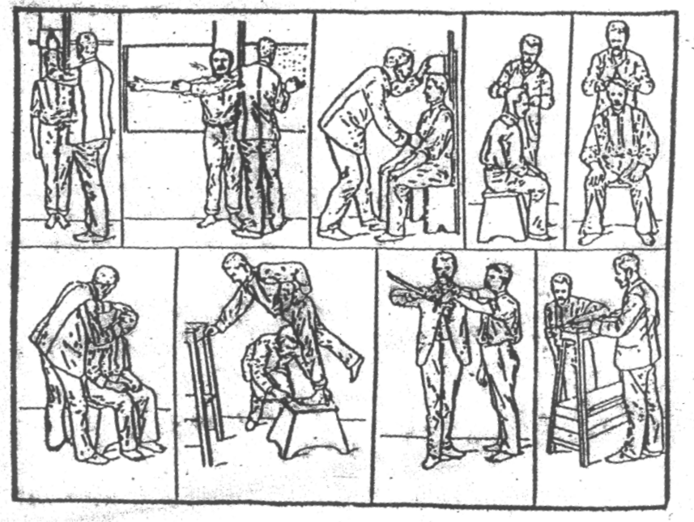
_________________________. You will make just 4 of the illustrated measurements to include in

your file.

PROCEDURE:

1. Obtain a meter stick and with the help of a partner, have your partner make the following measurements for you in inches and record them in the spaces provided below.

A) Your height (standing ) ___________________

B) Your height (seated) Note: Use seat designated by your teacher ____________________

C) The length of your foot _____________________

D) The distance from your elbow to the tip of your middle finger __________________

2 Record these measurements and your gender on the drawing of a 4” x 6” card supplied by your teacher by making an “X” in the appropriate boxes. (The symbol > means “greater than”, so that >5’ to 5’2” means greater than 5’ up to and including 5’2”.).

3. A) Carefully cut the drawing of the card out of your green paper

B) Using a hole punch, make a hole through each of the 5 “X’s” you have made.

C) Use scissors to cut out all of the boxes that have not been punched. Your card should look similar to the one illustrated below.

4. A) After you have completed your data card, give it to your teacher who will put it in a neat stack with the cards from the rest of the class.

B). A student volunteer will take the stack, and, use the measurements of a previously selected but unnamed student. The volunteer will push a dowel or similar instrument through the corresponding holes in the stack of cards.

C) As the stack is gently shaken, all the cards not held by the dowel will fall out. If this procedure is repeated for each measurement, eventually only the card(s) containing the measurement of the selected person will remain.

Questions:
1. Using the methods in this exercise, how would you know if there were more than one person with the same measurements in your class?

_________________________________________________________________________________

_________________________________________________________________________________

_________________________________________________________________________________

2. How could this method be improved? (Hint: see sketch at front of lab)

_________________________________________________________________________________

_________________________________________________________________________________

3. A student measures her partner while seated and ends up with three different measurements when repeating the test several times. Explain how this could happen. (Assume no error in correct use or reading of a ruler/measuring tape.)

_________________________________________________________________________________

_________________________________________________________________________________

_________________________________________________________________________________

_________________________________________________________________________________

4. Besides your answer to the question above, suggest one reason why the measurement of a person might not stay the same.

_________________________________________________________________________________

_________________________________________________________________________________

_________________________________________________________________________________

5. Explain why this method might be inaccurate when identifying a criminal from an eyewitness description.

_________________________________________________________________________________

_________________________________________________________________________________

_________________________________________________________________________________

_________________________________________________________________________________

6. What is the physical characteristic most often used by police to identify people nowadays?

_________________________________________________________________________________

7. Suggest a better way to store a lot of information. ________________________________________

Under 13 “
H eight (Standing)

___________________________________________
N A M E
Height (Seated)
Elbow to Fingertip
> 17 “
19 “

> 15 “
17 “

13 “

15 “

> 19 “

> 52 “

> 51 “

52 “

> 50 “

51 “

> 49 “

50“

> 48 “

49 “

> 47 “

48 “

46 “

47 “

Under

46 “
Under

5’0“

5’2 “

> 5’0“

5’4 “

>5’2” “

5’6 “

> 5’4“

5’8“

> 5’6“

5’10“

> 5’8

6’0”

>5’10”

>5’10”

> 6’ 0” “

21 “

> 9 “

10 “

> 10 “

11 “

> 11 “

8 “

9 “

Male
Female
Foot
Under

8 “

H eight (Standing)

___________________________________________
N A M E
Height (Seated)
Elbow to Fingertip
> 17 “

19 “

> 15 “

17 “

13 “

15 “

> 19 “

> 52 “

> 51 “

52 “

> 50 “

51 “

> 49 “

50“

> 48 “

49 “

> 47 “

48 “

> 46 “

47 “

Under

46 “
Under

5’0“

5’2 “

> 5’0“

5’4 “

> 5’2” “

5’6 “

> 5’4“

5’8“

> 5’6“

5’10“

> 5’8

6’0”

>5’10”
> 6’ 0” “

21 “

> 9 “

10 “

> 10 “

11 “

> 11 “

> 8 “

9 “

Male
Female
Foot
Mark data and hole punch in center
H eight (Standing)

___________________________________________
N A M E
Height (Seated)
Elbow to Fingertip
> 17 “

19 “

> 50 “

51 “

>5’8“

5’6“

> 10 “

11 “

Male
Foot
Cut out where NOT hole punched
Elbow to Fingertip

