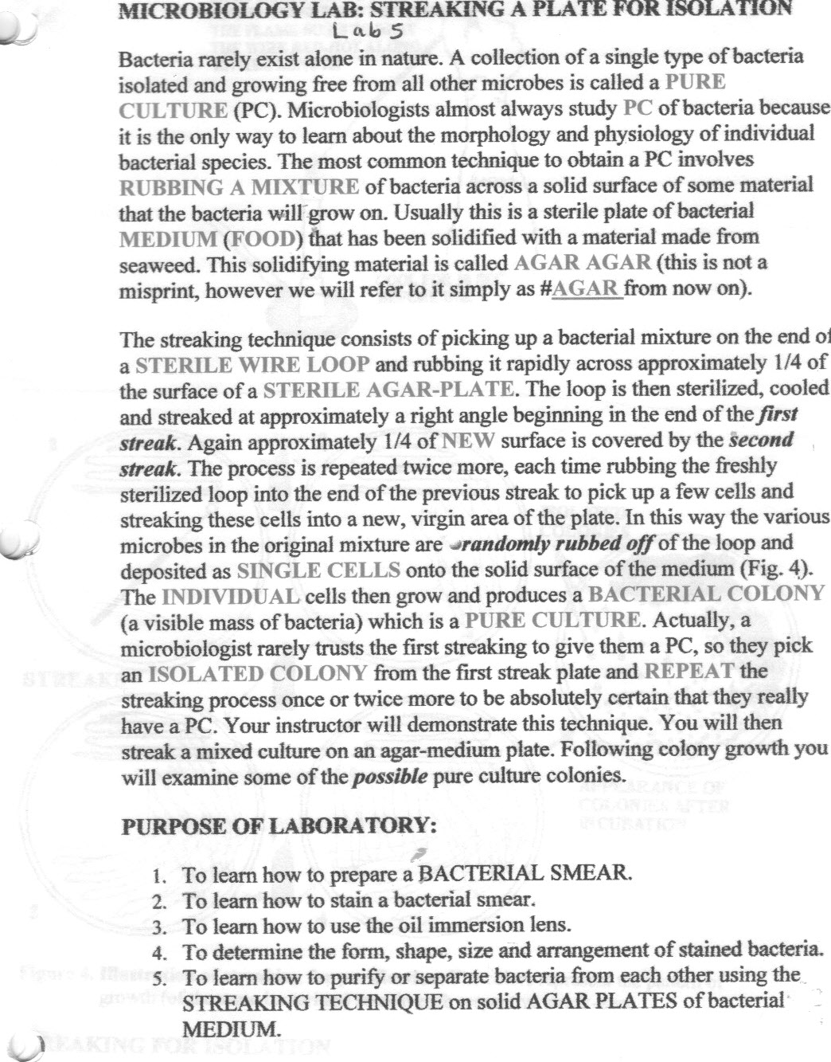

Handling and observing cultures

I. Procedures
A. Transfer of a culture
- Pick up the inoculating loop as you would a pencil, loop down. Hold the wire in the flame of the Bunsen burner until it glows red. Remove the loop from the flame and hold it quietly for a few moments until cool. Do not lay it down or touch it to anything.
- Pick up a slant culture with your left hand. Still holding the loop like a pencil in your right hand, use the little finger of the loop hand to remove and hold the closure of the culture tube. Pass the neck of the open tube rapidly through the flame two or three times to sterilize the mouth of the tube.
- Insert the loop into the open tube. Touch the loop to the cultured material and remove a loopful by scraping gently.
- Withdraw the loop slowly and steadily without touching the sides of the tube. Hold it steady and do not touch it to anything while you replace the tube closure.
- Still holding the loop in one hand. use the other hand to pick up a tube of sterile medium. Remove the tube closure, flame the neck of the tube, insert the loop into the tube and gently rub the loop on the surface of the medium to remove the culture material. Carefully remove the loop from the tube.
- Flame, close and replace the tube in the rack; then sterilize the loop as before.
- Label the freshly inoculated tube with your name, the name of the organism and the date.
- Describe and sketch the bacterial growth on the original culture in your lab notebook.
B. Incubation
- Check that all new tubes are properly and fully labeled with the organism, the date, and your name.
- Place the transferred cultures in an assigned area of the proper incubator. Record the the reading of the incubator thermometer at the start and at the end of your culture period. Let the instructor know immediately if it is not at the expected temperature.

II. Results
A. Examination
- Carefully note the characteristics of the cultures provided. Record information on the appearance, size, color, density, consistency, surface texture, and shape of colony.
- Sketch in your lab book representative bacterial colonies from each culture.
- After 24 and 48 hr of incubation observe the cultures you inoculated and record their appearance. If you have made successful transfers and achieved pure cultures, the color and appearance of your cultures should match that of the ones from which you transferred. See your notes and sketches from the original cultures. Note: Unless otherwise indicated, after 48 hr cultures should be removed from the incubator and stored at room temperature for future use.
- Sketch in your lab book representatives of the bacterial colonies you observe.
