**Jack the Ripper**

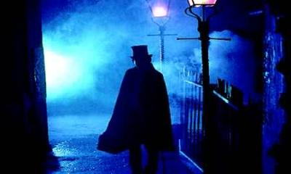 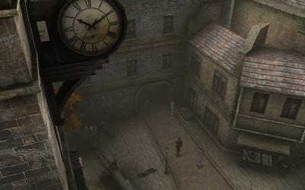

Introduction:

|  |  |
| --- | --- |
| Victorian age in England, the empire is opening into the XX century. Population increases, cities are not prepared to harbor the huge wave of immigrants, sanitation and housing services are almost collapsing. Along with this employment needs surpass the current offer, even more the most common offers are for men but women are in need for money too so they are forced into prostitution.  This is more or less the picture of the Victorian society. But even though all of this people managed to act and appear as educated and polite as they could, the English people was considered to be a well mannered and proper people ... until, a cold morning on August 31 1888, Mary Ann Nichols was found murdered on Durward Street, Whitechapel. Her thoath severed in two cuts and abdomen ripped open ...  **TASK**:  Follow the steps of Jack the Ripper and try to find out the true identity of the murderer!   |  | | --- | | Turn into a detective and find out the identity of The Ripper!  Review carefully at least 3 electronic sources and build a hypothesis about the true murderer. Remember that any statement you make MUST have support, it is very important to have hard evidence of all your theories.  After you have checked all the information, you should write an argumentative essay stating your theory, the essay must include aspects related to the characteristics of the Victorian lifestyle, society, economy, the nature of the murders and the identity of the Ripper.  **Question one to be completed:** *Analyze the people involved in the case.  Construct a character sketch of each person...anyone who is pertinent to the case.*  **Question two to be completed:** *Look at the testimony given by witnesses.  Summarize each person's testimony.  Include quotes of any testimony that you feel is important to your case.*  **Question three to be completed:** *Re-construct the sequence of events by creating a time line of the days leading up to and the actual day of the murders* |   Make notes on note cards as you will present your findings to the class. |

<http://www.crimelibrary.com/serial_killers/notorious/ripper/suspects_11.html>

[http://www.crimelibrary.com/serial_killers/notorious/ripper/suspects_18.htm http://www.crimelibrary.com/serial_killers/history/cream/yarn_8.htmll](http://www.crimelibrary.com/serial_killers/notorious/ripper/suspects_18.html)

|  |
| --- |
| Evaluation Rubric |
|  |
|  |
| |  |  |  |  |  |  | | --- | --- | --- | --- | --- | --- | |  | **Beginning 1** | **Developing 2** | **Very Good 3** | **Exemplary 4** | **Score** | |  | | | | | | | | **Effort (individual grade)** | The student used only one source or did not document any sources to gather information. | The student used two to three sources to gather information. | The student used a variety of materials to gather information. | The student used four or more sources to gather information. | %25 |  | |  | | | | | | | | **Accuracy (group work)** | Information presented was not based on fact. No documentation was included. | All factual information was not documented, nor was it completely accurate. | All information was factual. Most information was documented correctly. | All information was factual. All facts and information were documented to avoid plagiarism. | %25 |  | |  | | | | | | | | **Presentation (group work)** | Information presented was unorganized. No real purpose for presenting the information was established. No visual aids were presented. | Information presented was somewhat unorganized. Some of the information was irrelevant. Visual aids were not used to enhance presentation. | Student presented information in a relatively clear and concise manner. (For team): Speaker presented facts, but could have been more organized and convincing in the delivery. A variety of facts were presented. One visual aid was used to aid presentation. | Student presented information in a clear and concise manner. (for team): Presentation was done in a confident, convincing manner. A variety of facts were presented. More than one visual aid was used to aid presentation. | %25 |  | |  | | | | | | | | **Persuasive Paper (group work)** | Paragraphs lack organization. The position is not stated. Resources are not cited. The paper has many gramatical errors. | The closing argument may have a weak organizational structure. Some resources are cited. The paper has several grammatical errors. | Overall, the closing argument is clear and concise. Most citations are done correctly. Paper has some between 2-3 grammatical errors. | Closing argument is clear and concise. A clear position is stated. Citations are done correctly. Paper has no more than 2 grammatical errors. | %25 |  | |  | | | | | | | | **Total Score**: %100 | | | | | | | |